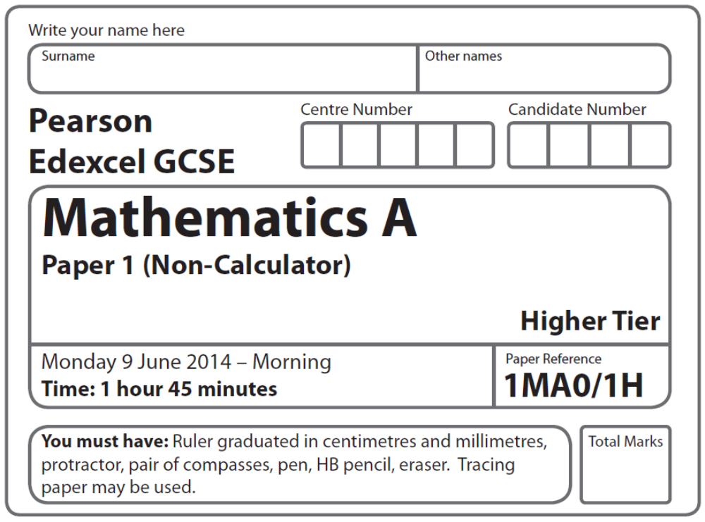
Practice Paper – Gold 4
Gold: 4 of 4

Instructions
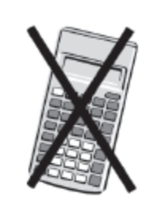
- Use black ink or ball-point pen.
- Fill in the boxes at the top of this page with your name,
centre number and candidate number.
- Answer all questions.
- Answer the questions in the spaces provided
– there may be more space than you need.
- Calculators must not be used.

Information
- The total mark for this paper is 100
- The marks for each question are shown in brackets
– use this as a guide as to how much time to spend on each question.
- Questions labelled with an asterisk (*) are ones where the quality of your
written communication will be assessed.

Advice
- Read each question carefully before you start to answer it.
- Keep an eye on the time.
- Try to answer every question.
- Check your answers if you have time at the end.

Suggested Grade Boundaries (for guidance only)
A* | A | B | C | D
77 | 55 | 38 | 26 | 17
GCSE Mathematics 1MA0

Formulae: Higher Tier

You must not write on this formulae page.
Anything you write on this formulae page will gain NO credit.

Volume of prism = area of cross section × length Area of trapezium = (a + b)h
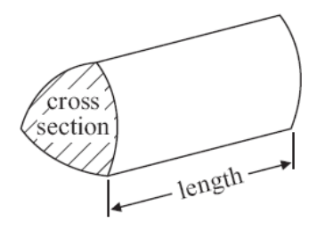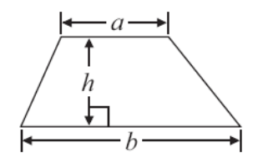

Volume of sphere πr³ Volume of cone πr²h
Surface area of sphere = 4πr² Curved surface area of cone = πrl

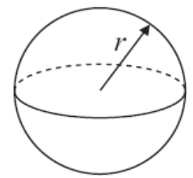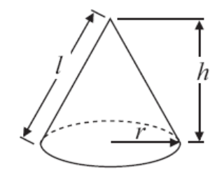

In any triangle ABC The Quadratic Equation
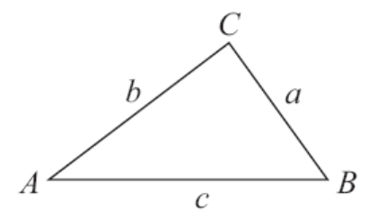
The solutions of ax²+ bx + c = 0
where a ≠ 0, are given by

x = 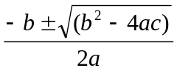

Sine Rule 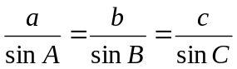

Cosine Rule a² = b²+ c²– 2bc cos A

Area of triangle = ab sin C
Answer ALL questions.
Write your answers in the spaces provided.
You must write down all stages in your working.
You must NOT use a calculator.

1. Given that 1793 × 185 = 331 705

write down the value of

(a) 1.793 × 185

..........................................
(b) 331 705 ÷ 1.85

..........................................
(Total for Question 1 is 2 marks)
___________________________________________________________________________
2. The diagram shows a patio in the shape of a rectangle.

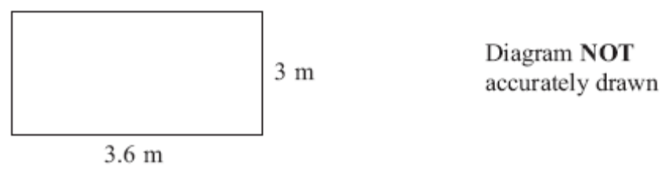

The patio is 3.6 m long and 3 m wide.

Matthew is going to cover the patio with paving slabs.
Each paving slab is a square of side 60 cm.

Matthew buys 32 of the paving slabs.

(a) Does Matthew buy enough paving slabs to cover the patio?
You must show all your working.

..............................................
(3)

The paving slabs cost £8.63 each.

(b) Work out the total cost of the 32 paving slabs.

£ ..............................................
(3)
(Total for Question 2 is 6 marks)
___________________________________________________________________________
3.
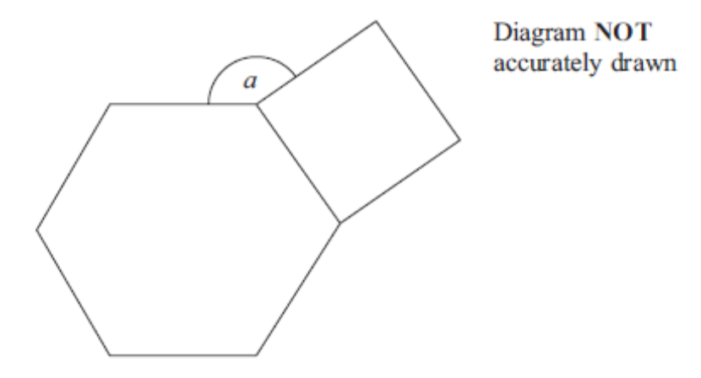

The diagram shows a regular hexagon and a square.
Calculate the size of the angle a.

................................... °
(Total 4 marks)
___________________________________________________________________________
4.
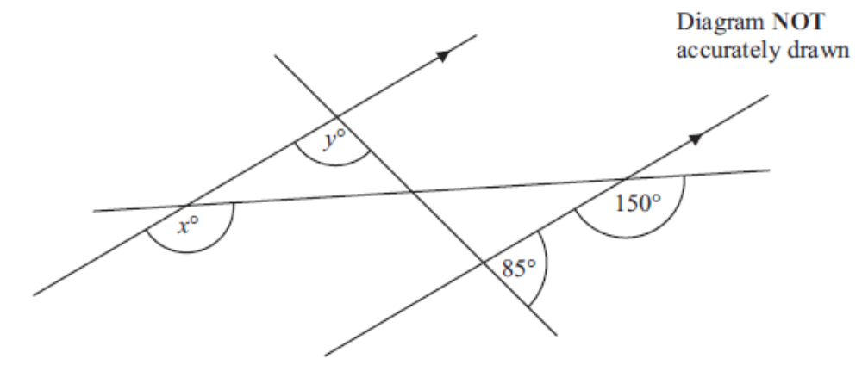

(a) Find the value of x.

.....................................
(1)

(b) Find the value of y.
Give reasons for your answer.

.....................................
(2)
(Total 3 marks)
___________________________________________________________________________
5.
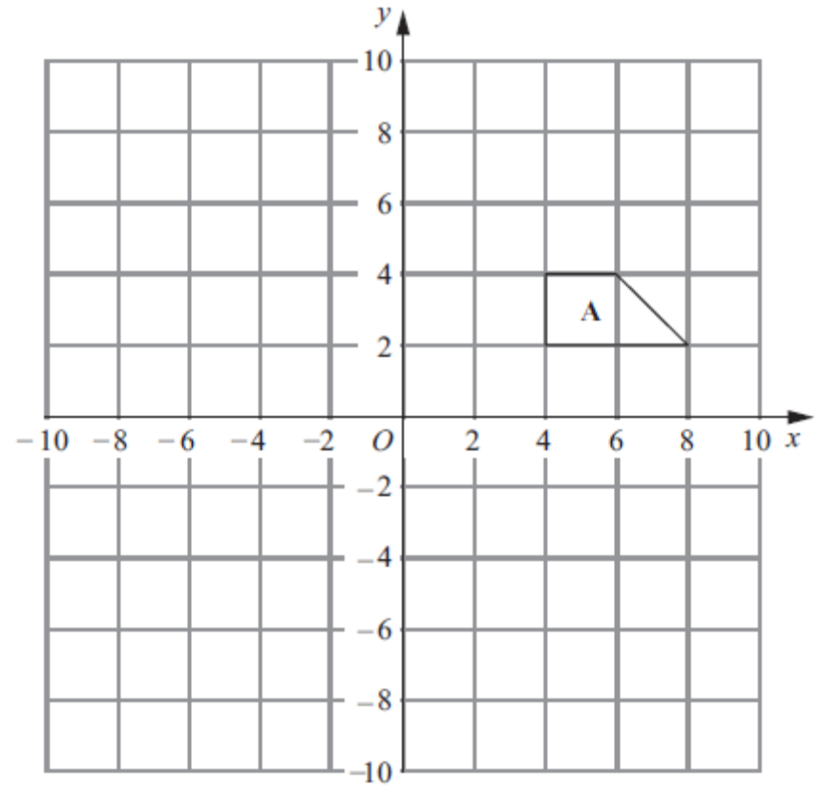

(a) Translate shape A by 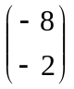.
Label the new shape B.
(2)
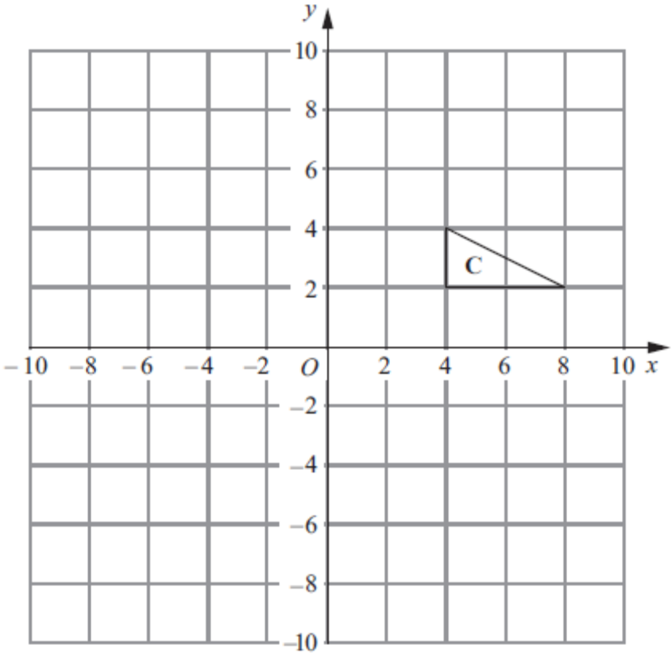

(b) Reflect shape C in the line y = x.
Label the new shape D.
(2)
(Total 4 marks)
___________________________________________________________________________

6.
Reading
22 | Slough
28 | 40 | Guildford
30 | 22 | 47 | Oxford
45 | 28 | 66 | 25 | Buckingham

The table gives distances in miles by road between some towns.

Izzy lives in Oxford.
She has to drive to a meeting in Buckingham and then from Buckingham to Reading to pick up a friend.
After she picks up her friend she will drive back to Oxford.
She plans to drive at a speed of 50 miles per hour.
The meeting will last 3 hours, including lunch.
She leaves Oxford at 9 a.m.

Work out the time at which she should get back to Oxford.

.....................................
(Total 4 marks)
___________________________________________________________________________
7. Buses to Acton leave a bus station every 24 minutes.
Buses to Barton leave the same bus station every 20 minutes.

A bus to Acton and a bus to Barton both leave the bus station at 9 00 am.

When will a bus to Acton and a bus to Barton next leave the bus station at the same time?

..............................................
(Total for Question 7 is 3 marks)
___________________________________________________________________________

8. Work out an estimate for the value of

(0.49 × 0.61)²

.....................................
(Total 2 marks)
___________________________________________________________________________
9. Sweets are sold in bags and in tins.

There are 20 sweets in a bag.
There are 30 sweets in a tin.

Lee buys B bags of sweets and T tins of sweets.

He buys a total of S sweets.
Write down a formula for S in terms of B and T.

.....................................
(Total 3 marks)
___________________________________________________________________________
*10.
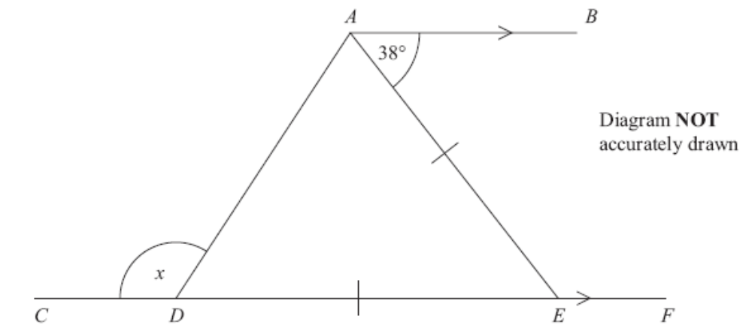

CDEF is a straight line.
AB is parallel to CF.
DE = AE.

Work out the size of the angle marked x.
You must give reasons for your answer.

(Total 4 marks)
___________________________________________________________________________
11. The diagram shows the positions of two telephone masts, A and B, on a map.

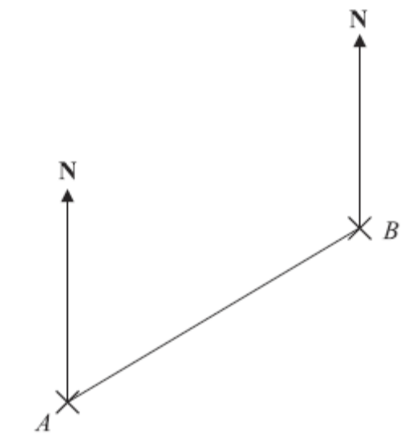

(a) Measure the bearing of B from A.
........................................ °
(1)

Another mast C is on a bearing of 160° from B.

On the map, C is 4 cm from B.

(b) Mark the position of C with a cross (×) and label it C.
(2)
(Total 3 marks)

12.
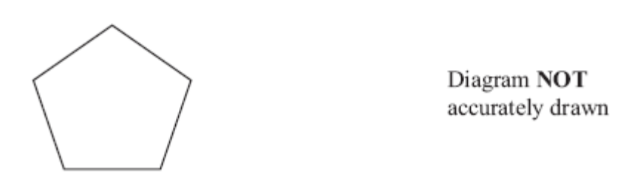

Work out the size of an exterior angle of a regular pentagon.

................................... °
(2 marks)
___________________________________________________________________________

13. Make v the subject of the formula t = + 2

v = ................................
(Total 2 marks)
___________________________________________________________________________
14. The diagram shows the graph of y = x² – 5x – 3

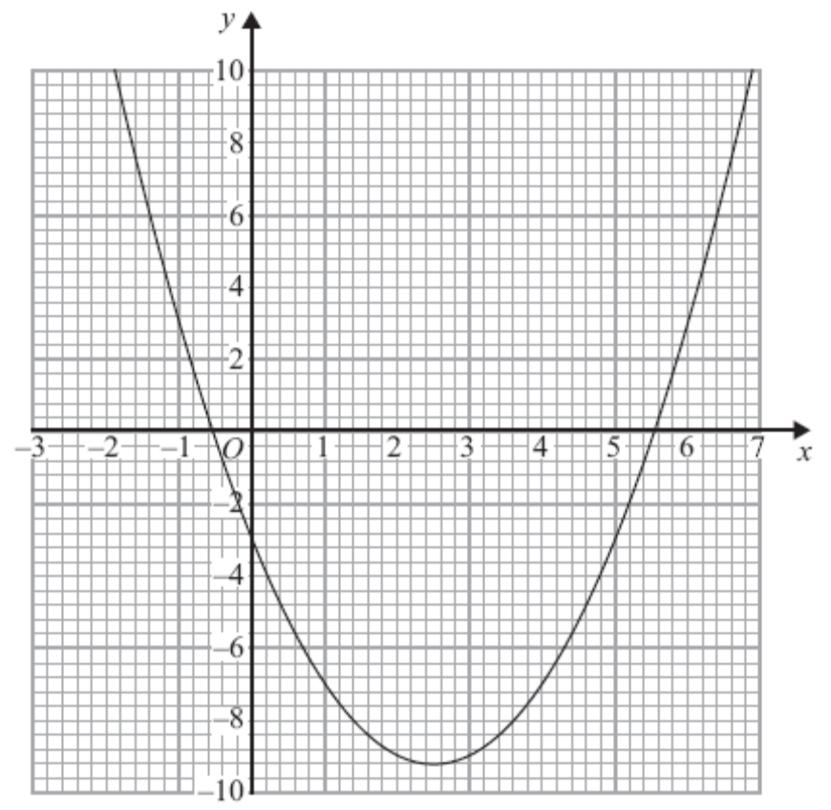

(a) Use the graph to find estimates for the solutions of

(i) x² – 5x – 3 = 0
........................................................

(ii) x² – 5x – 3 = 6
........................................................
(3)

(b) Use the graph to find estimates for the solutions of the simultaneous equations

y = x² – 5x – 3

y = x – 4

.....................................................................
(3)
(Total 6 marks)
___________________________________________________________________________
15. The students in a class kept a record of the amount of time, in minutes, they spent doing homework last week.

The table shows information about the amount of time the girls spent doing homework
last week.
 | Minutes
Least amount of time | 60
Range | 230
Median | 170
Lower quartile | 100
Upper quartile | 220

(a) On the grid, draw a box plot for the information in the table.
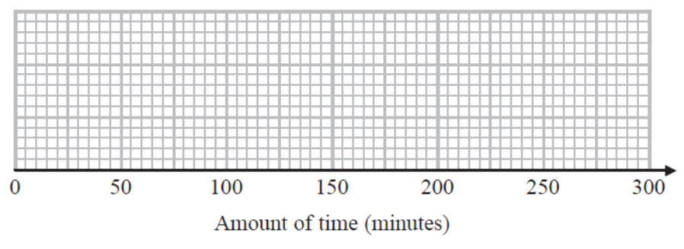
(2)
The box plot below shows information about the amount of time the boys spent doing homework last week.

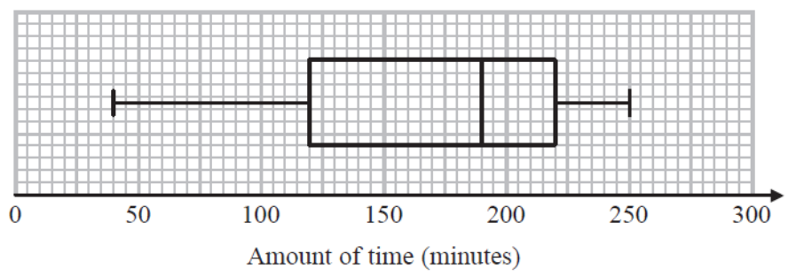

*(b) Compare the amount of time the girls spent doing homework with the amount of time
the boys spent doing homework.

......................................................................................................................................................
......................................................................................................................................................
......................................................................................................................................................
......................................................................................................................................................
(2)
(Total 4 marks)
___________________________________________________________________________
16. Colin took a sample of 80 football players.

He recorded the total distance, in kilometres, each player ran in the first half of their matches on Saturday.

Colin drew this box plot for his results.

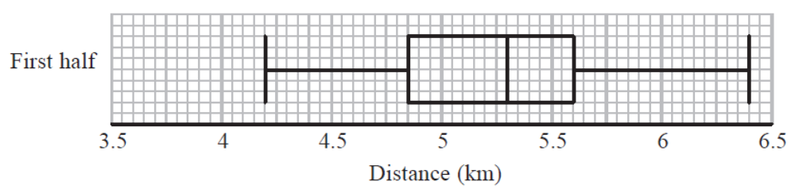

(a) Work out the interquartile range.
.............................................. km
(2)

There were 80 players in Colin’s sample.

(b) Work out the number of players who ran a distance of more than 5.6 km.

..............................................
(2)

Colin also recorded the total distance each player ran in the second half of their matches.

He drew the box plot below for this information.

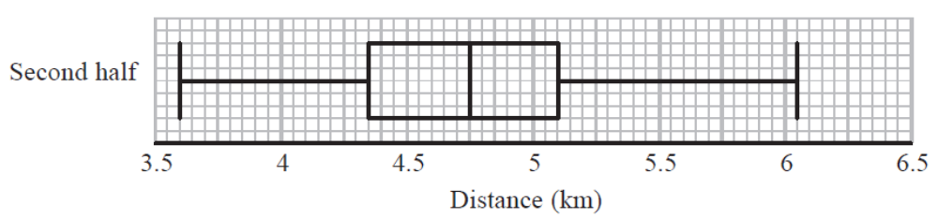

(c) Compare the distribution of the distances run in the first half with the distribution of the distances run in the second half.

......................................................................................................................................................
......................................................................................................................................................
......................................................................................................................................................
......................................................................................................................................................
(2)
(Total for Question 16 is 6 marks)
___________________________________________________________________________
17. Sumeet has a pond in the shape of a prism.

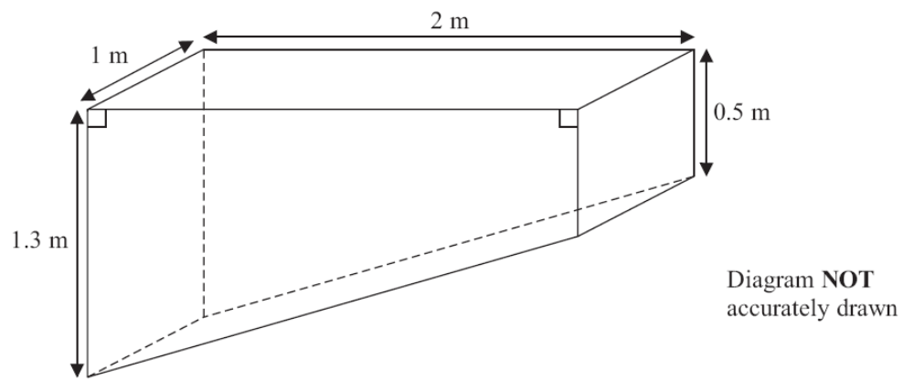

The pond is completely full of water.
Sumeet wants to empty the pond so he can clean it.
Sumeet uses a pump to empty the pond.

The volume of water in the pond decreases at a constant rate.
The level of the water in the pond goes down by 20 cm in the first 30 minutes.

Work out how much more time Sumeet has to wait for the pump to empty the pond completely.

..............................................
(Total 6 marks)
___________________________________________________________________________
18.
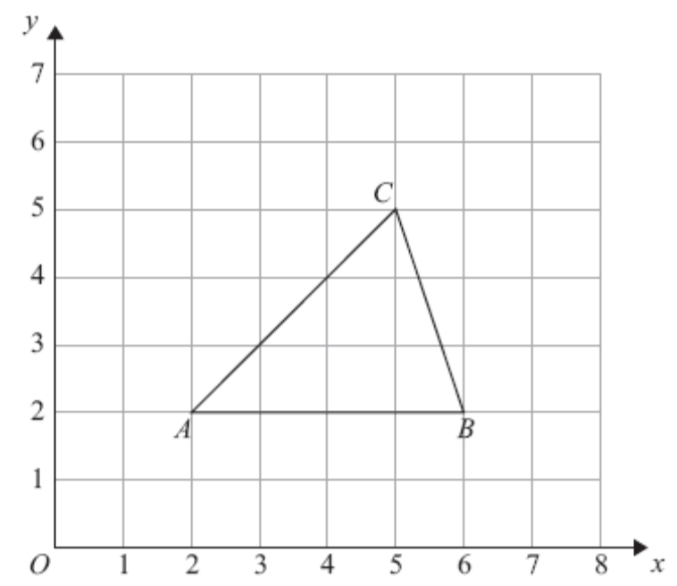

Triangle ABC is drawn on a centimetre grid.
A is the point (2, 2).
B is the point (6, 2).
C is the point (5, 5).

Triangle PQR is an enlargement of triangle ABC with scale factor  and centre (0, 0).
Work out the area of triangle PQR.

.............................................. cm²
(Total for Question 18 is 3 marks)
___________________________________________________________________________
19. In a supermarket, the probability that John buys fruit is 0.7.

In the same supermarket, the probability that John independently buys vegetables is 0.4.

Work out the probability that John buys fruit or buys vegetables or buys both.

..........................................
(Total 3 marks)
___________________________________________________________________________
20. The diagram shows a solid shape.
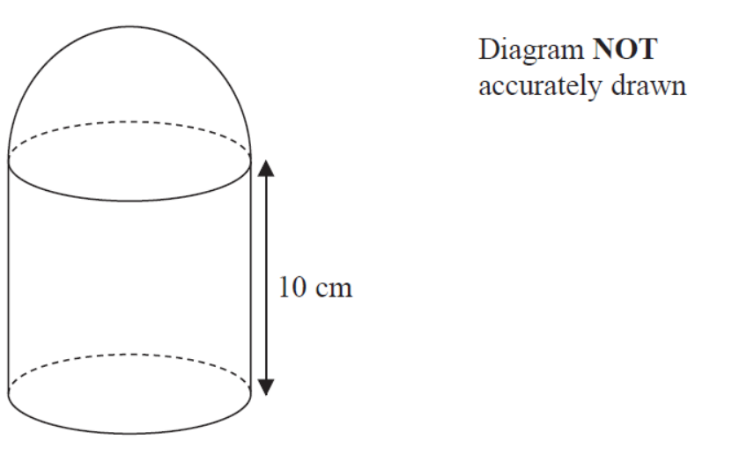

The solid shape is made from a cylinder and a hemisphere.
The radius of the cylinder is equal to the radius of the hemisphere.

The cylinder has a height of 10 cm.
The curved surface area of the hemisphere is 32π cm².

Work out the total surface area of the solid shape.
Give your answer in terms of π.

.......................................... cm²
(Total 5 marks)
___________________________________________________________________________
*21. Prove algebraically that the difference between the squares of any two consecutive integers is equal to the sum of these two integers.

(Total 4 marks)
___________________________________________________________________________

22. Expand and simplify (2 + √2)(3 + √8)

Give your answer in the form a + b√2, where a and b are integers.

.....................................
(Total 4 marks)
___________________________________________________________________________
23. Paul has 8 cards.
There is a number on each card.
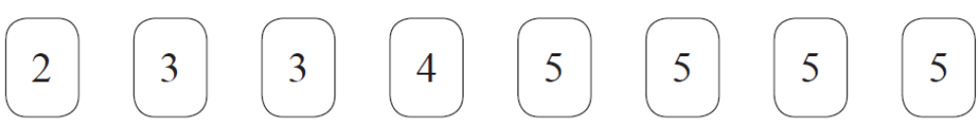

Paul takes at random 3 of the cards.
He adds together the 3 numbers on the cards to get a total T.

Work out the probability that T is an odd number.

..............................................
(Total 4 marks)
___________________________________________________________________________
24.
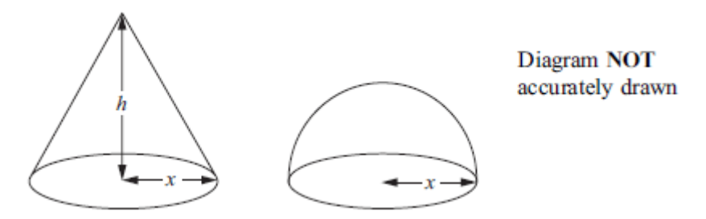

The diagram shows a solid cone and a solid hemisphere.

The cone has a base of radius x cm and a height of h cm.
The hemisphere has a base of radius x cm.
The surface area of the cone is equal to the surface area of the hemisphere.

Find an expression for h in terms of x.

.....................................
(Total 4 marks)
___________________________________________________________________________
25.
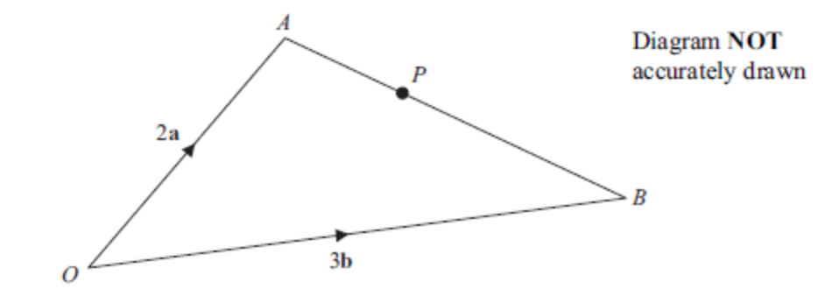

OAB is a triangle.

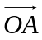 = 2a

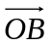 = 3b

(a) Find AB in terms of a and b.

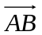 = ............................
(1)

P is the point on AB such that AP : PB = 2 : 3

(b) Show that 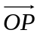 is parallel to the vector a + b.

(3)
(Total 4 marks)
___________________________________________________________________________
26. The diagram shows part of a sketch of the curve y = sin x°.

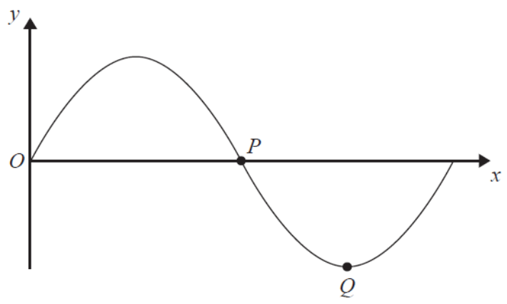

(a) Write down the coordinates of the point P.

(.................................. , ..................................)
(1)
(b) Write down the coordinates of the point Q.

(.................................. , ..................................)
(1)

Here is a sketch of the curve y = a cos bx° + c, 0 ≤ x ≤ 360

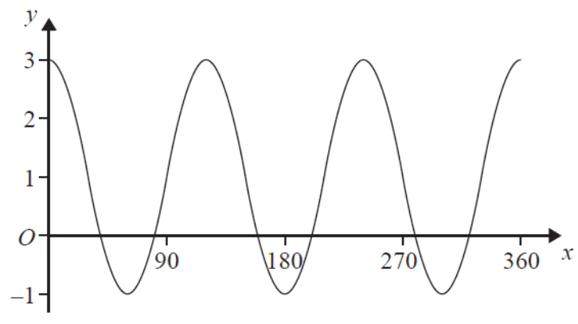

(c) Find the values of a, b and c.

a = ..........................................
b = ..........................................
c = ..........................................
(3)
(Total 5 marks)

TOTAL FOR PAPER IS 100 MARKS
1 | (a) |  | 331.705 | 1 | B1 cao
 | (b) |  | 179300 | 1 | B1 cao

2 | (a) | 360 ÷ 60 = 6  300 ÷ 60 = 5  6 × 5 = | Yes and 30 | 3 | M1 for dividing side of patio by side of paving slab  eg. 360 ÷ 60 or 300 ÷ 60 or 3.6 ÷ 0.6 or 3 ÷ 0.6 or  6 and 5 seen (may be on a diagram) or 6 divisions seen on length of diagram or 5 divisions seen on width of diagram  M1 for correct method to find number of paving slabs  eg. (360 ÷ 60) × (300 ÷ 60) oe or 6 × 5 or 30 squares seen on diagram  (units may not be consistent)  A1 for Yes and 30 (or 2 extra) with correct calculations

3 |  | Exterior angle = 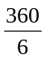 = 60  Interior angle = 180 – 60 = 120  120 + 90 = 210  360 – 210 = | 150 | 4 | M1 (= 60)  M1 (Interior angle =) 180 – ‘60’  M1 (dep on at least M1) 360 – (‘120’ + 90)  A1 cao

4 | (a) |  | 150 | 1 | B1 for 150 or 150º
 | (b) |  | 95+ reasons | 2 | B1 for 95 or 95º  B1 for full reasons, eg. alternate angles are equal and the sum of angles on a straight line is 180 OR  the sum of angles on a straight line is 180 and corresponding angles are equal  OR  vertically opposite angles and co-interior (or allied or supplementary) angles

5 | (a) | Vertices at  (–4, 2), (–4, 0), (0, 0) and (–2, 2) | Correct translation | 2 | M1 for any translation  A1 cao
 | (b) | Vertices at  (4, 4), (2, 4) and (2, 8) | Correct reflection | 2 | M1 Line y = x drawn or correct reflection in y = – x  A1 cao

6 |  | Distance = 25 + 45 + 30 = 100  Travel time = 100 ÷ 50 = 2  9 am + 2h + 3h | 2 pm | 4 | M1 adding 2 or 3 distances with at least 2 correct)  M1 ‘100’ ÷ 50 (= 2 hours)  M1 9 + 3 + ‘100 ÷ 50’ oe  A1 cao

7 |  | Acton after 24, 48, 72, 96, 120  Barton after 20, 40, 60, 80, 100, 120  LCM of 20 and 24 is 120  9: 00 am + 120 minutes | 11: 00 am | 3 | M1 for listing multiples of 20 and 24 with at least 3 numbers in each list ; multiples could be given in minutes or in hours and minutes  (condone one addition error in total in first 3 numbers in lists)  A1 identify 120 (mins) or 2 (hours) as LCM  A1 for 11: 00 (am) or 11(am) or 11 o'clock

8 |  | 0.5 × 0.6 = 0.3 (0)  0.3 × 0.3 | 0.09 | 2 | B1 0.5 or 0.6 or 0.3 seen  B1 cao

9 |  |  | S = 20B+30T | 3 | B3 for S = 20B + 30T oe  (B2 for 20B+30T or S = 20B + Tor S=B+30T or  S = 30B + 20T)  (B1 for S = a linear expression in B and T, or  20B + T or B + 30T)

*10 |  | Angle AED = 38 alternate angles are equal  Angle ADE = (180 – 38) ÷ 2 = 71  x = 180 – 71  base angles of an isosceles triangle are equal  angles in a triangle add up to 180  angles on a straight line sum to 180 | x = 109 | 4 | B1 for angle AED = 38 or AEF = 142  M1 for a complete method to find one of the base angles of the isosceles triangle  C2 (dep M1) for x = 109 with complete reasons  (C1 (dep M1) for one reason correctly used and stated)

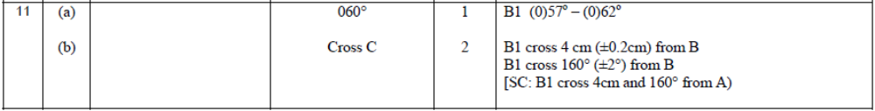

13 |  | t − 2 =  or 5t = v + 10 | v =5(t − 2) | 2 | M1 subtracting 2 from each side or multiplying each side by 5  A1 for v =5(t − 2) or v = 5t – 10 (multiplication signs may be present)  SC : If no marks scored, award B1 for  v = 5t – 2 oe or v = t – 10 or v = t – 2×5 oe

14 | (a) (i) |  | – 0.6 to – 0.5  5.5 to 5.6 | 3 | B1 for both, accept – 0.6 to – 0.5 and 5.5 to 5.6
 | (ii) |  | –1.4, 6.4 |  | M1 draw y = 6 or one value correct  A1 –1.4, 6.4 ± 0.2
 | (b) | Draw y = x – 4 | x = 0.2, y = –3.8  x = 5.8, y = 1.8 | 3 | B1 draw y = x – 4  M1 use the points of intersection, can be implied by  one value ft their line  A1 x = 0.2, y = –3.8 and x = 5.8, y = 1.8 ± 1 sq

15 | (a) |  | correct box plot | 2 | M1 for a box drawn with at least 2 correct points from LQ, Median and UQ or with maximum value of 290 plotted  A1 for a fully correct box plot
 | *(b) |  | 2 comparisons | 2 | C1 for a correct comparison of a measure of spread (using either range or IQR) or ft their box plot  C1 for a correct comparison of medians (accept averages)  For the award of both marks at least one of these comparisons must be in the context of the question.
   | girls | boys
  Med | 170 | 190
  Range | 230 | 210
  IQR | 120 | 100

16 | (a) |  | 0.75 | 2 | M1 for “5.6” – “4.85” with at least one value correct  A1 cao
 | (b) |  | 20 | 2 | M1 for a complete method e.g. 80 ÷ 4  A1 cao
 | (c) |  | 2 comparisons | 2 | B1 ft from (a) for a correct comparison of a measure of spread  B1 for a correct comparison of medians (accept averages)  For the award of both marks at least one of the comparisons made must be in the context of the question.
   | 1st half | 2nd half
  Med | 5.3 | 4.75
  Range | 2.2 | 2.45
  IQR | 0.75 | 0.75

17 |  |  | 1 hour 45 mins | 6 | M1 for method to find volume of pond,  e.g. 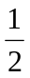(1.3 + 0.5) × 2 × 1 (= 1.8)  M1 for method to find the volume of water emptied  in 30 minutes, e.g. 1 × 2 × 0.2 (= 0.4),  100 × 200 × 20 (= 400000)  A1 for correct rate, eg 0.8 m³/hr, 0.4 m³ in 30 minutes  M1 for correct method to find total time taken to empty the pond,  e.g. “1.8” ÷ “0.8”  M1 for method to find extra time,  e.g. 2 hrs 15 minutes − 30 minutes  A1 for 1.75 hours, 1 hours, 1 hour 45 mins or 105 mins

18 |  | × 4 × 3 = 6  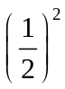× 6 = | 1.5 | 3 | M1 for × 4 × 3 oe  M1 for × “6”  A1 cao

19 |  |  | 0.82 | 3 | M1 for 1 – 0.7 (= 0.3) or 1 – 0.4 (= 0.6)  M1for 1− ‘0.3’×’0.6’  A1 for 0.82 oe  OR  M1 for 1 – 0.7 (= 0.3) or 1 – 0.4 (= 0.6)  M1 (0.7 × 0.4) + (0.7 × ‘0.6’) + (‘0.3’× 0.4)  A1 for 0.82 oe

20 |  |  | 128π | 5 | M1 for 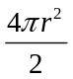 = 32π oe  A1 for (r =) 4  M1 for 2×π×"4"×10 (=80π) or π×"4"² (=16π) or ft their r  M1 for 32π + "80π" + "16π" oe or 402.1 −402.3 or ft their r  A1 cao

*21 |  | (n + 1)² – n²  = n² + 2n + 1 – n² = 2n + 1  (n + 1) + n = 2n + 1  OR  (n + 1)² – n²  = (n + 1 + n)(n + 1 – n)  = (2n + 1)(1) = 2n + 1  (n + 1) + n = 2n + 1  OR  n² – (n + 1)² = n² – (n² + 2n + 1) =  –2n – 1 = – (2n + 1)  Difference is 2n + 1  (n + 1) + n = 2n + 1 | proof | 4 | M1 for any two consecutive integers expressed algebraically  eg n and n +1  M1(dep on M1) for the difference between the squares of ‘two consecutive integers’ expressed algebraically eg (n + 1)² – n²  A1 for correct expansion and simplification of difference of squares, eg 2n + 1  C1 (dep on M2A1) for showing statement is correct,  eg n + n + 1 = 2n + 1 and (n + 1)² – n² = 2n + 1 from correct supporting algebra

22 |  | 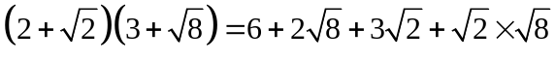  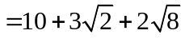  OR  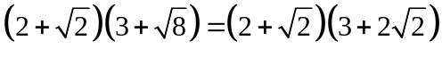  = 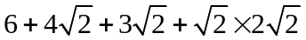 | 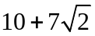 | 4 | M1 3 or 4 out 4 terms correct 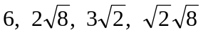 - terms may be simplified and could be in a list  M1 for 10 from 6 + 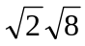  B1 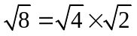 oe or 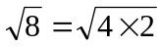  A1 cao  OR  B1 or  M1 3 or 4 out of 4 terms ft from the expansion of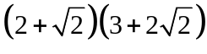  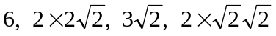 - terms may be simplified and could be in a list  M1 for 10 from 6 + 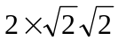  A1 cao

23 |  |  | 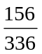 | 4 | Method 1 (Combinations for odd T)  M1 for one probability for odd T, eg P(2,3,4) = or P(2,4,5) = or P(3,3,5) = or P(3,5,5) = or P(5,5,5) =  M1 for adding at least two probabilities for odd T, eg + or  M1 for completely correct method, ie +  + + + oe  A1 for oe, eg 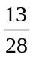or 0.46(4…)  OR  Method 2 (Combinations for even T)  M1 for one probability for even T, eg P(3,4,5) = or P(2,3,3) = or P(2,5,5) = or P(2,3,5) = or P(4,5,5) = or P(3,3,4) =  M1 for adding at least two probabilities for even T, eg + or  M1 for completely correct method, ie +  + + + + oe  A1 for oe, eg or 0.46(4…)  PTO  Method 3 (Combinations of odd and even numbers- odd totals)  M1 for one probability for odd T, eg P(E,E,O) =. or P(O,O,O) =  M1for adding at least two probabilities for odd T,  eg or + 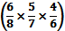  M1 for completely correct method, ie +  A1 for oe, eg or 0.46(4…)  OR  Method 4 (combinations of odd and even numbers- even totals)  M1 for probability for even T, ie =  M1 for adding at least two probabilities for even T,  eg 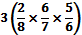  M1 for completely correct method, ie 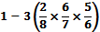  A1 for oe, eg or 0.46(4…)  SC (with replacement)  For example,  M0  M1 for adding at least two probabilities for odd or even T, eg P(E,E,O) = or P(O,O,O) =  M1 for completely correct method, eg + or 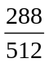 oe, eg 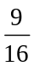or 0.56(25)  A0

24 |  | πxl = 2πx²  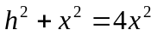  h² = 3x² | 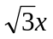 | 4 | B1 for curved surface area of one of the shapes e.g. πxl or 2πx²  M1 for for attempt to equate surface areas  e.g πxl = 2πx² or l = 2x  M1 for attempt to connect h and x using Pythagoras’s theorem e.g.  A1 for √3x or 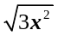

25 | (a) | 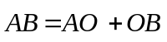 | –2a + 3b | 1 | B1 for –2a + 3b or 3b – 2a
 | (b) | 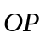 = 2a + (3b – 2a)  =a + b  = (a + b)  parallel | (a + b) is parallel to a + b | 3 | M1 for 2a ± ('3b – 2a') OR 3b ± ('2a - 3b')  A1 for a + b oe  A1 for (a + b) is parallel to a + b oe

26 | (a) |  | 180, 0 | 1 | B1 for 180, 0 Accept π, 0
 | (b) |  | 270, –1 | 1 | B1 for 270, –1 accept 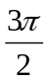, –1
 | (c) |  | a = 2  b = 3  c = 1 | 3 | B1 cao  B1 cao  B1 cao

Examiner report: Gold 4
Question 1
Part (a) of this question was well answered with over two thirds of all candidates being awarded the mark for a correct answer. Part (b) was poorly done even by some of the best candidates. Commonly seen incorrect answers included 17.93. An estimate (300 000 ÷ 2) could have helped candidates with this part of the question.

Question 2
Part (a) had the instruction ‘You must show your working’, within the demand. When this instruction is present it is vital that candidates do show all their working; in this case a correct answer of 'yes' with no correct supporting working scored no marks. The vast majority of students did show working. There was frequently confusion over conversion between metres and centimetres and, more frequently, between cm² and m². Provided all other working was correct, candidates were only penalised for either inconsistent units or incorrect conversions in the final mark. There were two favoured methods of solution. One of these was to work out the area of the patio and the area of the 32 slabs. In this method the most common error occurred when attempting to find the area of the 32 slabs, 32 × 60 rather than 32 × 60 × 60 was frequently seen. Accuracy in arithmetic was also a problem with 60 × 60 seen as 1200 and 0.6 × 0.6 given as 3.6 on many occasions. The most successful method was to find the number of slabs needed by dividing the corresponding lengths but, again, the necessary arithmetic did cause some problems.

Many different methods to carry out the necessary multiplication were seen in (b). When candidates choose to use a build up method for their calculation it is important that they check that they are working out 32 × 8.63; frequently the complete calculation was actually for 20 × 8.63 or 24 × 8.63 or 31 × 8.63 or 30 × 8.63 in which case no marks could be awarded. Candidates who attempted to partition the numbers prior to calculation sometimes made errors in dealing with the decimal place and used 8 rather than 800 so came out with a very wrong answer.

Question 3
Candidates did well in part (a) although occasionally the 7.01 and the 13.1 were round the wrong way.

Part (b) was answered correctly by nearly all candidates.

In part (c) the brackets proved to be a challenge. (15 – 4) was seen as often as the correct (2 + 1). Many candidates had more than one set of brackets and these were often unmatched.

Question 4
Part (a) was well answered.

The answer given in part (b) was just as likely to be the incorrect value of 85 as it was to be the correct value of 95. Full reasons were only given by a minority of candidates; more often than not just the reason ‘corresponding angles’ or ‘alternate angles’ was present which, by itself, was insufficient to gain the mark for reasons.

Question 5
Many candidates were able to score 1 or 2 marks for answers to the first two parts.

Since the pie chart was drawn accurately it was possible to get a mark for the angle of the sector by giving an answer in the range 103° to 107°. However, most candidates calculated their value. The entry for chocolate proved more of a challenge as candidates had to reason proportionally presumably from the entry in the top row by finding one third of 12 and adding on to get 16. This was rarely seen and the answer of 18 was much more common.

Question 6
There was less evidence of confusion between the area and perimeter concepts on this question than has been seen on some past examination papers. This may be due to the fact that the area was much easier to count than the perimeter. Units were generally correct or omitted or occasionally represented just by the power, so 282 was not uncommon. There was the occasional cm3. Some candidates thought they had to calculate the area rather than count squares.

Question 7
Most candidates realised that they had to find the LCM of 20 and 24. One approach was to use the numbers 20 and 24, the other was to work with times from 9 a.m. Those who used times, frequently made errors in their list with the common first error being for the 10:12 time. Another error was to produce two correct lists of times but then fail to realise that 11am was a common time in each list. Some found LCM of 120 and then thought it was 1 hour 20 minutes resulting in time of 10.20.

Question 8
This was well answered. Most candidates knew what went in the tally column and were then able to summarise that in the frequency column, usually with correct results. Very occasionally, frequencies were put in the tally column with the frequency column left blank or filled with other numbers such as the rankings of the frequencies.

The bar chart was completed well in part (b).

Question 9
A variety of incorrect formulae were seen, the most common being S = B + T. Some candidates gave the correct answer of S = 20B + 30T but then spoilt their answer by attempting to simplify and gave 20B + 30T = 50S. A mark was deducted for the incorrect simplification.

Question 10
Candidates’ performances on this starred question gave a good differentiation of marks. Only a quarter of candidates gained 1 mark for stating either that angle AED was 38° or that angle AEF was 142˚; a further mark was gained for a correct method to find one of the base angles of isosceles triangle ADE. A large number of candidates realised the triangle was isosceles but then failed to identify the correct pair of equal angles possibly because they thought ‘base angles’ are those at the bottom of the diagram.
Problems arose when candidates had to give their reasons. The most successful candidates were those who wrote their reasons next to the working the reason applied to. It was a pity that only a very small percentage of candidates gained both marks for a correct answer with a full set of reasons, but some gained 1 mark for one correct reason. Many candidates knew the correct reasons but failed to write enough, e.g. ‘angles in a triangle’ without stating they add up to 180°.
Candidates are realising that Z-angles will not gain them the mark but often confuse corresponding angles with alternate angles, some resorting to talking about parallel lines. Many candidates failed to score as they did not identify the correct angles in the working, by using correct angle notation or by showing them on the diagram.

Question 11
Few candidates gave the correct bearing of (0)60º. It was really disappointing to see the number of candidates who gave the answer as 5.5 cm, presumably having no idea what a bearing was. There were corresponding poor attempts at the second part. There were the usual errors of back bearings or from measuring angles from due East or due West rather than due North. About one in six candidates could not measure out a length of 4 cm correctly.

Question 12
This question was not answered well. Many candidates were confused between the meaning of exterior and interior angles. Often those understanding exterior as outside mistakenly found the reflex angle. Many candidates did divide 360 by 5 to get an answer of 72 but then subtracted from either 180 or 360 to give answers of 108º or 288º respectively. A significant number of candidates used correct methods to find 108º as an interior angle but then subtracted from 360 giving an incorrect answer of 252º. Quite often information drawn on the diagram contradicted the candidate’s working.

Question 13
Very few fully correct solutions were seen to this question. Many candidates were unable to make a start. Those who carried out some correct algebra generally gained a mark for dealing with the +2. The most common error by far was to only multiply some of the terms in the equation by 5 leading to the commonly seen incorrect answers of v = 5t – 2 and v = t – 10.

Question 14
Many candidates that attempted the question did not seem to have any idea what was required. Only 11% of the candidates were able to find an estimate for the solutions to (a)(i) and 10% to a(ii). Attempts were seen at solving the equation by factorisation and some crude, unsuccessful attempts to use the quadratic formula. Those candidates that were able to use the graph to find the solutions to x² – 5x – 3 = 6 generally gained full marks, reading the graph correctly to within the tolerance of ±0.2; marks were not lost by inaccuracy. The line y = 6 was seldom seen.

In part (b) drawing the line y = x – 4 on the graph was not handled well with many unable to produce a worthwhile attempt. Not all the attempted lines drawn actually intersected the given curve thus making the solutions of the equations somewhat alien. 91% of candidates failed to score. If the line was drawn correctly points of intersection were often identified, although many candidates failed to appreciate the difference in scales. Many responses only gave x values instead of the co-ordinate pair, failing to appreciate that they were solving simultaneous equations.

Question 15
In part (a), most students were able to score 1 mark for drawing a box plot for at least 2 points correct from the lower quartile, the median and the upper quartile. By far the most common error here was to draw the greatest value at 230 (rather than 290). Some students had difficulty interpreting the scale, taking one small square to represent 10 minutes (rather than two small squares).

Part (b) was not done so well. Many students did not explicitly compare the medians or a suitable measure of spread. A common incorrect answer here was e.g. “Boys spend more time doing homework”. Students should be advised to name the measures they are comparing. Other incorrect answers include the comparison of the greatest values and/or the least values of the distributions, and not giving at least one of the comparisons in context, e.g. by referring to time in some way.

Question 16
In part (a) candidates were expected to read off the values of the upper and lower quartiles from the box plot and then to subtract. The standard of subtraction was very poor with 5.6 – 4.85 often been worked out as 0.85. Even worse, it was sometimes worked out as 1.25. Of course, many candidates did not get that far and commonly worked out the range. Reading off the scale was also a challenge for many students.

Part (b) was a problem for those candidates who did not have a grasp of the meaning of the quartiles and that the upper quartile essentially divides off the upper 25% of the population. Some candidates had some idea but worked it out as the upper 75%.

In part (c), candidates only scored a mark if they referred to a meaningful statistic from both the distributions and made a comparison. For many candidates this comparison naturally involved the median. A second comparison had to come from a measure of dispersion in keeping with practice from previous examinations. Candidates could compare the range or the interquartile range. For full marks one of the comparisons had to be in context (rather than as an interpretation) so a reference to distance ran, for example, was expected. Many candidates were unable to abstract meaningful statistics from the box plots and resorted to vague answers such as ‘ they ran further in the first half than in the second half’ which, of course, scored 0 marks. Answers which just referred to maximum and/or minimum values were not awarded any marks.

Question 17
This proved to be a challenging question for the vast majority of candidates on this paper. Many candidates failed to show their working in an organised manner and they rarely made it clear exactly what they were working out. As a result examiners were faced with working scattered all over the working space with little explicit description of the strategy the candidate was using. It was often difficult to make out whether candidates were using volumes, areas or lengths. Some candidates employed methods involving the division of a volume or a rate by a length to find a time. Whilst a reasonable number of candidates were awarded some credit for their responses, only a small number were able to see the problem through to a successful conclusion. Some candidates worked with a cuboid rather than a prism.

Question 18
The most common method used that lead to the correct answer was to enlarge the triangle and then find the area of the enlarged triangle. It was, however, disappointing to see many candidates successfully enlarge the triangle and then fail to find its area. Those candidates who started with the area of the given triangle invariably divided by 2 rather than (2)² to find the area of the enlarged triangle. It was very rare indeed to see the area scale factor being used. Equally disappointing was the number of candidates who tried and failed to find the correct area of the given triangle. A significant number of students who drew the enlarged triangle did not understand that a scale factor of would result in a smaller triangle.

Question 19
Overall, this question was not answered well with a large number of candidates unable to use an appropriate method. It was rather disconcerting that many answers were greater than 1. Drawing a correct tree diagram seemed to be the key to success. Most candidates made an attempt at drawing a tree diagram and many recognised the need to find 1 – 0.4 and 1 – 0.7 though very few actually wrote these calculations down. Not all candidates, though, recognised that the probabilities of ‘not fruit’ and ‘not vegetables’ were relevant and tree diagrams were often used with all branches having 0.7 and 0.4 on them. Candidates with a correct tree diagram usually attempted to multiply their probabilities in some way. Some candidates obtained probabilities for ‘fruit’, ‘vegetables’ and ‘both’ from three correct products but failed to add them and gave three answers, thus losing 2 marks. Those that did add them often went on to get the correct answer but some made arithmetic errors (0.3 × 0.6 = 1.8, for example). Of those scoring full marks, the vast majority added the probabilities of the three favourable outcomes with surprisingly few candidates using 1 – 0.3 × 0.6.

Question 20
Few students were able to score full marks on this question. Though many were able to find the radius of the hemisphere and use this to find either the curved surface area of the cylinder or the area of the circular base. Common errors here were to find the volume of the cylinder rather than the curved surface area of the cylinder and/or to omit to include the area of the circular base in the calculation of the total surface area. A significant number of students started their answers correctly by writing a suitable equation for the given information, e.g. 2πr² = 32π, but were then unable to solve it correctly for r, often cancelling π on only one side of the equation.

Question 21
In this question on algebraic proof there were very few fully correct answers. One mark for establishing n and n + 1 or equivalent was awarded to a few candidates and another small number of candidates who were able to write (n + 1)² − n² gained 2 marks. Some candidates were then able to correctly expand the brackets and correctly simplify the expression to 2n + 1 or equivalent, scoring 3 marks. For the fourth mark candidates had to establish and state that both elements of the original statement were equal.
A significant number of candidates used an arithmetic approach and gained no marks. There were also many nil attempts.

Question 22
Candidates who were able to make a start by expanding the brackets were generally able to score at least one mark. Following a correct expansion, the use of 2√2 for √8 was not seen that often although √2 × √8 was more successfully given as √16 = 4. However, able candidates were frequently able to cope well with this question and gain full marks.

Question 23
Few students were able to score full marks in this question but many scored 1 or 2 marks for writing down and adding at least two correct probabilities. Whereas a significant number of students recognised the need to combine the cards to obtain different totals for odd T, relatively few could relate these combinations to the actual process of selecting the cards at random. Most students considered specific odd and/or even totals for T, as shown by methods 1 and 2 in the mark scheme, rather than by considering odd and even numbers with odd/ even totals, as shown by methods 3 and 4 in the mark scheme.

Question 24
This question about the surface area of a cone and a hemisphere was not very well understood by candidates. Many candidates did not realise that the areas of the bases could be ignored as they were equal, some equated them and cancelled them out, which was fine and some only included the circle on one of the shapes which was a mistake. 14% of candidates were able to equate the areas correctly in terms of the radius r and were awarded one mark as were those candidates who found an expression for one area in terms of x. Two marks were awarded for a correct equation connecting the areas in terms of x and 6% gained these two marks. If candidates were able to find an expression to connect the slant height of the cone, the vertical height of the cone and x using Pythagoras’ theorem then three marks were gained. 2% of candidates gained these three marks. Fully correct solutions were only obtained by 1% of candidates.

Some candidates were not aware that the formula for the surface area of a sphere and cone were given at the beginning of the exam paper whilst which highlights the need to be familiar with the formula sheet. Others incorrectly used the formulae for volumes. Although some did write down correct formulae, they did not realize r should be replaced by x. Many candidates did manage to equate surface areas (not always correctly) but few realised they needed to use Pythagoras and of those not many were able to manipulate the expression to a final simplified answer. Several confused their l and h and wrote that the curved surface area of a cone was πxh and going on to show that h = 2x.

Question 25
Candidates, even on the higher tier, often struggle with vector algebra and this was certainly true in this question. Part (a) was fairly straightforward and 42% of candidates gained the mark. In part (b) only 4% of candidates obtained the full 3 marks for showing the two vectors were parallel though 5% gained 1 mark for writing a correct expression for OP and a further 2% gained the mark for simplifying the expression correctly. The majority of candidates failed to deal with the ratio correctly, assuming that OP was 2a + (3b – 2a).

Of those who did obtain OP = 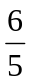(a + b) many did not then go on to say that they were parallel. There were many blank spaces. The few who chose the 3b + 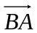 route seldom remembered to reverse the direction of .

Question 26
The first two parts of the question were basically about how well candidates knew their trigonometric curves. The response was very poor with very few being able to give the correct coordinates. Surprisingly for this target level, there were candidates who gave the correct values, but reversed – for example (0, 180) instead of the correct (180, 0).

The next part of the question was meant to assess how well candidates understood transformations when applied to the cosine curve. Again, correct answers were few and far between as most candidates did not seem to appreciate the basic structure of y = cos x as evidenced by the first part of the question with the sine curve so were unable to relate the transformed curve to the original one.
Practice paper: Gold 4
 |  |  |  |  |  |  |  | Mean score for students achieving Grade:
Spec | Paper | Session  YYMM | Question | Mean score | Max score | Mean  % | ALL | A* | A | % A | B | C | % C | D | E
1MA0 | 1H | 1306 | Q01 | 0.96 | 2 | 48 | 0.96 | 1.83 | 1.54 | 77.0 | 1.18 | 0.77 | 38.5 | 0.43 | 0.23
1MA0 | 1H | 1206 | Q02 | 3.41 | 6 | 57 | 3.41 | 5.38 | 4.50 | 75.0 | 3.79 | 2.94 | 49.0 | 1.76 | 0.95
1380 | 1H | 1111 | Q03 | 1.57 | 4 | 39 | 1.57 | 3.70 | 3.00 | 75.0 | 2.22 | 1.30 | 32.5 | 0.63 | 0.37
1380 | 1H | 1203 | Q04 | 1.34 | 3 | 45 | 1.34 | 2.22 | 1.84 | 61.3 | 1.51 | 1.17 | 39.0 | 0.84 | 0.62
1380 | 1H | 1111 | Q05 | 1.58 | 4 | 40 | 1.58 | 3.62 | 2.93 | 73.3 | 1.97 | 1.25 | 31.3 | 0.90 | 0.74
1380 | 1H | 1111 | Q06 | 1.73 | 4 | 43 | 1.73 | 3.62 | 2.95 | 73.8 | 2.25 | 1.50 | 37.5 | 0.96 | 0.69
1MA0 | 1H | 1206 | Q07 | 2.00 | 3 | 67 | 2.00 | 2.77 | 2.43 | 81.0 | 2.20 | 1.87 | 62.3 | 1.20 | 0.58
1380 | 1H | 1111 | Q08 | 0.84 | 2 | 42 | 0.84 | 1.62 | 1.26 | 63.0 | 1.02 | 0.81 | 40.5 | 0.56 | 0.39
1380 | 1H | 1203 | Q09 | 1.67 | 3 | 56 | 1.67 | 2.80 | 2.42 | 80.7 | 1.92 | 1.42 | 47.3 | 0.98 | 0.73
1MA0 | 1H | 1303 | Q10 | 1.08 | 4 | 27 | 1.08 | 3.05 | 2.42 | 60.5 | 1.58 | 0.78 | 19.5 | 0.32 | 0.11
1380 | 1H | 911 | Q11 | 1.60 | 3 | 53 | 1.60 | 2.69 | 2.24 | 74.7 | 1.77 | 1.33 | 44.3 | 0.95 | 0.70
1380 | 1H | 1006 | Q12 | 0.89 | 2 | 45 | 0.89 | 1.59 | 1.19 | 59.5 | 0.89 | 0.61 | 30.5 | 0.28 | 0.09
1380 | 1H | 1011 | Q13 | 0.63 | 2 | 32 | 0.63 | 1.73 | 1.33 | 66.5 | 0.80 | 0.31 | 15.5 | 0.08 | 0.03
1380 | 1H | 1111 | Q14 | 0.57 | 6 | 10 | 0.57 | 4.47 | 2.09 | 34.8 | 0.50 | 0.09 | 1.5 | 0.02 | 0.02
1MA0 | 1H | 1411 | Q15 | 1.33 | 4 | 33 | 1.33 | 3.14 | 2.84 | 71.0 | 2.34 | 1.47 | 36.8 | 0.86 | 0.39
1MA0 | 1H | 1406 | Q16 | 1.92 | 6 | 32 | 1.92 | 4.56 | 3.52 | 58.7 | 2.39 | 1.15 | 19.2 | 0.39 | 0.15
1MA0 | 1H | 1306 | Q17 | 0.51 | 6 | 9 | 0.51 | 3.08 | 1.20 | 20.0 | 0.44 | 0.12 | 2.0 | 0.03 | 0.02
1MA0 | 1H | 1206 | Q18 | 0.80 | 3 | 27 | 0.80 | 2.20 | 1.48 | 49.3 | 0.92 | 0.37 | 12.3 | 0.09 | 0.04
1MA0 | 1H | 1311 | Q19 | 0.59 | 3 | 66 | 0.59 | 1.85 | 1.19 | 39.7 | 0.69 | 0.36 | 12.0 | 0.18 | 0.07
1MA0 | 1H | 1411 | Q20 | 0.19 | 5 | 4 | 0.19 | 3.30 | 1.64 | 32.8 | 0.38 | 0.03 | 0.6 | 0.00 | 0.00
1MA0 | 1H | 1303 | Q21 | 0.11 | 4 | 3 | 0.11 | 2.09 | 0.38 | 9.5 | 0.03 | 0.00 | 0.0 | 0.00 | 0.00
1380 | 1H | 1203 | Q22 | 0.56 | 4 | 14 | 0.56 | 2.67 | 1.39 | 34.8 | 0.57 | 0.13 | 3.3 | 0.02 | 0.01
1MA0 | 1H | 1411 | Q23 | 0.07 | 4 | 2 | 0.07 | 1.33 | 0.56 | 14.0 | 0.11 | 0.01 | 0.3 | 0.00 | 0.00
1380 | 1H | 1106 | Q25 | 0.35 | 4 | 9 | 0.35 | 1.69 | 0.63 | 15.8 | 0.14 | 0.02 | 0.5 | 0.00 | 0.00
1380 | 1H | 1106 | Q26 | 0.63 | 4 | 16 | 0.63 | 2.57 | 1.05 | 26.3 | 0.41 | 0.10 | 2.5 | 0.02 | 0.00
1MA0 | 1H | 1406 | Q26 | 0.50 | 5 | 10 | 0.50 | 2.82 | 1.22 | 24.4 | 0.33 | 0.06 | 1.2 | 0.02 | 0.01
 |  |  |  | 27.43 | 100 | 27 | 27.43 | 72.39 | 49.24 | 49.24 | 32.35 | 19.97 | 19.97 | 11.52 | 6.94

