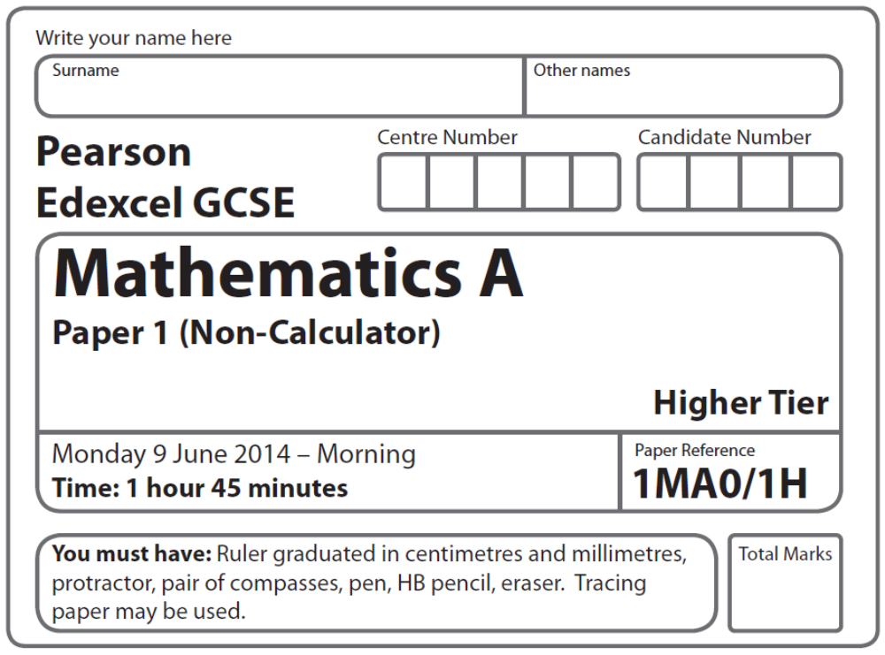
Practice Paper – Silver 1
Silver: 1 of 4

Instructions
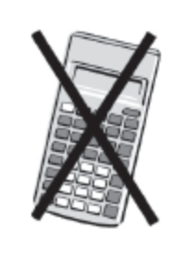
- Use black ink or ball-point pen.
- Fill in the boxes at the top of this page with your name,
centre number and candidate number.
- Answer all questions.
- Answer the questions in the spaces provided
– there may be more space than you need.

Information
- The total mark for this paper is 100
- The marks for each question are shown in brackets
– use this as a guide as to how much time to spend on each question.
- Questions labelled with an asterisk (*) are ones where the quality of your
written communication will be assessed.

Advice
- Read each question carefully before you start to answer it.
- Keep an eye on the time.
- Try to answer every question.
- Check your answers if you have time at the end.

Suggested Grade Boundaries (for guidance only)
A* | A | B | C | D
99 | 90 | 73 | 55 | 39
GCSE Mathematics 1MA0

Formulae: Higher Tier

You must not write on this formulae page.
Anything you write on this formulae page will gain NO credit.

Volume of prism = area of cross section × length Area of trapezium = (a + b)h
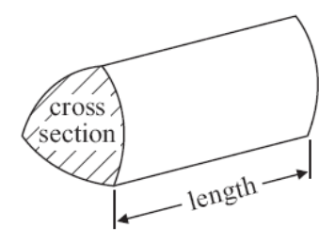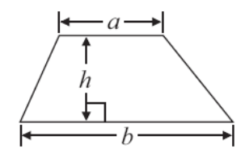

Volume of sphere πr³ Volume of cone πr²h
Surface area of sphere = 4πr² Curved surface area of cone = πrl

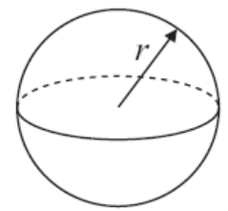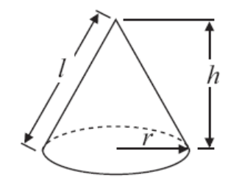

In any triangle ABC The Quadratic Equation
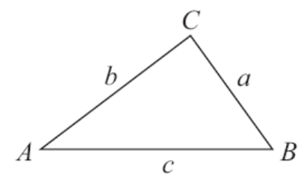
The solutions of ax²+ bx + c = 0
where a ≠ 0, are given by

x = 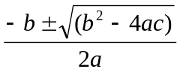

Sine Rule 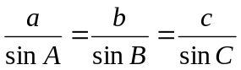

Cosine Rule a² = b²+ c²– 2bc cos A

Area of triangle = ab sin C
Answer ALL questions.
Write your answers in the spaces provided.
You must write down all stages in your working.
You must NOT use a calculator.

- Simplify 6x + 9y + 2x – 3y

.....................................
(Total 2 marks)
___________________________________________________________________________
2. Here are the times, in minutes, that 20 children took to walk to school.

13 21 19 27 31 5 23 29 18 25
34 15 28 23 22 40 16 19 32 9

Draw an ordered stem and leaf diagram for these times.

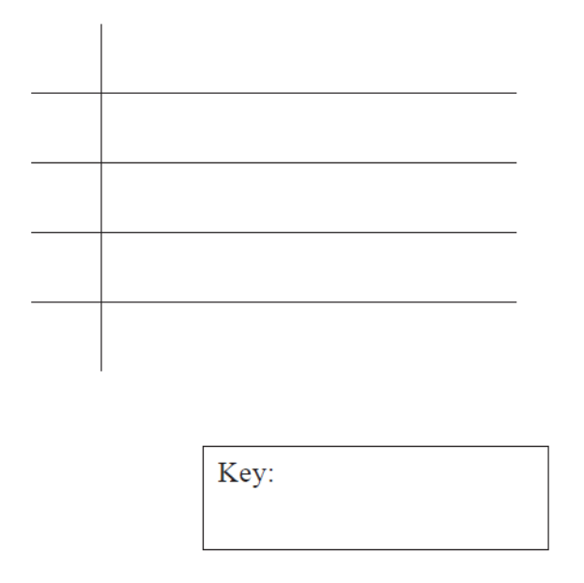

(Total for Question 2 is 3 marks)
___________________________________________________________________________
3. Here is a triangular prism.

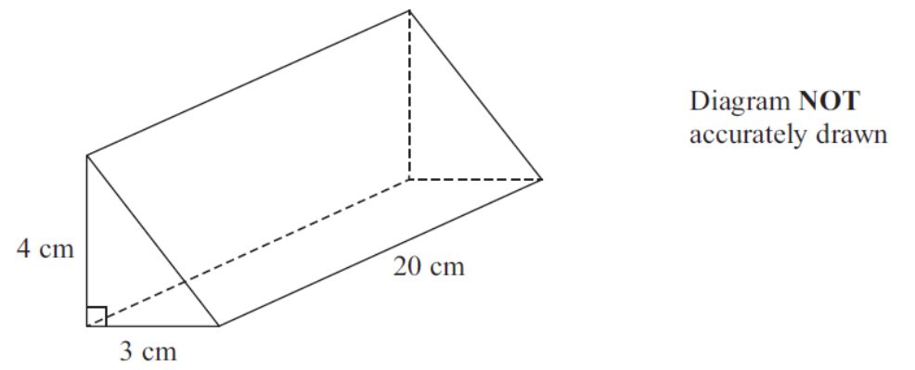

Work out the volume of this triangular prism.

..........................................
(Total 4 marks)
___________________________________________________________________________
4.
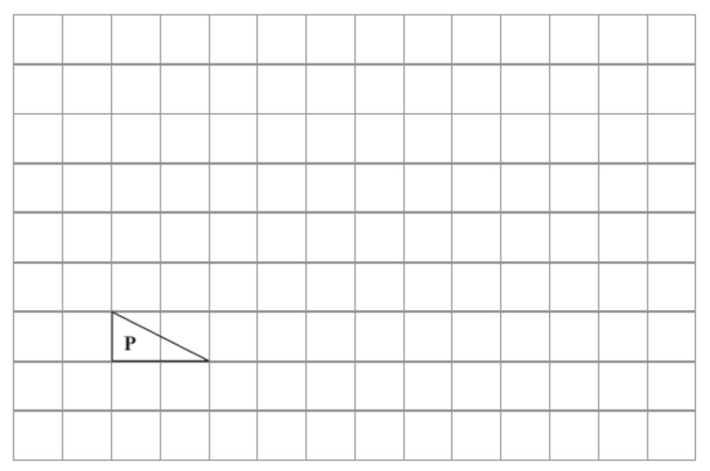

Triangle P has been drawn on a grid.

(a) On the grid, draw an enlargement of the triangle P with scale factor 3
(2)
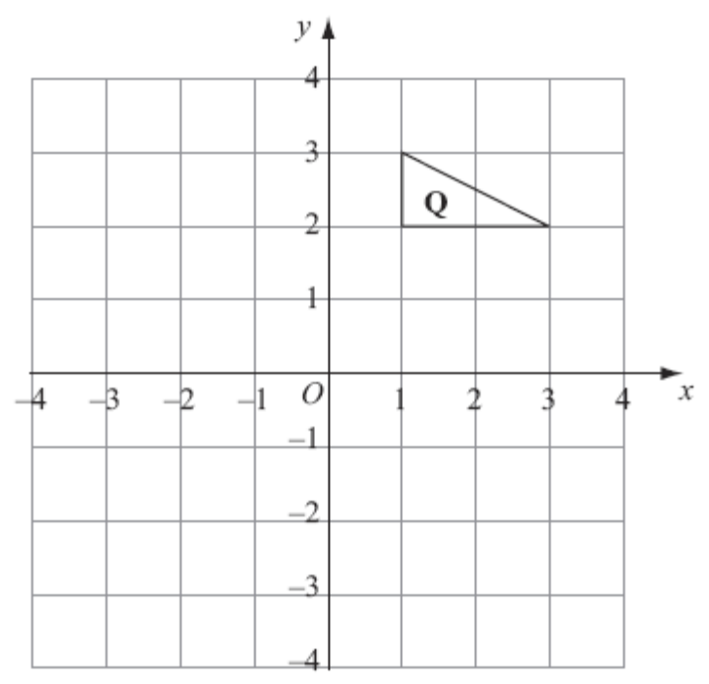
Triangle Q has been drawn on a grid.

(b) On the grid, rotate triangle Q 90° clockwise, centre O.
(3)
(Total 5 marks)

5.
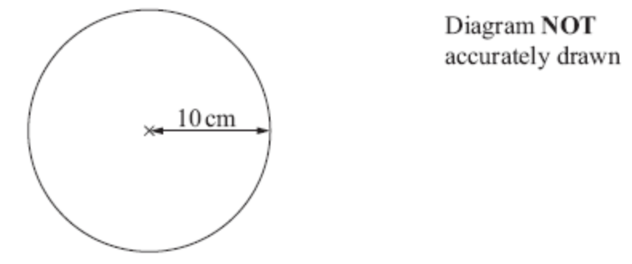

The radius of a circle is 10 cm.

Work out the area of this circle.
Use π = 3.14

...............................cm²
(Total 2 marks)
___________________________________________________________________________

*6. Steve wants to put a hedge along one side of his garden.

He needs to buy 27 plants for the hedge.
Each plant costs £5.54.

Steve has £150 to spend on plants for the hedge.

Does Steve have enough money to buy all the plants he needs?

(Total for Question 6 is 4 marks)
___________________________________________________________________________
7. (a) Work out

Give your answer in its simplest form.

..............................
(2)
(b) Work out 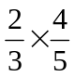

..............................
(2)
(c) Work out 423 × 12

You must show all your working.

..............................
(3)
(Total 7 marks)
8. (a) Expand 3(2y – 5)

..............................................
(1)

(b) Factorise completely 8x² + 4xy

..............................................
(2)

(c) Make h the subject of the formula
t = 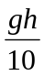

h = ..............................................
(2)
(Total for Question 8 is 5 marks)
___________________________________________________________________________
9. Julia is investigating how much exercise people do in a week.

She uses these two questions in a questionnaire.

Question 1 What is your age?
Under 15 15 to 25 25 to 40 over 40

Question 2 How much exercise do you do?
A bit Some A lot

(a) Write down one thing wrong with each of these questions.

Question 1
......................................................................................................................................................
......................................................................................................................................................
Question 2
......................................................................................................................................................
......................................................................................................................................................
(2)

Julia wants to know how much time people spend exercising.

(b) Design a question Julia could use in her questionnaire.

(2)
(Total 4 marks)
___________________________________________________________________________
10. The diagram shows a garden in the shape of a rectangle.

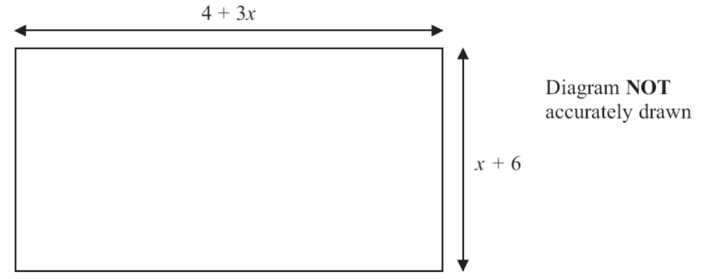

All measurements are in metres.
The perimeter of the garden is 32 metres.

Work out the value of x.

..........................................
(Total 4 marks)
___________________________________________________________________________
11. Each day a company posts some small letters and some large letters.

The company posts all the letters by first class post.

The tables show information about the cost of sending a small letter by first class post
and the cost of sending a large letter by first class post.

Small Letter Large Letter
Weight | First Class Post |  | Weight | First Class Post
0–100 g | 60p |  | 0–100 g | £1.00
 |  |  | 101–250 g | £1.50
 |  |  | 251–500 g | £1.70
 |  |  | 501–750 g | £2.50

One day the company wants to post 200 letters.

The ratio of the number of small letters to the number of large letters is 3 : 2.

70% of the large letters weigh 0–100 g.

The rest of the large letters weigh 101–250 g.

Work out the total cost of posting the 200 letters by first class post.

£..........................................
(Total 5 marks)
___________________________________________________________________________
12. You can change temperatures from °F to °C by using the formula

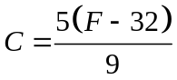

F is the temperature in °F.
C is the temperature in °C.

The minimum temperature in an elderly person’s home should be 20°C.

Mrs Smith is an elderly person.
The temperature in Mrs Smith’s home is 77°F.

*(a) Decide whether or not the temperature in Mrs Smith’s home is lower than the minimum temperature should be.

(3)
(b) Make F the subject of the formula .

..........................................
(3)
(Total for Question 12 is 6 marks)
___________________________________________________________________________
13. (a) Express 180 as a product of its prime factors.

..........................................
(3)

Martin thinks of two numbers.

He says,

“The Highest Common Factor (HCF) of my two numbers is 6.
The Lowest Common Multiple (LCM) of my two numbers is a multiple of 15.”

(b) Write down two possible numbers that Martin is thinking of.

........................ , ........................
(2)
(Total 5 marks)
___________________________________________________________________________
14. –2 < n ≤ 3

(a) Represent this inequality on the number line.

(2)
(b) Solve the inequality 8x – 3 ≥ 6x + 4

..............................................
(2)
(Total 3 marks)
___________________________________________________________________________
15. Solve the simultaneous equations

3x + 4y = 5
2x – 3y = 9

x = ..........................................
y = ..........................................
(Total 4 marks)
___________________________________________________________________________
16. There are 200 workers at a factory.

The cumulative frequency table gives information about their ages.

Age (a years) | Cumulative frequency
0 < a ≤ 20 | 25
0 < a ≤ 30 | 70
0 < a ≤ 40 | 138
0 < a ≤ 50 | 175
0 < a ≤ 60 | 186
0 < a ≤ 70 | 194
0 < a ≤ 80 | 200

(a) On the grid opposite, draw a cumulative frequency graph for this information.
(2)
(b) Graham says,

“10% of workers at the factory are older than 65”

Is Graham correct?
You must show how you get your answer.

......................................................................................................................................................
......................................................................................................................................................
......................................................................................................................................................
......................................................................................................................................................
(2)
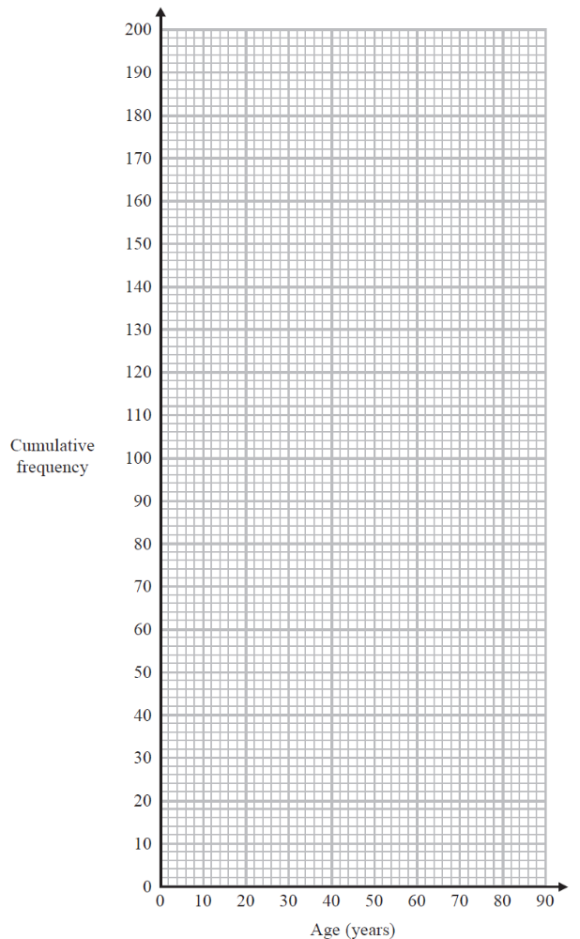

(Total 4 marks)
___________________________________________________________________________
17. AB is a line segment.

A is the point with coordinates (3, 6, 7).
The midpoint of AB has coordinates (–2, 2, 5).

Find the coordinates of B.

..............................................
(Total 2 marks)
___________________________________________________________________________
18. Solve the simultaneous equations

4x + y = 25
x – 3y = 16

x = ..........................................
y = ..........................................
(Total for Question 18 is 3 marks)
___________________________________________________________________________
19. Emma has 7 pens in a box.
5 of the pens are blue.
2 of the pens are red.

Emma takes at random a pen from the box and writes down its colour.
Emma puts the pen back in the box.

Then Emma takes at random a second pen from the box, and writes down its colour.

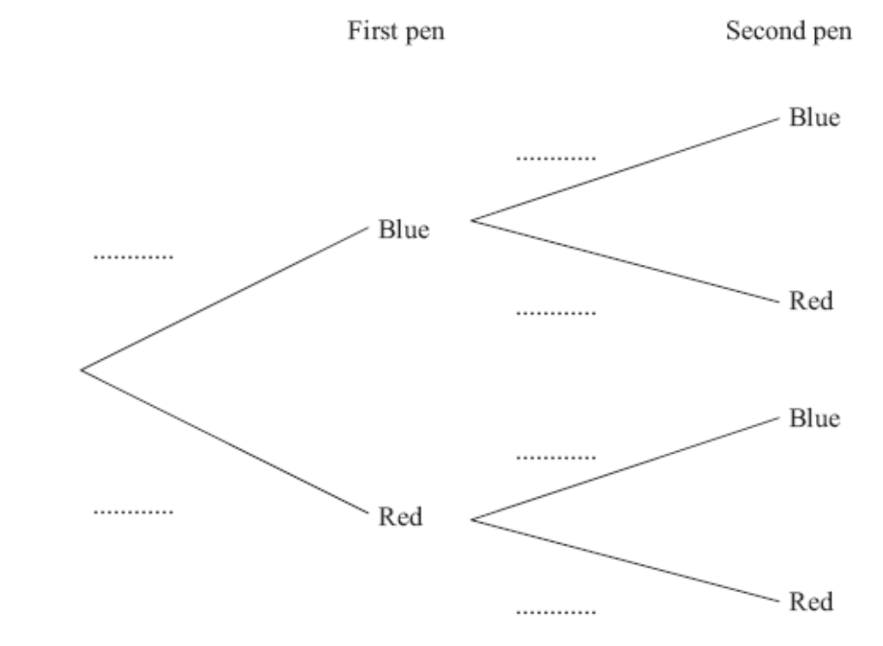

(a) Complete the probability tree diagram.
(2)

(b) Work out the probability that Emma takes exactly one pen of each colour from the box.

........................................
(3)
(Total 5 marks)
20. Steve has a photo and a rectangular piece of card.

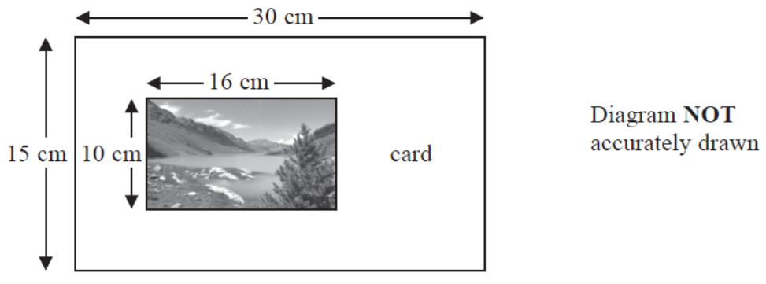

The photo is 16 cm by 10 cm.
The card is 30 cm by 15 cm.

Steve cuts the card along the dotted line shown in the diagram below.

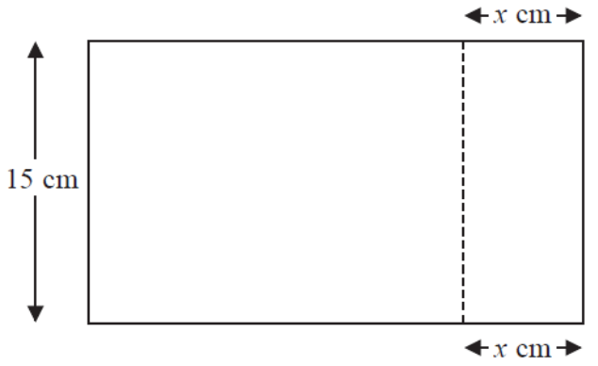

Steve throws away the piece of card that is 15 cm by x cm.
The piece of card he has left is mathematically similar to the photo.

Work out the value of x.

..........................................
(Total for Question 20 is 3 marks)
___________________________________________________________________________
21. y is directly proportional to the square of x.

When x = 3, y = 36.

Find the value of y when x = 5.

..........................................
(Total 4 marks)
___________________________________________________________________________
22. (a) Simplify fully (3e)⁰

..............................................
(1)
(b) Simplify 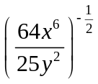

..............................................
(2)
(c) Write 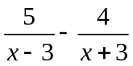 as a single fraction in its simplest form.

..............................................
(3)
(Total 6 marks)
___________________________________________________________________________
23. Simplify 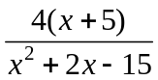

..............................................
(Total 2 marks)
___________________________________________________________________________

24.
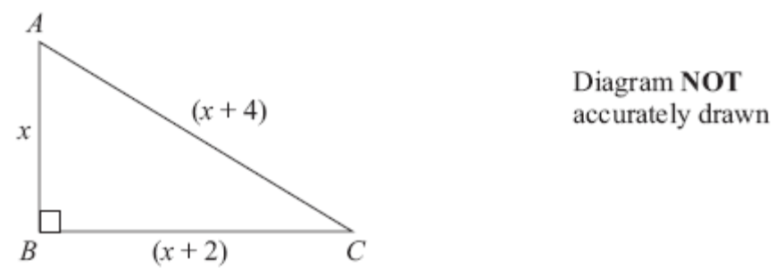

ABC is a right-angled triangle.
All the measurements are in centimetres.

AB = x
BC = (x + 2)
AC = (x + 4)

(a) Show that x² – 4x – 12 = 0

(3)

(b) (i) Solve x² – 4x – 12 = 0

........................................................

(ii) Hence, write down the length of AC.
AC = .......................cm
(4)
(Total 7 marks)

TOTAL FOR PAPER IS 100 MARKS

2 |  |  | 0 5 9  1 3 5 6 8 9 9  2 1 2 3 3 5 7 8 9  3 1 2 4  4 0 | 3 | B2 for fully correct diagram. Accept a stem of 10, 20, etc.  (B1 for ordered with at most 2 errors or omissions or for correct unordered diagram)  B1 for a correct key (units may be omitted) consistent with diagram.

3 |  |  | 120 cm³ | 4 | M1 for × 3 × 4  M1 (dep) for ‘× 3 × 4’ × 20  A1 for 120  B1 (indep) for cm³

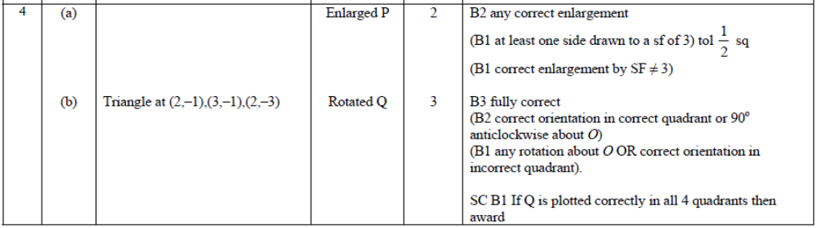

5 |  | π × 10² | 314 | 2 | M1 for π × 10² oe or 3.14 × 10² oe or 100π  A1 for 314 oe

*6 |  | 554  ×27  3878  11080  14958 | Yes with correct working | 4 | M1 for a complete method with relative place value correct. Condone 1 multiplication error, addition not necessary.  M1 (dep) for addition of all the appropriate elements of the calculation.  A1 for £149.58 or 42p (spare)  C1 ft (dep on M1) for correct decision for their total cost

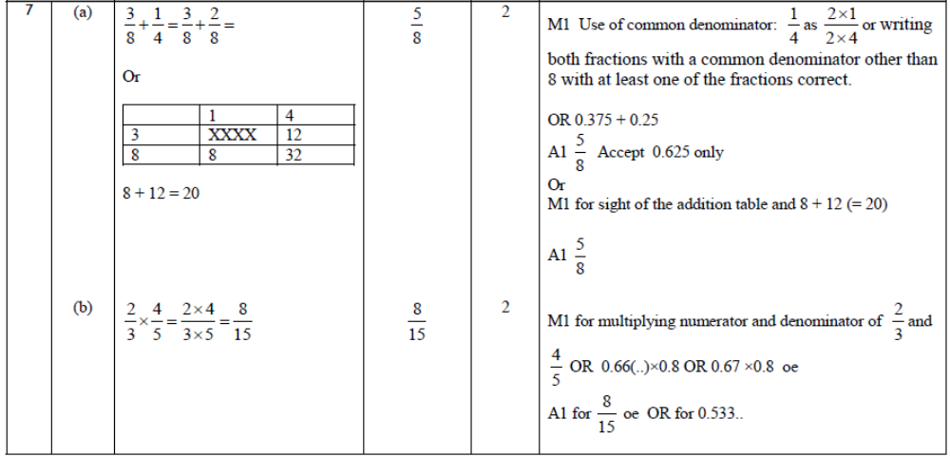

8 | (a) |  | 6y – 15 | 1 | B1 cao
 | (b) |  | 4x(2x + y) | 2 | B2 cao  (B1 for x(8x + 4y) or 2x(4x +2y) or 4(2x² + xy) or  4x(ax + by) where a, b are positive integers or  ax(2x + y) where a is a positive integer or  4x(2x – y))
 | (c) | 10t = gh  h = 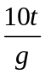 |  | 2 | M1 for clear intention to multiply both sides of the equation by 10 (eg. ×10 seen on both sides of equation) or  clear intention to divide both sides of the equation by g (e.g. ÷g seen on both sides of equation)  A1 for oe

9 | (a) |  | Criticisms | 2 | B1 Qu 1 Overlapping boxes, no units  B1 Qu 2 e.g. no time frame, non-specific responses, no  number quantities, open to interpretation, no option for those who do not exercise
 | (b) |  | Question given | 2 | B1 for a correct question with a time frame  B1 for at least 3 correctly labelled non-overlapping response boxes (need not be exhaustive) or at least 3 response boxes that are exhaustive for all integer values of their time unit (could be overlapping)  NB Units must be included in either question or response boxes to score full marks  [Do not allow inequalities in response boxes]

10 |  |  | 1.5 | 4 | M1 for correct expression for perimeter  e.g. 4 + 3x + x + 6 + 4 + 3x + x + 6 oe  M1 for forming a correct equation  e.g. 4 + 3x + x + 6 + 4 + 3x + x + 6= 32 oe  M1 for 8x = 12 or 12 ÷ 8  A1 for 1.5 oe

11 |  |  | 164 | 5 | M1 200 ÷ (3+2) (= 40) or an equivalent ratio seen  M1 (dep) 3 ×‘40’ (= 120) or 2 ×‘40’ (= 80) or 120: 80 or 80:120  M1 a complete method to find 70% of their total number of large letters e.g. 0.7 × ‘80’ (=56)  M1 multiplies their three totals by the correct unit price and adds, e.g. 60(p) × ‘120’ + (£)1 × ‘56’ + (£)1.50 × ‘24’  A1 164

12 | *(a) |  | No, temp is 25°C | 3 | M1 for substitution of 77 into the RHS of the formula  A1 for 25 cao or for 225/9 and 180/9 cao  C1 (dep on M1) for conclusion (ft) following from working shown  OR  M1 for substitution of 20 into LHS of formula and correct process to find F  A1 for 68 cao  C1 (dep on M1) for conclusion (ft) following from working shown
 | (b) |  | F = 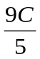+ 32 | 3 | M1 for expansion of the brackets (eg 5 × F – 5 × 32) or an attempt to multiply both sides by 9, or divide both sides by 5 as the first step.  M1 (dep) for a correct second step  A1 for F = + 32 oe

13 | (a) |  | 2×2×3×3×5 | 3 | M1 for a continual prime factorisation (at least two consecutive steps correct) or at least two stages of a factor tree correct  M1 for a fully correct factor tree or list 2,2,3,3,5  A1 for 2×2×3×3×5 or 2²×3²×5
 | (b) |  | Eg  6, 30 | 2 | M1 for two numbers with an HCF of 6 or for two numbers with a LCM a multiple of 15  A1 for two numbers with an HCF of 6 and a LCM a multiple of 15 (eg (6, 30), (12, 30), …)

14 | (a) | Line joins an empty circle at – 2 to a solid circle at 3 | diagram | 2 | B2 cao  (B1 for line from – 2 to 3)
 | (b) | 2x ≥ 7 | x ≥ 3.5 | 2 | M1 for correct method to isolate variable and number terms (condone use of =, >, ≤, or <) or (x =) 3.5  A1 for x ≥ 3.5 oe as final answer

15 |  | 6x + 8y = 10  6x − 9y =27  y = −1  3x − 4 = 5  3x = 9  x = 3 | x = 3, y = −1 | 4 | M1 for a correct process to eliminate either variable (condone one arithmetic error)  A1 cao for either x or y  M1 (dep on M1) for correct substitution of found value into one of the equations or appropriate method after starting again (condone one arithmetic error)  A1 cao

16 | (a) |  | correct graph | 2 | M1 for 5 or 6 or 7 points plotted correctly at the ends of the intervals (overlay)  A1 cao for correct graph with points joined by curve or straight line segments  [SC: B1 if the shape of the graph is correct and 5 or 6 or 7 of their points are not at the ends but are plotted consistently within (10,20) (20,30) (30,40) etc.]
 | (b) |  | No with supporting figures | 2 | M1 for 0.1 × 200 (=20) or 0.9×200 (=180) or sight of 180 used on cf axis or 200 – 186 (=14)  A1 ft for correct decision with 20 and “9” or 20 and 14 or “age” from reading graph at 180

17 |  | (3,6,7) to (−2,2,5)  (−5, −4, −2)  (−2− 5, 2 − 4, 5 − 2) | (−7, −2, 3) | 2 | M1 for midpoint plus change or complete method for 2 out of 3 coordinates, can be implied by 2 correct values  A1 cao

18 |  |  | x = 7  y = – 3 | 3 | M1 for correct process to eliminate one variable (condone one arithmetic error)  M1 (dep) for substituting found value in one of the equations or appropriate method after starting again (condone one arithmetic error)  A1 for x = 7 and y = – 3

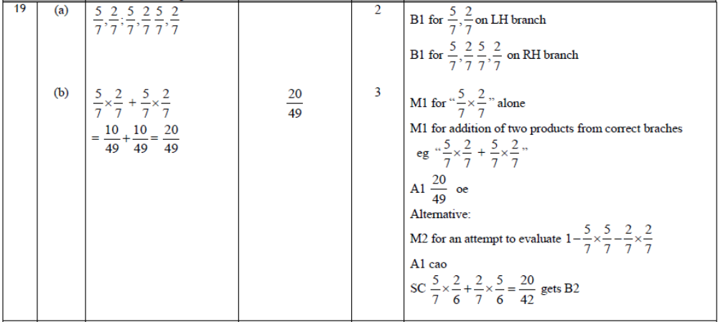

20 |  |  | 6 | 3 | M1 for 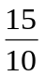 (=1.5) or 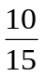 (=0.66..) or 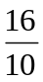(=1.6) or 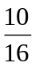(=0.625)  M1 for × 16 (=24) oe  A1 cao

21 |  |  | 100 | 4 | M1 y = kx² oe or 36 = k×3²  A1 k = 4  M1 (dep on M1) (y =) ‘4’×5²  A1 cao

22 | (a) |  | 1 | 1 | B1 cao
 | (b) |  | 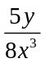 | 2 | M1 for correct square root or correct use of reciprocal  eg or 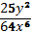  A1 for 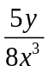 or 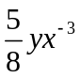oe
 | (c) |  | 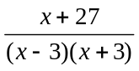 | 3 | M1 for denominator (x − 3)(x + 3) or x² − 9  M1 for 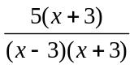 oe or 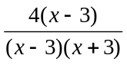 oe  (NB The denominator must be (x − 3)(x + 3) or x² − 9 or another suitable common denominator)  A1 for or 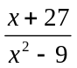

23 |  | 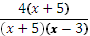 |  | 2 | M1 for (x ± 5)(x±3)  A1 for

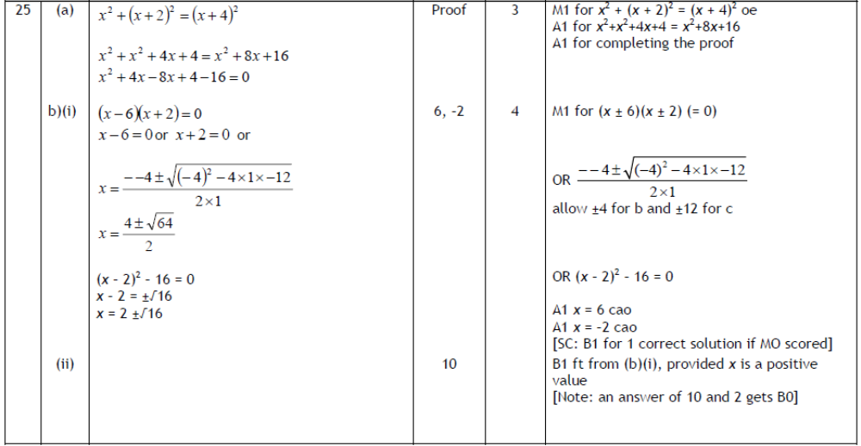
24
Question 1
The most common error, gaining one mark only for the term 8x, was an answer of 8x – 6y. Some candidates chose to factorise their correct answer of 8x + 6y; this was acceptable provided the factorisation was correct. Some candidates still want to combine the 8x and 6y to give 14xy. Sometimes candidates factorised but lost the multiplier leading to a final answer 4x + 3y, this may have been an attempt to "simplify".

Question 2
This was well answered. Very few candidates were unable to show they understood what they had to do. There was a substantial number who lost a mark because they omitted a value (usually in the twenty row). Presumably they had not counted the entries in the table and compared with the twenty numbers in the list at the top. Most candidates gave a sensible key, often without units, but some lost a mark because they wrote ‘children’ as the units, which is clearly wrong.

Question 3
The method of volume = area of cross-section × length was well known and regularly quoted. If candidates remembered how to find the area of a triangle they generally went on to find the correct volume of the prism. The vast majority of errors came from candidates failing to divide by 2 in their area calculation for the triangle which meant that 240 was a very common incorrect answer. Centres need to ensure that candidates know how to find the area of a triangle and use it in a context. A few candidates attempted to find the surface area of the prism rather than the volume. Some candidates failed to give any units with their answer or wrote cm or cm², losing the independent units mark.

Question 4
Part (a) and (b) were generally well answered. The most common errors in (a) were to get only one side correct (so not an enlargement) or to enlarge by a scale factor of 2 or 4

In part (b) the most common errors were to rotate the shape by 90º so that the image rested up against the origin in the 4th quadrant. or to miss the correct place by one full square.

Question 5
The majority of students were able to recall correctly and apply the formula for the area of a circle. Disappointingly, a number of candidates were able to give the correct calculation of 3.14 × 100 but then unable to evaluate this correctly. Other errors included using the formula for the circumference, giving 10² as 20 and evaluating (π × 10)².

Question 6
Most students attempted to answer this question by calculating 27 × £5.54, usually by a method of partitioning or by using a grid. A significant number of students were unable to use their chosen methods without error, often making simple errors in multiplications or in the subsequent addition of the various elements of the calculation. Students should be advised to take particular care when dealing with place values, eg in the correct partitioning of 5.54 to 5, 0.5 and 0.04 rather than the incorrect 5, 0.5 and 0.4. Errors in addition were often due to incorrect numbers, or no numbers, carried between columns, or to the incorrect alignment of columns. Some students omitted to include a correct monetary unit with their final answers. The vast majority of students were able to make a correct decision based on the totals they had calculated.

Question 7
Part (a) was a straightforward fraction addition question where the most direct method was to change the  to 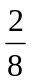 and then get the answer in its simplest form of . Many candidates changed the fractions to a denominator of 16 or 24 and then even if they added correctly often did not score the second mark because they did not simplify their answer. Many candidates could not add fractions correctly and gave an answer of 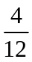 from adding numerators and denominators.

Part (b) was generally answered more successfully. However, there was a great deal of confusion in evidence where candidates had made the denominators of the fractions the same (usually over 15). They then went on to add the numerators or multiply the numerators but not the denominators. There was also evidence that candidates had cross multiplied.

There were a variety of correct approaches to part (c), with successful techniques shared between traditional setting out, Napier’s bones and grid methods. A few candidates attempted to add 423 twelve times and a few worked out 423 times 10 and then 4230 times 2 presumably decomposing 12 into 10 times 2 rather than 10 add 2. There were a significant number of misreads of 423 as 432.

Question 8
Part (a) was generally well answered. The most common errors were either to forget to multiply the 5 by 3 resulting in 6y – 5 and to add the 3 and 2 resulting in 5y – 15. In part (b) the demand asked candidates to ‘Factorise completely’ despite this, many gave a correct partially factorised expression so only gained one out of the two available marks. Those who showed a method in part (c) rather than just attempting to write down an answer were generally more successful and scored at least one mark. However, too many candidates just gave an answer which was frequently wrong; as the two stages were not shown it was not possible to award any marks. A significant number incorrect answers included a subtraction rather than a division, probably coming from candidates not recognising gh means g × h and so the inverse operation would be division.

Question 9
It was encouraging that almost all candidates attempted this question and it was generally answered well.

In part (a) most candidates realised that there was an overlap at 25 in question 1, but a significant minority thought there was also an overlap at 15 and 40. Most candidates were able to write down one thing wrong with question 2. This was usually related to the lack of a time frame, the vagueness of the response boxes or the absence of a box for those who do not exercise. Some gave a reason for question 2 in the answer space for question 1. A few candidates found it difficult to express their criticisms in a coherent manner or were too vague in their answers.

The questions designed in part (b) were generally well presented and often gained full marks. Some candidates omitted a time frame or the units of time, e.g. hours, and some designed a question to find out how often people exercised instead of how much time people spend exercising. A small number of candidates wrote an appropriate question but failed to include any response boxes. Too many candidates are still losing marks by using inequality signs in their response boxes. These are not acceptable.

Question 10
Not surprisingly this question was successfully completed by the more able candidates and there were many fully correct answers seen. These candidates had generally found the formation and solution of an equation straightforward. However, a significant proportion of candidates either formed an expression or equation involving the area of the rectangle or added the expressions given for the two sides to form the incorrect equation 4 + 3x + x + 6 = 32. There were many attempts using a trial and improvement approach – these were often unsuccessful.

Question 11
There was a lot of information in this multi-stage functional question and candidates found sequencing their work a challenge. Many candidates used the ratio correctly although some took 120 to be the number of large parcels. A significant minority found 70% of 200 and ignored the small parcels. A build up method to find 70% was used by many candidates, with a mixed level of success. The majority of candidates multiplied their totals by the correct unit price and added. Many responses exhibited basic arithmetic errors, both addition and multiplication. Some errors could have been avoided if candidates had considered if their answer was reasonable, e.g. 120 × 60p = £7.20. Some candidates set their solutions out clearly and logically, often gaining full marks, but too many gave a mixture of calculations in no particular order without any explanation of what it was they were attempting to work out. Candidates should be encouraged to set out working clearly and to communicate the meaning of their calculations.

Question 12
In part (a) most candidates were able to substitute the given value correctly into the formula. After that, there were many problems as a result of weakness with basic numerical techniques – firstly some candidates tried to expand the brackets but quite often did this wrongly by multiplying the 5 by the 77 only and leaving 32. Others worked out 77 – 32 and got the wrong answer whilst others did get the right answer but could not multiply accurately by 5. In addition, for those that got the correct numerator of 225 many could not even begin to divide by 9. Those that did get to the correct answer of 25 almost invariably made the correct conclusion. It was rare to see candidates who got to 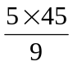 carry out the division first, so simplifying the calculation.

In part (b), the most common error from those candidates who understood what they had to do, was mismanagement of the 32 term with answers of the form 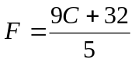 often seen. Candidates should write out every single step when rearranging a formula. The mark scheme is designed to reward those who show a sequence of logical, algebraically correct processes.

There were a few flow chart attempts – these had to be correct the F to C way and then display that the order of operations had to be reversed as well as each operation being replaced by its inverse. Full marks were only given when the flowchart was correct and translated back into a correct algebraic formula.

Question 13
Part (a) was done quite well. Many students were able to write 180 as a product of prime factors- the use of factor trees being by far the most popular approach. Here, as elsewhere, basic arithmetic was an issue for some students, e.g. 180 written as 2 × 60 or as 8 × 20. A common incorrect answer was to write the prime factors as a list of prime factors rather than as a product of prime factors.

Part (b) was not done so well, though many students were able to get 1 mark for writing two numbers with one of the two required properties, ie as having an HCF of 6 or as having a LCM a multiple of 15. Popular incorrect answers, scoring 1 mark, were 30, 60 and 3, 5.

Question 14
Part (a) of this question was quite well done though some candidates were unable to use the correct notation, ie that of empty or solid circles, at each end of the interval. A relatively common error was for candidates to draw a line from −1 to 3. It would appear that these candidates assumed that the values needed to be integers but then drew a continuous line between the 2 values. Some candidates indicated the correct end points of the interval but did not draw a line joining them. In part (b) candidates often found the critical value 3.5 or equivalent and so gained one mark. However 3.5 alone or x = 3.5 was often written on the answer line and examiners could not give this full marks. Poor manipulation of the inequality was also commonplace with incorrect simplifications such as 2x 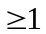 seen.

Question 15
Many candidates appeared familiar with simultaneous equations and were able to achieve a pair of equations which they could add or subtract to eliminate one of the variables. However, simple errors in multiplication, addition or subtraction and a failure to deal correctly with the negative numbers involved hampered many. Candidates who tried to eliminate y first were usually more successful as they had to add the equations rather than subtract although 51÷17 caused problems for some. Those who attempted to eliminate x often struggled with subtracting –9y from 8y or vice versa. Some of the candidates who successfully eliminated x could not deal with –17y = 17 (although 17y = –17 seemed to pose fewer problems). Having found one value, candidates usually went on to substitute their value into an equation to find the other value. There were many candidates who had a correct first answer (mostly x = 3) who substituted their value but then couldn't rearrange the linear equation correctly. Candidates should be encouraged to substitute their answers into one of the original equations to check they are correct. Only few candidates attempted the substitution method and generally these candidates were not as successful as those using the elimination method.

Question 16
Part (a) was done quite well. Many students were able to draw a correct cumulative frequency diagram for the information given in the table. Common errors were due to misinterpreting the vertical scale, particularly at (40, 138) and (60, 186), plotting points at mid-interval values, and careless drawing of the graph, such that the curve did not pass through all the points. Students should be advised to take more care when drawing cumulative frequency graphs and ensure that these pass through all the plotted points.

In part (b), many students were able to use either their cumulative frequency graphs, or the information given in the table, to comment on the accuracy of the given statement. Most students used the given percentage (10%) to calculate a frequency to compare, ie 20, rather than use a frequency from the table/cumulative frequency graph to calculate a percentage to compare, eg 5%. When reading values from a cumulative frequency graph, students should be advised to show their working by drawing clear lines between the axes of the graph and the graph.

Question 17
A significant number of candidates did not attempt this question. There were few clear strategies used and many correct answers showed no working at all. Many candidates did get at least 2 of the 3 numbers correct. Brackets were often omitted from the answer but this was not penalised. Common errors were to try to find the midpoint of the two sets of coordinates given or to give the differences between A and the midpoint as the final answer.

Question 18
This was a standard simultaneous equation question which was, for some candidates a single step to eliminate one of the variables. Most candidates who had an idea of what to do multiplied the first equation by 3 and added. Those that subtracted were not awarded any marks. Others multiplied the second equation by 4 and subtracted. Those that added were not awarded any marks. In fact, elimination rather than substitution was the overwhelmingly commonly seen approach. Often, the elimination was carried out incorrectly with the difference between 12x and – x being found as 11x, for example.
Once again, arithmetical weakness meant that candidates were losing marks. Typical errors included:

- Getting to 13x = 91 and failing to go any further.
- Working out the difference between 64 and 25 and getting 41.

It was a pleasure to see some candidates properly checking their solution.

Question 19
Many candidates were able to write down the correct fractions for part (a) and gain their two marks. However, it was clear that some of the entry were completely unfamiliar with the basic idea of a probability tree diagram and wrote in integers or in some cases names of colours. Success on part (b) proved to be more elusive, with many candidates writing down expressions like 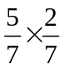 but then failing to multiply the fractions correctly. Again, there was a lack of awareness of the suitability of answers with attempts like 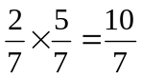 sometimes seen.

Question 20
This question was seen by candidates often successfully as one about similarity in context. Candidates were expected to find a suitable scale factor, for example, 1.5, or to do some work on equating ratios of corresponding sides. They had to write their equation in a form which enabled them to rearrange to find the unknown side if they did use ratios before they were awarded marks.

A few candidates realised that they could turn the sheet through a right angle with respect to the photo. This was accommodated in the mark scheme.

There were many attempts to equate areas in some form. These scored no marks unless there was a reference to the square of the scale factor, for example.

Question 21
Many of the attempted solutions demonstrated that candidates were not conversant with this part of the specification. A large proportion of candidates used y = kx leading to an answer of 60 and gained no marks. A minority understood that y ∝ x² or y = kx² was the essence of this problem and most of these candidates gained full marks. Some, however, correctly worked out k = 4 but then went on to multiply 4 by 5 instead of by 5² and lost two possible marks. Some candidates doubled the value of x and then squared to get the correct answer of 100, i.e. using y = (2x)².

Question 22
Part (a) was done quite well. Many students were able to correctly simplify the given expression. A common incorrect answer here was 0.

In part (b), few students could score the marks for both taking the square root and taking the reciprocal of the expression. A common incorrect answer involved taking the square root of only part of the expression, e.g. 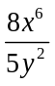, which was not always followed by an attempt to find the reciprocal. Another common error was to incorrectly take the square root by halving both the powers and the coefficients, e.g. 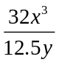, again not always followed by an attempt to find the reciprocal.

In part (c), few students were able to score full marks but many scored 2 marks, usually for 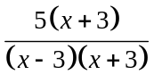. Common errors in simplifying the algebraic fractions were often due to errors in signs and/or to poor or absent bracketing, e.g. 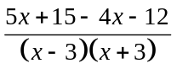, or in continuing to “simplifying” a correct expression incorrectly, e.g. incorrectly cancelled to .

Question 23
About one in six candidates scored full marks for their solution to this question with examiners awarding one mark to candidates who realised the need to express the denominator of the fraction as a product of factors and making a good attempt to do this. A good proportion of candidates began by expanding the numerator rather than factorising the denominator so, even if they did go on to factorise the denominator, they did not always identify the common factor.

Question 24
Those candidates who recognised the need to apply Pythagoras’s theorem to the given triangle often gained at least 2 marks in part (a). The final mark was often lost as a result of not being able to offer a convincing conclusion to the proof. The success in squaring a bracket was very high this year. It was rare to see (x + 4)² expanded to x² + 16. Many candidates thought that they were being asked to solve the equation not obtain it. Hence, some answers to (b) were seen in (a). The notion of proof still clearly differentiates at the top level. In part (b), methods to solve the quadratic equation included factorisation, completing the square and using the quadratic formula. Factors of (x + 6)(x – 2) or incorrect substitution into the formula were the general factors preventing the award of full marks. Often spurious methods leading to a single answer of x = 6 were seen. These were awarded one mark only. A significant number of candidates relied on trial and improvement methods to obtain a solution. Many of them came up with 6 but failed to find the other solution. A positive answer in (i) usually led to a ‘correct’ answer in (ii), although a significant number of candidates were happy to use negative values of x.
Practice paper: Silver 1

 |  |  |  |  |  |  |  | Mean score for students achieving Grade:
Spec | Paper | Session  YYMM | Question | Mean score | Max score | Mean  % | ALL | A* | A | % A | B | C | % C | D | E
1380 | 1H | 1006 | Q01 | 1.80 | 2 | 90 | 1.80 | 1.92 | 1.89 | 94.5 | 1.85 | 1.73 | 86.5 | 1.54 | 1.32
1MA0 | 1H | 1406 | Q02 | 2.69 | 3 | 90 | 2.69 | 2.93 | 2.87 | 95.7 | 2.81 | 2.69 | 89.7 | 2.41 | 1.78
1MA0 | 1H | 1311 | Q03 | 2.38 | 4 | 75 | 2.38 | 3.88 | 3.72 | 93.0 | 3.32 | 2.19 | 54.8 | 0.87 | 0.22
1380 | 1H | 911 | Q04 | 4.20 | 5 | 84 | 4.20 | 4.94 | 4.82 | 96.4 | 4.58 | 4.10 | 82.0 | 3.35 | 2.48
1380 | 1H | 1011 | Q05 | 1.10 | 2 | 55 | 1.10 | 1.97 | 1.84 | 92.0 | 1.47 | 0.83 | 41.5 | 0.35 | 0.13
1MA0 | 1H | 1411 | Q06 | 2.46 | 4 | 62 | 2.46 | 3.84 | 3.56 | 89.0 | 3.29 | 2.83 | 70.8 | 2.09 | 1.08
1380 | 1H | 911 | Q07 | 5.27 | 7 | 75 | 5.27 | 6.91 | 6.59 | 94.1 | 5.90 | 4.84 | 69.1 | 3.74 | 2.91
1MA0 | 1H | 1206 | Q08 | 2.82 | 5 | 56 | 2.82 | 4.87 | 4.48 | 89.6 | 3.43 | 1.95 | 39.0 | 0.99 | 0.51
1MA0 | 1H | 1311 | Q09 | 3.33 | 4 | 92 | 3.33 | 3.64 | 3.57 | 89.3 | 3.52 | 3.39 | 84.8 | 3.08 | 2.48
1MA0 | 1H | 1306 | Q10 | 1.93 | 4 | 48 | 1.93 | 3.87 | 3.58 | 89.5 | 2.72 | 1.32 | 33.0 | 0.38 | 0.11
1MA0 | 1H | 1311 | Q11 | 3.03 | 5 | 82 | 3.03 | 4.79 | 4.55 | 91.0 | 4.09 | 2.86 | 57.2 | 1.28 | 0.29
1MA0 | 1H | 1406 | Q12 | 3.18 | 6 | 53 | 3.18 | 5.73 | 5.26 | 87.7 | 4.10 | 2.29 | 38.2 | 0.90 | 0.23
1MA0 | 1H | 1411 | Q13 | 2.04 | 5 | 41 | 2.04 | 4.19 | 3.61 | 72.2 | 3.07 | 2.35 | 47.0 | 1.52 | 0.76
1MA0 | 1H | 1306 | Q14 | 1.83 | 4 | 46 | 1.83 | 3.66 | 3.20 | 80.0 | 2.34 | 1.34 | 33.5 | 0.68 | 0.27
1MA0 | 1H | 1311 | Q15 | 1.67 | 4 | 61 | 1.67 | 3.90 | 3.56 | 89.0 | 2.53 | 1.02 | 25.5 | 0.22 | 0.03
1MA0 | 1H | 1411 | Q16 | 1.88 | 4 | 47 | 1.88 | 3.76 | 3.40 | 85.0 | 2.88 | 2.07 | 51.8 | 1.39 | 0.89
1MA0 | 1H | 1311 | Q17 | 0.80 | 2 | 34 | 0.80 | 1.84 | 1.55 | 77.5 | 1.12 | 0.55 | 27.5 | 0.22 | 0.06
1MA0 | 1H | 1406 | Q18 | 1.26 | 3 | 42 | 1.26 | 2.90 | 2.56 | 85.3 | 1.73 | 0.63 | 21.0 | 0.11 | 0.01
1380 | 1H | 911 | Q19 | 2.06 | 5 | 41 | 2.06 | 4.75 | 3.86 | 77.2 | 2.34 | 1.27 | 25.4 | 0.67 | 0.34
1MA0 | 1H | 1406 | Q20 | 0.90 | 3 | 30 | 0.90 | 2.68 | 2.06 | 68.7 | 1.12 | 0.29 | 9.7 | 0.08 | 0.05
1MA0 | 1H | 1311 | Q21 | 1.10 | 4 | 80 | 1.10 | 3.71 | 2.92 | 73.0 | 1.46 | 0.41 | 10.3 | 0.10 | 0.02
1MA0 | 1H | 1411 | Q22 | 0.69 | 6 | 12 | 0.69 | 4.78 | 3.47 | 57.8 | 1.77 | 0.46 | 7.7 | 0.17 | 0.06
1MA0 | 1H | 1306 | Q23 | 0.43 | 2 | 22 | 0.43 | 1.83 | 1.23 | 61.5 | 0.45 | 0.09 | 4.5 | 0.01 | 0.00
1380 | 1H | 1006 | Q25 | 1.80 | 7 | 26 | 1.80 | 6.05 | 3.22 | 46.0 | 1.11 | 0.38 | 5.4 | 0.11 | 0.05
 |  |  |  | 50.65 | 100 | 51 | 50.65 | 93.34 | 81.37 | 81.37 | 63.00 | 41.88 | 41.88 | 26.26 | 16.08

