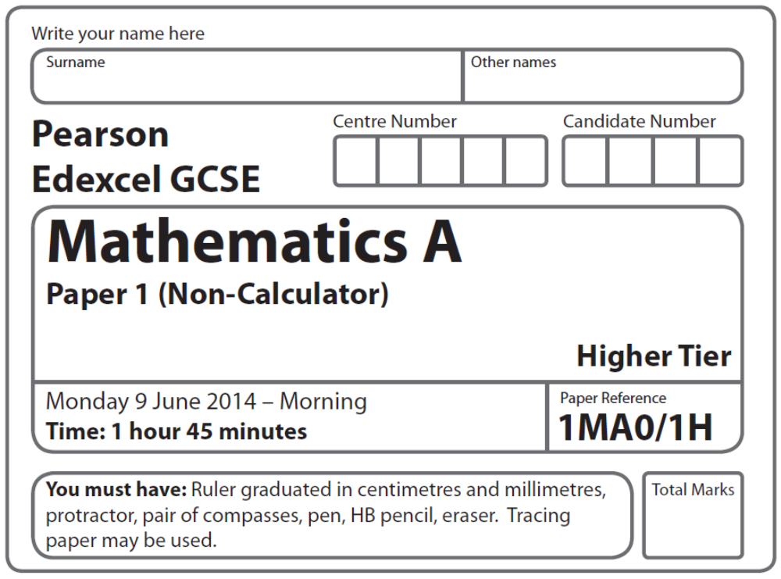
Practice Paper – Bronze 2
Bronze: 2 of 4

Instructions

- Use black ink or ball-point pen.
- Fill in the boxes at the top of this page with your name,
centre number and candidate number.
- Answer all questions.
- Answer the questions in the spaces provided
– there may be more space than you need.
- Calculators must not be used.

Information
- The total mark for this paper is 101
- The marks for each question are shown in brackets
– use this as a guide as to how much time to spend on each question.
- Questions labelled with an asterisk (*) are ones where the quality of your
written communication will be assessed.

Advice
- Read each question carefully before you start to answer it.
- Keep an eye on the time.
- Try to answer every question.
- Check your answers if you have time at the end.

Suggested Grade Boundaries (for guidance only)
A* | A | B | C | D
100 | 97 | 84 | 67 | 49
GCSE Mathematics 1MA0

Formulae: Higher Tier

You must not write on this formulae page.
Anything you write on this formulae page will gain NO credit.

Volume of prism = area of cross section × length Area of trapezium = (a + b)h
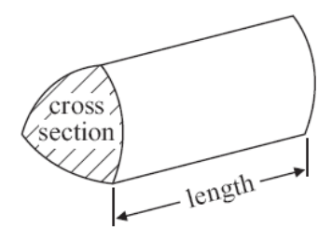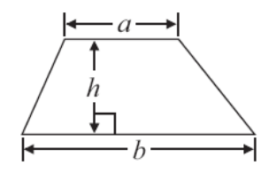

Volume of sphere πr³ Volume of cone πr²h
Surface area of sphere = 4πr² Curved surface area of cone = πrl

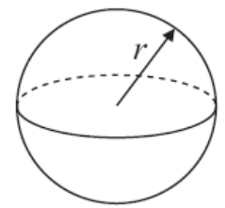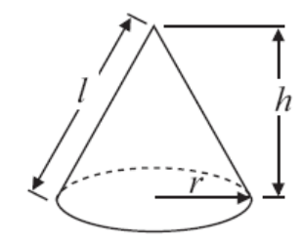

In any triangle ABC The Quadratic Equation
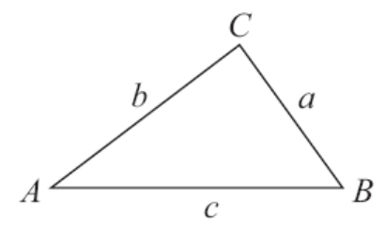
The solutions of ax²+ bx + c = 0
where a ≠ 0, are given by

x = 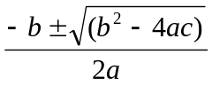

Sine Rule 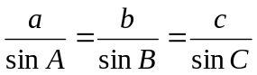

Cosine Rule a² = b²+ c²– 2bc cos A

Area of triangle = ab sin C
Answer ALL questions.
Write your answers in the spaces provided.
You must write down all stages in your working.
You must NOT use a calculator.

1. Here is a list of ingredients for making 10 Flapjacks.

Ingredients for 10 Flapjacks

80 g rolled oats

60 g butter

30 ml golden syrup

36 g light brown sugar

Work out the amount of each ingredient needed to make 15 Flapjacks.

..................... g rolled oats

..................... g butter

..................... ml golden syrup

..................... g light brown sugar
(Total 3 marks)
___________________________________________________________________________
2. The scatter graph shows information about 10 apartments in a city.

The graph shows the distance from the city centre and the monthly rent of each apartment.
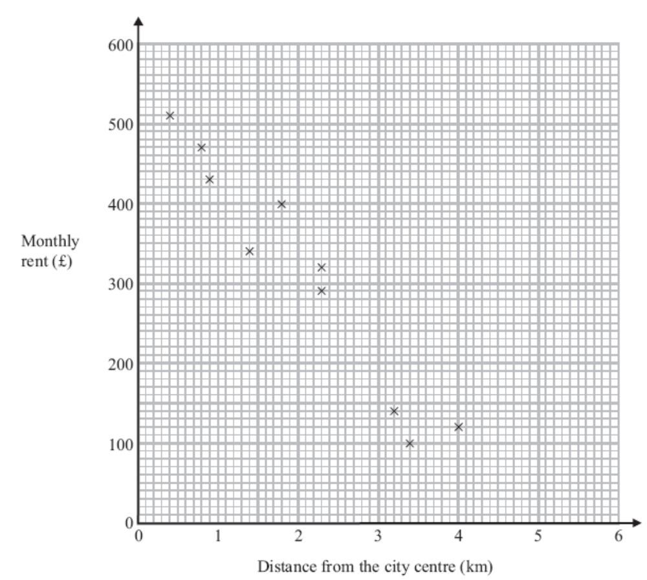

The table shows the distance from the city centre and the monthly rent for two other apartments.

Distance from the city centre (km) | 2 | 3.1
Monthly rent (£) | 250 | 190

(a) On the scatter graph, plot the information from the table.
(1)

(b) Describe the relationship between the distance from the city centre and the monthly rent.

...............................................................................................................................................

...............................................................................................................................................
(1)
An apartment is 2.8 km from the city centre.

(c) Find an estimate for the monthly rent for this apartment.

£ ......................................................
(2)
(Total 4 marks)
___________________________________________________________________________
3. Louise spins a four-sided spinner and a five-sided spinner.
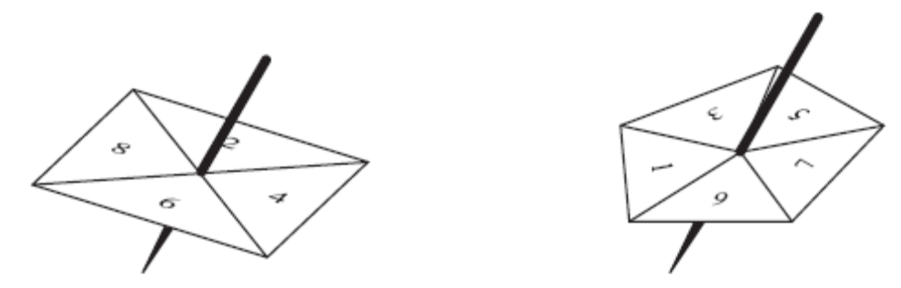

The four-sided spinner is labelled 2, 4, 6, 8
The five-sided spinner is labelled 1, 3, 5, 7, 9

Louise adds the score on the four-sided spinner to the score on the five-sided spinner.
She records the possible total scores in a table.

4-sided spinner
5-sided spinner | + | 2 | 4 | 6 | 8
5-sided spinner | 1 | 3 | 5 | 7 | 9
5-sided spinner | 3 | 5 | 7 | 9 | 11
5-sided spinner | 5 | 7 | 9 | 11 | 13
5-sided spinner | 7 | 9 | 11 | x | x
5-sided spinner | 9 | 11 | 13 | x | x

(a) Complete the table of possible total scores.
(1)

(b) Write down all the ways in which Louise can get a total score of 11
One way has been done for you.

(2, 9)......................................................................................................................................
(2)

Both spinners are fair.

(c) Find the probability that Louise’s total score is less than 6

.....................................
(2)
(Total 5 marks)
___________________________________________________________________________
4. (a) Expand 3(2 + t)

..............................................
(1)
(b) Expand 3x(2x + 5)

..............................................
(2)
(c) Expand and simplify (m + 3)(m + 10)

..............................................
(2)
(Total 5 marks)
___________________________________________________________________________
5.
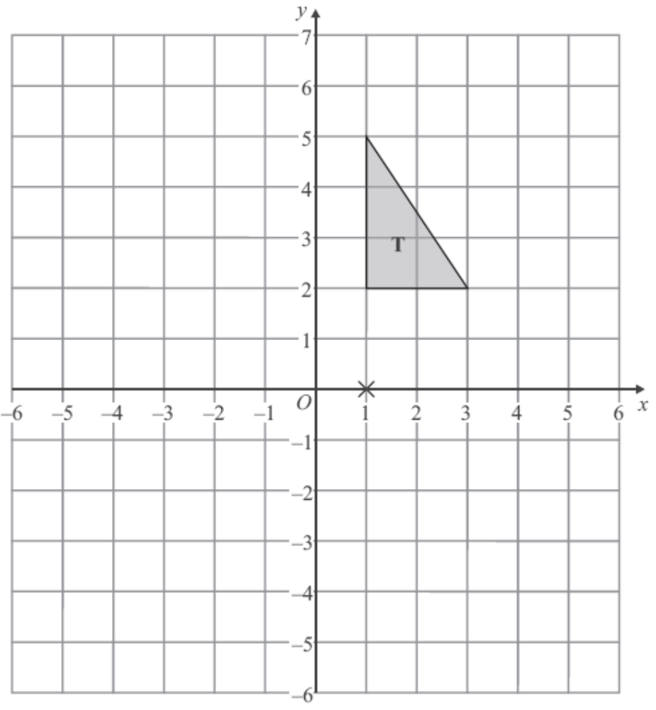

Triangle T has been drawn on the grid.

Rotate triangle T 180° about the point (1, 0).
Label the new triangle A.
(Total 2 marks)

6. Work out an estimate for 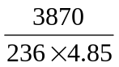

.....................................
(Total 2 marks)
___________________________________________________________________________
7. Rita is going to make some cheeseburgers for a party.
She buys some packets of cheese slices and some boxes of burgers.

There are 20 cheese slices in each packet.
There are 12 burgers in each box.

Rita buys exactly the same number of cheese slices and burgers.

(i) How many packets of cheese slices and how many boxes of burgers does she buy?

.............................................. packets of cheese slices

.............................................. boxes of burgers

Rita wants to put one cheese slice and one burger into each bread roll.
She wants to use all the cheese slices and all the burgers.

(ii) How many bread rolls does Rita need?

.............................................. bread rolls
(Total 4 marks)
___________________________________________________________________________
8. The diagram shows a garden in the shape of a rectangle.

The scale of the diagram is 1 cm represents 2 m.

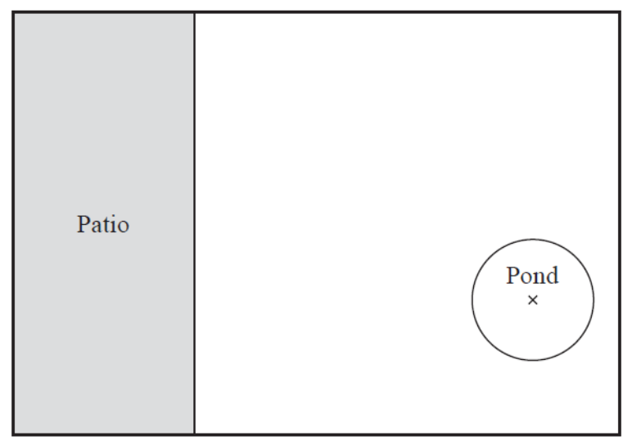

Scale: 1 cm represents 2 m

Irfan is going to plant a tree in the garden.
The tree must be

more than 3 metres from the patio
and more than 6 metres from the centre of the pond.

On the diagram, shade the region where Irfan can plant the tree.

(Total for Question 8 is 3 marks)
___________________________________________________________________________
9.
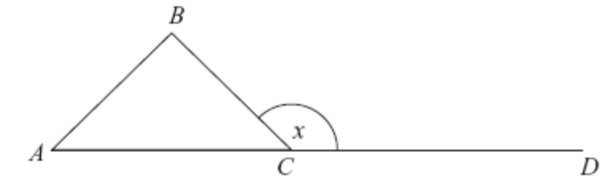

ABC is an equilateral triangle.
ACD is a straight line.

(a) Work out the size of the angle marked x.

................................... °
(2)

(b) Give a reason for your answer.

...............................................................................................................................................

...............................................................................................................................................
(1)
(Total 3 marks)
___________________________________________________________________________
10. (a) Simplify 3a + 4c – a + 3c

.......................................
(2)
(b) Expand y(2y – 3)

.......................................
(1)
(c) Factorise x² – 4x

.......................................
(2)
(d) Expand and simplify 2(x + 3) + 3(2x – 1)

.......................................
(2)
(e) Solve 3(x + 2) = 8

x = ............................
(2)
(Total 9 marks)

11. Ria is going to buy a caravan.
The total cost of the caravan is £7000 plus VAT at 20%.

Ria pays a deposit of £3000.
She pays the rest of the total cost in 6 equal monthly payments.

Work out the amount of each monthly payment.

£..............................
(Total 4 marks)
___________________________________________________________________________
12. 5 schools sent some students to a conference.

One of the schools sent both boys and girls.
This school sent 16 boys.
The ratio of the number of boys it sent to the number of girls it sent was 1 : 2

The other 4 schools sent only girls.
Each of the 5 schools sent the same number of students.

Work out the total number of students sent to the conference by these 5 schools.

....................................................................
(Total 4 marks)
___________________________________________________________________________
13. (a) Write in standard form 213 000

...............................................
(1)
(b) Write in standard form 0.00123

...............................................
(1)
(Total 2 marks)

14.

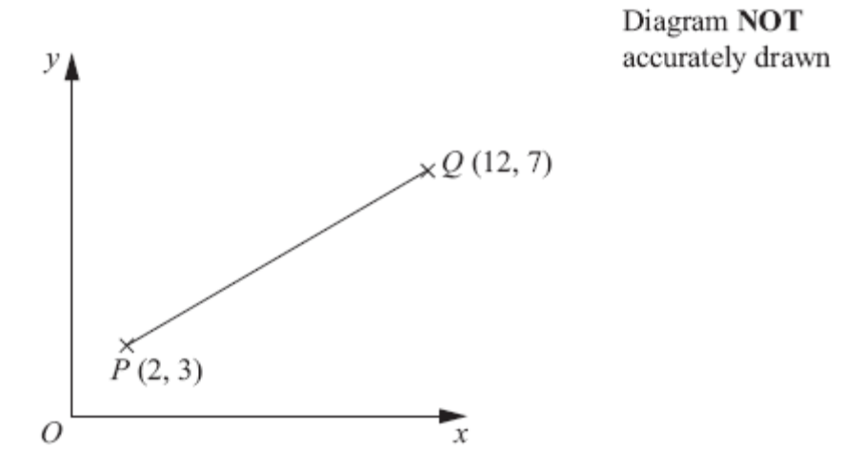

P is the point with coordinates (2, 3).
Q is the point with coordinates (12, 7).

Work out the coordinates of the midpoint of the line PQ.

( ..............., ............... )
(Total 2 marks)
___________________________________________________________________________
15. Express 180 as a product of its prime factors.

................................................................
(Total 3 marks)
___________________________________________________________________________

16. (a) Simplify (m^{–2})⁵

..............................................
(1)

(b) Factorise x² + 3x – 10

..........................................................................
(2)
(Total for Question 16 is 3 marks)
___________________________________________________________________________
17. (a) Write down the value of 10⁰.

..........................................
(1)
(b) Write down the value of 10^{–2}.

..........................................
(1)
(c) Write these numbers in order of size.
Start with the smallest number.

2.73 × 10³ 27.3 × 10^{–3} 273 × 10² 0.00273

..............................................................................................................................
(2)
(Total for Question 17 is 4 marks)
___________________________________________________________________________
18. The cumulative frequency graph shows information about the times 80 swimmers take to swim 50 metres.

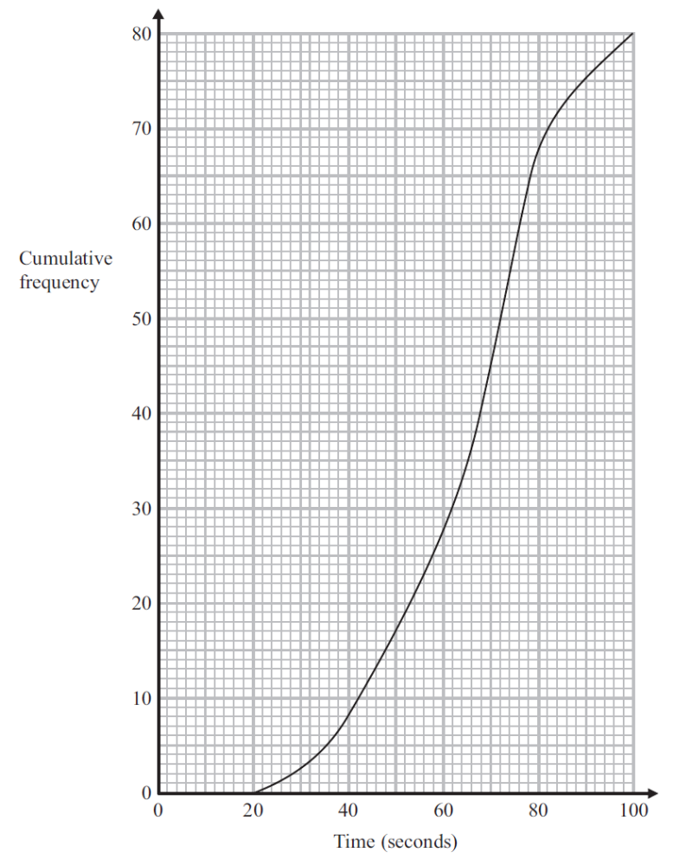

(a) Use the graph to find an estimate for the median time.

.............................................. seconds
(1)
A swimmer has to swim 50 metres in 60 seconds or less to qualify for the swimming
team.

The team captain says,

“More than 25% of swimmers have qualified for the swimming team.”

*(b) Is the team captain right?

You must show how you got your answer.

(3)
For these 80 swimmers

the least time taken was 28 seconds
and the greatest time taken was 96 seconds.

(c) Use the cumulative frequency graph and the information above to draw a box plot for
the times taken by the swimmers.

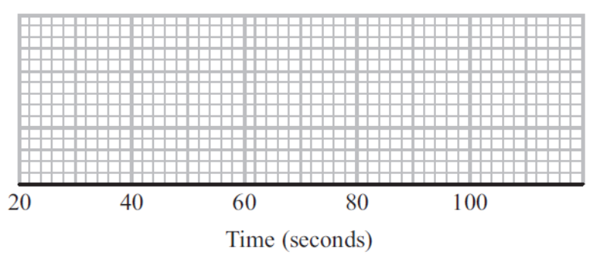
(3)
(Total 7 marks)
___________________________________________________________________________
19. Arwen buys a car for £4000
The value of the car depreciates by 10% each year.

Work out the value of the car after two years.

£ ...................................
(Total 3 marks)
___________________________________________________________________________
20. Solve the simultaneous equations

5x + 2y = 11
4x – 3y = 18

x = ..............................................

y = ..............................................
(Total for Question 20 is 4 marks)
___________________________________________________________________________

21. Solve the simultaneous equations

3x + 2y = 8
2x + 5y = –2

x = ...............................

y = ...............................
(Total 4 marks)

22. The table gives some information about the delays, in minutes, of 80 flights.

Delay (n minutes) | Frequency
0 < n ≤ 20 | 16
20 < n ≤ 30 | 26
30 < n ≤ 40 | 23
40 < n ≤ 50 | 10
50 < n ≤ 60 | 5

(a) Write down the modal class interval.

.....................................
(1)

(b) Complete the cumulative frequency table.

Delay (n minutes) | Frequency
0 < n ≤ 20
0 < n ≤ 30
0 < n ≤ 40
0 < n ≤ 50
0 < n ≤ 60
(1)

(c) On the grid opposite, draw a cumulative frequency graph for your table.
(2)

(d) Use your graph to find an estimate for

(i) the median delay,

........................ minutes
(ii) the interquartile range of the delays.

........................ minutes
(3)
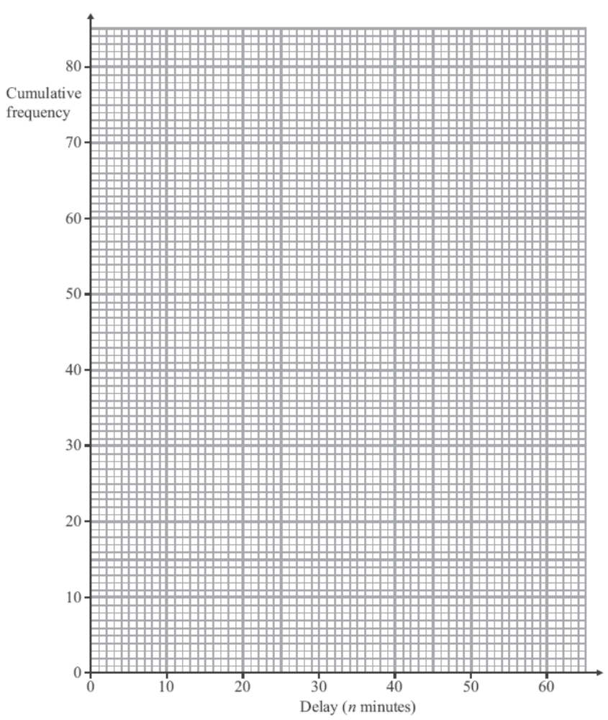
(Total 7 marks)
___________________________________________________________________________
23. (a) Expand and simplify (x − 3)(x + 5)

.....................................
(2)

(b) Solve x² + 8x − 9 = 0

.....................................
(3)
(Total 5 marks)
___________________________________________________________________________
24. There are three different types of sandwiches on a shelf.

There are

4 egg sandwiches,
5 cheese sandwiches
and 2 ham sandwiches.

Erin takes at random 2 of these sandwiches.

Work out the probability that she takes 2 different types of sandwiches.

........................................
(Total 5 marks)
___________________________________________________________________________
25. (a) Rationalise the denominator of 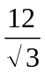

..............................................
(2)
(b) Work out the value of (√2 + √8)²

..............................................
(2)
(Total 4 marks)

TOTAL FOR PAPER IS 100 MARKS
1 |  | 15 ÷ 10  80 × 1.5  60 × 1.5  30 × 1.5  36 × 1.5 | 120, 90, 45, 54 | 3 | M2 for any one of 80 + 40 or 60 + 30 or 30 + 15 or 36 + 18 or 120 or 90 or 45 or 54 seen  A1 cao  OR  M1 for 15 ÷ 10 or 3 ÷ 2 or sight of 1.5  M1(dep) for 80 × '1.5' or 60 × '1.5' or 30 × '1.5' or  36 × '1.5'  A1 cao  OR  M1 for 80 ÷ 10 or 60 ÷ 10 or 30 ÷ 10 or 36 ÷ 10 or 8 or 6 or 3 or 3.6  M1(dep) for '8' × 15 or '6' × 15 or '3' × 15 or '3.6' × 15  A1 cao  OR  M1 for 80 ÷ 2 or 60 ÷ 2 or 30 ÷ 2 or 36 ÷ 2 or 40 or 30 or 15 or 18  M1 (dep) for '40' × 3 or '30' × 3 or '15' × 3 or '18' × 3  A1 cao

2 | (a) | Plot (2, 250) and (3.1, 190) | Plot points | 1 | B1 for both points plotted accurately
 | (b) |  | Relationship | 1 | B1 for “As the distance from the centre increases the monthly rent  decreases” or the nearer you are to the centre the more you have to pay oe (accept negative correlation)
 | (c) |  | 200 to 260 | 2 | M1 for attempting a correct method, eg a line of best fit  or any other indication, on a line that could be used as a line of best fit eg line to graph at x = 2.8or a mark on the line at 2.8  A1 for value in the range 200 to 260

3 | (a) |  |  | 1 | B1 cao
  13 | 15
  15 | 17
 | (b) |  | (4, 7), (6, 5), (8, 3) | 2 | B2 for all 3 pairs (numbers in any order in each pair, condone use of addition sign) and no extra pairs  (B1 for one or two or three correct pairs and no more than three extra pairs given, ignoring repeats)
 | (c) |  | 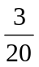 oe | 2 | B2 ft accept answer as fraction or decimal or percentage  (B1 for 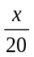, x < 20, x ≠ 3 or , x > 3, x ≠ 3)  SC: If no marks scored award B1 for ‘3 out of 20’ as final answer or other use of incorrect notation

4 | (a) |  | 6 + 3t | 1 | B1 for 6 + 3t
 | (b) |  | 6x² + 15x | 2 | B2 for 6x² + 15x  (B1 for 6x² or 15x)
 | (c) | m² + 10m + 3m + 30 | m² + 13m + 30 | 2 | M1 for all 4 terms (and no additional terms) correct with or without signs or 3 out of no more than four terms correct with  signs  A1 for m² + 13m + 30

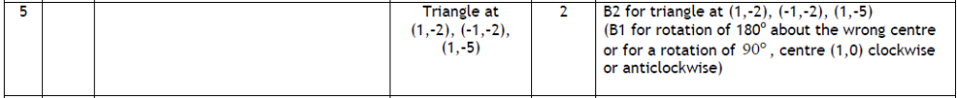

6 |  | 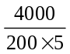 | 4 | 2 | M1 for rounding at least one of the numbers to 1 significant figure correctly  A1 for answer between 3 and 4 inclusive

7 | (i) | 20, 40, 60  12, 24, 36, 48, 60  20 = 4×5 = 2×2×5  12 = 4×3 = 2×2×3 | 3 and 5  or  any multiple  of 3, 5 | 4 | M1 attempts multiples of both 20 and 12  (at least 3 of each shown but condone errors if intention is clear) or identifies 60 or a multiple of 60  M1 (dep on M1) for a division by 20 or 12  or counts up ‘multiples’ or identifies a common multiple  (implied if one answer is correct or answers reversed)  A1 cheese slices (packets) 3, burgers (boxes) 5  or any multiple of 3, 5
 | (ii) |  | 60 |  | B1 for 60 or ft from their correct answer in (i) or ft ‘common multiple’

8 |  |  | Correct region | 3 | B1 for full line drawn 1.5 cm from edge of patio and parallel to it  B1 for full arc of circle radius 3 cm centre the centre of the pond  B1 ft for shading region to the right of their vertical line and outside the arc of their circle with correct centre

9 | (a) | 180º - 60º  or  60º + 60º | 120º | 2 | M1 for 180 ÷ 3 or 60 as angle of triangle or 180 – 60 or 60 + 60  A1 cao
 | (b) |  | Reason | 1 | B1 for at least one correct reason and no incorrect reasons (ignore irrelevant reasons)  ‘angles on a straight line add to 180º’ or ‘angles in a triangle add up to 180º’ or ‘angles in an equilateral triangle are equal’ or  ‘exterior angle of a triangle is equal to the sum of the interior angles at the two other vertices’

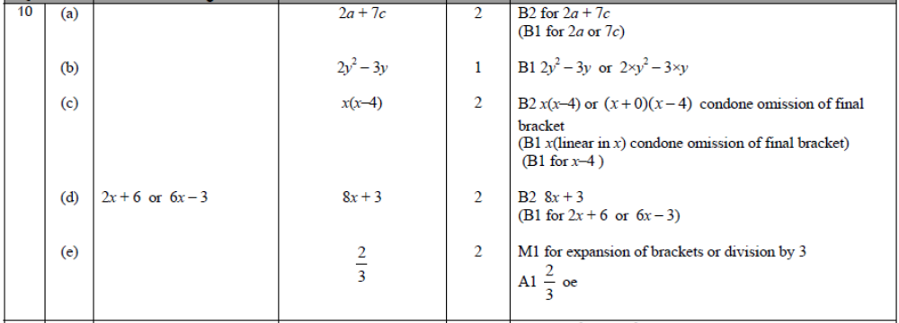

11 |  |  | 900 | 4 | M1 for 0.2 × 7000 (=1400) or 1.2 × 7000 (=8400) oe  M1 for 7000 + "1400" − 3000 (=5400) oe  M1 for "5400" ÷ 6  A1 cao

12 |  |  | 240 | 4 | M1 for 16 × 2 (= 32 girls)  M1 for 16 + ‘16 × 2’ (= 48)  M1 (dep on the previous M1) for (16 + ‘32’ )× 5 or  (16 + ‘32’) × (4 + 1)  A1 cao

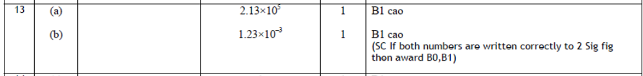

14 |  | 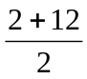, 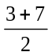 | 7, 5 | 2 | M1 for 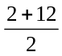 oe or oe (may be implied by one correct co-ordinate)  A1 cao

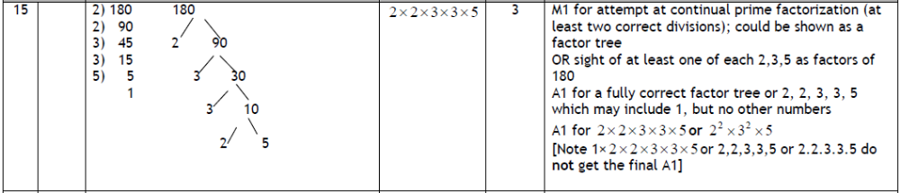

16 | (a) |  | m⁻¹⁰ | 1 | B1 for m^{–10} or 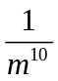
 | (b) |  | (x + 5)(x – 2) | 2 | M1 for (x ± 5)(x ± 2) or  x(x – 2) + 5(x – 2) or x(x + 5) – 2(x + 5)  A1

17 | (a) |  | 1 | 1 | B1 cao
 | (b) |  | 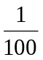 | 1 | B1 for or 0.01
 | (c) |  | 0.00273  27.3 × 10 ^{–3}  2.73 × 10³  273 × 10² | 2 | M1 for converting all numbers to same form with at least one conversion correct  A1 for fully correct order with correct numbers in any correct form  (SC B1 if one number incorrectly placed or all 4 numbers listed in reverse order)

18 | (a) |  | 68 | 1 | B1 cao
 | *(b) |  | Yes  as 28 > 20  or 35% > 25%  or 53 < 60 | 3 | M1 for reading a value from graph at time = 60 (=28, accept 27 to 28)  M1 for ‘28’ ÷ 80 × 100 (= 35) or 25 ÷ 100 × 80 (= 20)  C1 (dep on M2) for correct decision based on their figures
 | (c) | 28, 53, 68, 76, 96 | Box plot plotted | 3 | B1 for ends of whiskers at 28 and 96 with a box  B1 ft for median at ‘68’ inside a box  B1 for ends of box at 53 (accept 52 to 54) and 76

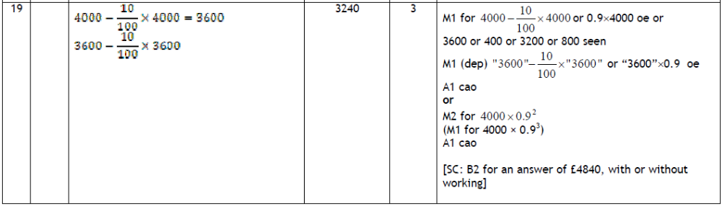

20 |  | 15x + 6y = 33  8x – 6y = 36  23x = 69  5× 3 + 2y = 11 | x = 3  y = – 2 | 4 | M1 for coefficients of x or y the same followed by correct operation (condone one arithmetic error)  A1 cao for first solution  M1 (dep on M1) for correct substitution of found value into one of the equations or appropriate method after starting again (condone one arithmetic error)  A1 cao for second solution

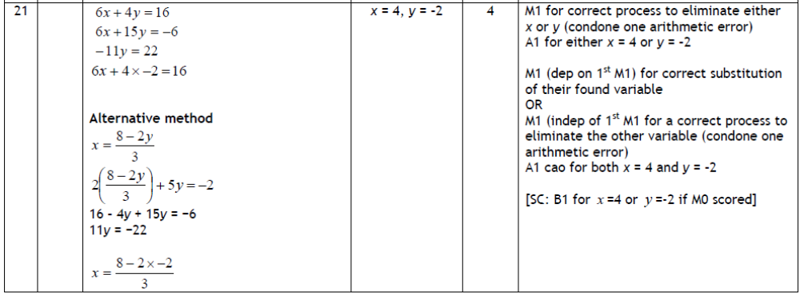

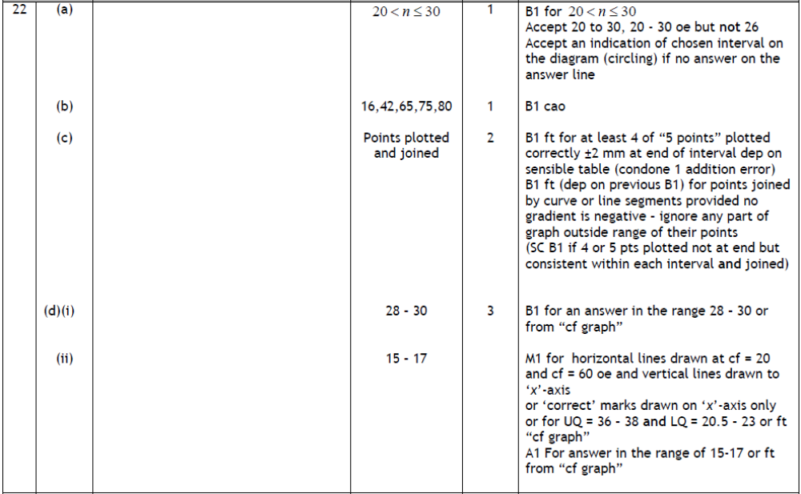

23 | (a) | x² − 3x + 5x − 15 | x² + 2x− 15 | 2 | M1 for four correct terms with or without signs, or 3 out of no more than 4 terms with correct signs. The terms may be in an expression or in a table  A1 cao
 | (b) | (x + 9)(x − 1) = 0  OR  a = 1, b = 8, c = − 9  x = 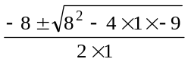  = 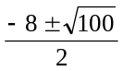 | x = 1 or  x = − 9 | 3 | M2 for (x + 9)(x − 1)  (M1 for (x ± 9)(x ± 1))  A1 cao

24 |  | EE + CC + HH | 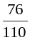 | 5 | M1 for use of 10 as denominator for 2nd probability  M1 for 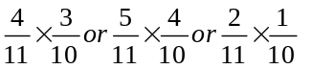  M1 for 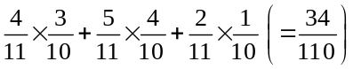  M1 (dep on previous M1 for 1 – ‘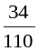’  A1 for oe

25 | (a) |  | 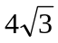 | 2 | M1 for 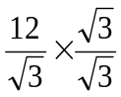  A1 for 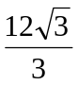 oe with a rational denominator
 | (b) |  | 18 | 2 | M1 for √2×√2 + √2×√8 + √8×√2 + √8×√8 oe  A1 cao  OR  M1 for (√2 + 2√2)²  A1cao

BLANK PAGE

Examiner report: Bronze 2

Question 1
This question was very well understood and very well answered with 83% of candidates gaining all three marks for correctly calculating the amount of every ingredient. 13% of candidates obtained two marks for obtaining the correct value for at least one amount correctly. Candidates found that calculating the weight of the sugar was more difficult than the other quantities. One mark was awarded for candidates that attempted to find the amount for 1 flapjack or for attempting to use the ratio 2 : 3 and 1% of candidates were able to show this. Only 3% of candidates did not gain any marks.

Question 2
This question was well answered with three quarters of candidates gaining full marks. Part (a) was almost always correct with part (b) being well understood, although many candidates wrote ‘negative relationship’, or just ‘negative’, rather than ‘negative correlation’ and so did not score the mark.
Some wrote a correct description, eg ‘the closer to the centre the more expensive the rent’ but then contradicted this by writing ‘positive correlation’ and so failed to score any marks.
In part (c), 1 mark was awarded for drawing an appropriate line of best fit but some candidates, having drawn a line of best fit, misread the scales and so lost the accuracy mark.

Question 3
Parts (a) and (b) were well understood and generally completed correctly. The most common error in (b) was to assume that, for example, both (7, 4) and (4, 7) were possible pairs. Students were slightly less successful in the final part of the question but the majority were able to obtain full marks. It was, however, encouraging to see very few instances of incorrect notation (such as 3 out of 20) for the answer to part (c).

Question 4
This question was generally well answered with the majority of candidates obtaining at least 3 marks for their responses. Nearly all candidates were able to expand 3(2 + t) in part (a) of the question. In part (b) nearly all candidates scored at least one of the two marks with most candidates giving a fully correct answer. Commonly seen incorrect answers included 6x² + 15 and 6x + 15x, sometimes simplified to 21x. Part (c) was also answered well with most candidates being awarded 2 marks though a common error was to write 13 as the constant term. Some candidates lost marks by making errors in trying to simplify m² + 10m + 3m + 30.

Question 5
Most candidates were able to rotate the given shape although not always about the given point and sometimes through 90º, either in a clockwise or anticlockwise direction, instead of 180º. A few candidates made the mistake of reflecting the given shape, usually in the x – axis. Candidates have access to tracing paper for this question; those who struggle to locate the image correctly would be well advised to take advantage of it.

Question 6
A number of students failed to pick up on the word ‘estimate’ in the question and therefore wasted time by trying to work out the accurate answer. Students should be encouraged to round all numbers to 1 significant figure when working out estimates.

Question 7
This question was generally answered very well. Candidates usually attempted it by listing multiples of 12 and multiples of 20. Arithmetic mistakes were surprisingly common and some candidates miscounted the multiples or transposed the two answers.

Some wrote the common multiple, not the number of boxes of each required, on the answer lines in part (i). Relatively few candidates expressed 12 and 20 as a product of prime factors although those that attempted this method were often successful.

Part (ii) was usually answered correctly, although some candidates did double their LCM to 120 and some halved it to 30.

Question 8
Very many candidates were able to get full marks on this question. Many others were able to score at least 1 mark – either by a suitable straight line at the right distance from the given shaded region or from the arc of a circle drawn correctly. Some candidates lost a mark because they did not draw a complete arc that met the rectangle.

Question 9
This question was generally very well done. Some candidates did, however, assume that the triangle had a right angle and so gave an incorrect answer of 135º for their answer. Reasons were, on the whole, appropriately given although a very few candidates persist in writing out their working rather than giving a reason.

Question 10
Part (a) was well answered with few errors. Candidates were less successful on (b) where too many candidates could not work out 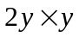 and gave an answer of 3y. Part (c) was generally well answered although some candidates thought that the answer should be 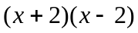. In part (d), most candidates were able to expand the brackets correctly but then could not go on to simplify the resulting 4 term expression. Answers of 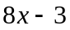 or 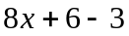 were commonly seen. Attempts at part (e) were disappointing. The main errors came from those candidate who subtracted 2 from both sides without expanding the brackets and from those who got as far as 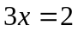 but then could not take the next step to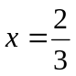. Some tried to fall back on trial and improvement but got nowhere.

Question 11
This question was done quite well. Many students were able to work out the monthly payments for the caravan. A significant number of students were unable to calculate 20% of 7000. A common incorrect answer here was “10% = 70, (so) 20% = 140”. Students should be advised to show all the stages in calculations of percentages, eg by stating 10% of 7000 = 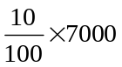 etc, rather than simply stating the results of calculations they may do incorrectly their heads. Most of those students who were able to reach the total payment £5400 were then able to divide this by 6 correctly for the final answer, but relatively simple errors in arithmetic were not uncommon, e.g. 8400 – 3000 evaluated as 4700.

Question 12
This question on simple ratio was often misunderstood. Candidates who understood that a ratio of 1:2 meant that you had to double 16 often went on to give a fully correct solution but those who halved the 16 failed to score any marks.

Many candidates only multiplied by 4, mistaking the number of schools, and a significant number divided the 16 boys by 3, the total of the ratio components. Despite this, about half the candidates did score full marks, with a smaller number gaining 3 marks for understanding what they had to do with the correct number of boys and girls.

Question 13
Many candidates did not know what standard form was. Near misses included 213×10³ and 1.2×10^{–3} missing out one of the figures.

Question 14
It was pleasing to see many candidates showing their working for this question whether it was using the diagram, writing out a list of numbers or using a remembered method to work out the mid point. Common errors included errors in arithmetic, finding the mean of the coordinate pairs and subtracting the corresponding values of x and y. A small minority of candidates transposed the coordinates and so gave their answer as (5, 7) rather than (7, 5).

Question 15
The factor tree method was the most popular method employed here. Often this was carried out accurately although an alarming number of simple arithmetic errors prevented many candidates scoring more than one mark. Many began working with 180 = 2 x 60. A great number of candidates demonstrated their lack of understanding of the word ‘product’ and simply listed the five prime factors of 180 or as a sum 2 + 2 + 3 + 3 + 5. Candidates who included the number ‘1’ in their product failed to gain full marks. Some mistook 9 as prime giving 2 x 2 x 5 x 9.

Question 16
In part (a) the common error was to add or subtract rather than multiply the indices. Those candidates who knew how to factorise a quadratic expression generally gained both available marks in part (b) although (x – 5)(x + 2) was frequently seen as an answer. A popular error was to factorise the first two terms to x(x + 3) – 10.

Question 17
Parts (a) and (b) were essentially knowledge based For part (b) a few candidates left their answer as 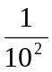. This was not awarded the mark.

For part (c), candidates were expected to adopt one of two strategies. The first was to reduce each of the given numbers to an ordinary number and them compare sizes. If a candidate did the conversion correctly for at least 1 number, they were awarded the method mark. The second strategy, much more rarely seen, was to write each number in standard form. If a conversion was done correctly for at least one number then the method mark was awarded. Many candidates, however, did not show what they had done and went straight to writing down the 4 given numbers.

Question 18
In part (a) many candidates correctly read the value of the median from the cumulative frequency graph. Incorrect answers were usually due to misreading the scale. Both 64 and 69 were common wrong answers.

Most candidates gained at least one mark in part (b) with many giving fully correct answers. The most common approach was to read from the graph at 60 seconds (28) and compare this with 25% of 80 (20). Some candidates worked out 25% of 80 but failed to obtain a comparative statistic. Sometimes candidates stated ‘yes’ without providing sufficient evidence to show why.

Part (c) was attempted by the majority of candidates and most were able to produce a box and whisker diagram and show an understanding of the five measures required, even if they failed to read the scales correctly. Most errors were made with the two quartiles.

Question 19
A large number of candidates were able to find the correct value of the car after one year by subtracting £400 (10% of £4000) from the initial cost, but then assumed that the depreciation was the same amount each year and offered an answer of £3200. This gained one mark only. A significant number of candidates were clearly unable to find 10% of £4000, often giving an answer of £40. Unless this was a result of an arithmetic error as opposed to a conceptual error no credit was given. Some candidates misinterpreted depreciation as appreciation and answers of £4840 were not uncommon.

Question 20
Candidates who have had experience of solving simultaneous equations were generally able to show evidence of using a correct method although this was frequently spoilt by arithmetic errors either in the initial multiplication or in the addition or subtraction of the multiplied equations particularly where negative numbers were involved. In order to gain any marks in questions of this type, candidates must show a complete method including using the correct operation to eliminate one of the variables with a maximum of one arithmetic error. Trial and error was frequently seen; this approach scored no marks unless correct values were given, as a final answer, for both variables.

Question 21
Many candidates showed an understanding of the method of solving a pair of simultaneous equations but only a few were able to carry out the algebraic manipulation without error. The most common errors were in the subtraction of one equation from another, usually adding the right hand sides of the equations, eg 16 and –6 and/or 40 and –4, instead of subtracting. Incorrect values of x or y were then often correctly substituted into one of the equations in an effort to find the second unknown, gaining some credit. A small number of candidates tried methods of substitution, but these usually led to algebraic errors preventing correct solutions. A few candidates were successful employing ‘trial and error’ methods, but this is not to be encouraged. This question showed up the weakness of algebra skills in many of the candidates. Most realised that the simplest method is to equate coefficients by multiplying first, but after that had no idea whether to add or subtract. This topic seems to be taught by recipe with the students not really understanding what they are doing.

Question 22
In part (a), most candidates correctly quoted the modal class interval; although a significant number offered 30 < n ≤ 40 or 0 < n ≤ 20 or simply 26 as their answer. Accurate completion of the cumulative frequency table was the norm in part (b) but the drawing of the graph was less good in part (c). Many candidates plotted their points at mid interval values, some at beginning of the intervals and a significant number used the middle value of the cumulative frequency intervals. In part (d), the median was often correctly found, but many did not understand ‘interquartile range’ in the second part, often merely quoting the range from the lower quartile to the upper quartile or just giving the value of the lower quartile. It was a concern that a good number of candidates attempted to find the median and quartiles reading values (30, 15, 45) initially from the Delay axis.

Question 23
The most common errors in part (a) were failure to simplify the terms in x correctly and to give + 15 rather than –15 as the last term in the expanded expression. Even candidates who obtained the correct 4 terms would give their final expression incorrectly as x² – 8x – 15 or x² – 2x – 15.

In part (b) those candidates who realised that the best method of solution was to factorise the given expression generally went on to score full marks. However, a significant number of these candidates just gave the factorised equation as their final answer rather than the values of x. Some correct solutions were seen using the formula but, more often than not, the use of the formula did not give the correct solutions due either to incorrect substitution or poor arithmetic.

Question 24
This probability question without replacement was recognised as such by most of the candidates, although a surprising number did give a denominator of 121, showing that they thought one of the sandwiches was replaced before the second one was taken. An answer of 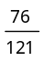 was awarded 2 marks for the work in dealing correctly with the numerator.
If candidates were able to correctly show a denominator of 10 on a tree diagram or use it as part of a second probability then 1 mark was earned and some candidates earned this 1 mark.
A second mark was earned by candidates who could write the probability of one combination of correct probabilities as a product and a further mark was gained if those, or at least three of them, were shown to be added.
The fourth method mark was awarded if all six combinations were added or if they were working from 1 − probability of both of the same types taken. Fully correct answers were given by only a small number of candidates.

Question 25
Part (a) was done correctly by those candidates who understood the standard process of rationalisation. Answers in any correct form, such as 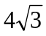 or 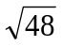were accepted for full marks. If candidates went on to attempt to simply their answer and gave a subsequent incorrect answer then they were not awarded the final A mark.

Some candidates think that they can rationalise the denominator of the fraction by squaring the top and squaring the bottom presumably under a misapprehension that they are dealing with equivalent fractions.

Part (b) required candidates to expand the square – in many cases this proved too much, with many cases of the equivalent of 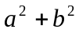. The use of 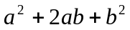 was rarely used even by successful candidates. Some could expand the brackets correctly, but could not see how to simplify their square roots so unsimplified answers such as 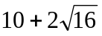 were seen. Many went on to ‘simplify’ wrongly, giving answers such as 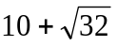.
Practice paper: Bronze 2

 |  |  |  |  |  |  |  | Mean score for students achieving Grade:
Spec | Paper | Session  YYMM | Question | Mean score | Max score | Mean  % | ALL | A* | A | % A | B | C | % C | D | E
1380 | 1H | 1106 | Q01 | 2.75 | 3 | 92 | 2.75 | 2.96 | 2.91 | 97.0 | 2.84 | 2.68 | 89.3 | 2.36 | 1.91
1MA0 | 1H | 1303 | Q02 | 3.57 | 4 | 89 | 3.57 | 3.91 | 3.88 | 97.0 | 3.81 | 3.65 | 91.3 | 3.24 | 2.39
1380 | 1H | 1011 | Q03 | 4.20 | 5 | 84 | 4.20 | 4.89 | 4.73 | 94.6 | 4.49 | 4.11 | 82.2 | 3.56 | 3.02
1MA0 | 1H | 1306 | Q04 | 3.82 | 5 | 76 | 3.82 | 4.96 | 4.91 | 98.2 | 4.64 | 3.72 | 74.4 | 2.33 | 1.01
1380 | 1H | 1006 | Q05 | 1.71 | 2 | 86 | 1.71 | 1.97 | 1.90 | 95.0 | 1.77 | 1.56 | 78.0 | 1.24 | 0.81
1380 | 1H | 1011 | Q06 | 1.42 | 2 | 71 | 1.42 | 1.95 | 1.86 | 93.0 | 1.70 | 1.37 | 68.5 | 0.82 | 0.39
1MA0 | 1H | 1311 | Q07 | 3.50 | 4 | 68 | 3.50 | 3.95 | 3.89 | 97.3 | 3.80 | 3.57 | 89.3 | 3.09 | 2.24
1MA0 | 1H | 1406 | Q08 | 1.93 | 3 | 64 | 1.93 | 2.95 | 2.82 | 94.0 | 2.46 | 1.64 | 54.7 | 0.64 | 0.15
1380 | 1H | 1011 | Q09 | 2.23 | 3 | 74 | 2.23 | 2.95 | 2.82 | 94.0 | 2.60 | 2.17 | 72.3 | 1.40 | 0.73
1380 | 1H | 911 | Q10 | 5.95 | 9 | 66 | 5.95 | 8.75 | 8.37 | 93.0 | 7.28 | 5.14 | 57.1 | 2.98 | 1.68
1MA0 | 1H | 1411 | Q11 | 2.20 | 4 | 55 | 2.20 | 3.84 | 3.71 | 92.8 | 3.48 | 2.74 | 68.5 | 1.56 | 0.45
1MA0 | 1H | 1303 | Q12 | 2.69 | 4 | 67 | 2.69 | 3.88 | 3.70 | 92.5 | 3.40 | 2.71 | 67.8 | 1.60 | 0.61
1380 | 1H | 911 | Q13 | 0.91 | 2 | 46 | 0.91 | 1.93 | 1.73 | 86.5 | 1.22 | 0.52 | 26.0 | 0.15 | 0.07
1380 | 1H | 1011 | Q14 | 1.33 | 2 | 67 | 1.33 | 1.88 | 1.70 | 85.0 | 1.49 | 1.24 | 62.0 | 0.93 | 0.68
1380 | 1H | 1006 | Q15 | 2.09 | 3 | 70 | 2.09 | 2.92 | 2.72 | 90.7 | 2.26 | 1.53 | 51.0 | 0.74 | 0.31
1MA0 | 1H | 1206 | Q16 | 1.48 | 3 | 49 | 1.48 | 2.85 | 2.59 | 86.3 | 1.94 | 0.84 | 28.0 | 0.30 | 0.13
1MA0 | 1H | 1406 | Q17 | 2.51 | 4 | 63 | 2.51 | 3.77 | 3.39 | 84.8 | 2.89 | 2.18 | 54.5 | 1.46 | 0.94
1MA0 | 1H | 1311 | Q18 | 4.07 | 7 | 48 | 4.07 | 6.56 | 6.11 | 87.3 | 5.31 | 3.79 | 54.1 | 1.97 | 0.66
1380 | 1H | 1006 | Q19 | 2.09 | 3 | 70 | 2.09 | 2.90 | 2.65 | 88.3 | 2.20 | 1.59 | 53.0 | 0.96 | 0.58
1MA0 | 1H | 1206 | Q20 | 1.59 | 4 | 40 | 1.59 | 3.88 | 3.29 | 82.3 | 1.99 | 0.59 | 14.8 | 0.10 | 0.04
1380 | 1H | 1006 | Q21 | 1.95 | 4 | 49 | 1.95 | 3.92 | 3.38 | 84.5 | 1.90 | 0.63 | 15.8 | 0.18 | 0.07
1380 | 1H | 1006 | Q22 | 4.13 | 7 | 59 | 4.13 | 6.73 | 5.87 | 83.9 | 4.24 | 2.53 | 36.1 | 1.24 | 0.51
1380 | 1H | 1011 | Q23 | 1.82 | 5 | 36 | 1.82 | 4.62 | 3.60 | 72.0 | 2.22 | 1.07 | 21.4 | 0.43 | 0.17
1MA0 | 1H | 1303 | Q24 | 0.79 | 5 | 16 | 0.79 | 4.43 | 2.96 | 59.2 | 1.10 | 0.22 | 4.4 | 0.04 | 0.01
1MA0 | 1H | 1406 | Q25 | 0.87 | 4 | 22 | 0.87 | 3.41 | 2.29 | 57.3 | 0.89 | 0.17 | 4.3 | 0.03 | 0.01
 |  |  |  | 61.60 | 101 | 61 | 61.60 | 96.76 | 87.78 | 86.91 | 71.92 | 51.96 | 51.45 | 33.35 | 19.57

