Practice Paper 2
May 2016
Higher Tier
Edexcel Style

Mark Scheme

Commissioned by The PiXL Club Ltd.

1 | 0.13 | 2 | M1 for 1 – 0.34 – 0.53  A1
2 | 2.03094(6823) | 2 | B2 for 2.03094 or better  B1 for 20.62 or 10.1529 seen
3 | 2 3 7 8  3 1 4 5 6  4 1 2 4 5 5  5 0 2 3  Key eg 2/3 represents 23 years | 3 | M1 for stem  A1 ordered stem and leaf diagram  A1 for key
4 | -9 | 2 | M1 for 2x3+3x-5  A1 cao
5 | 3, 10, 29 | 2 | M1 for  1³ +2  2³+2  3³+2  A1
6a | Negative | 1 | B1
6b | 110-116 | 2 | M1 for line of best fit  A1
7 | Straight line from (-2,-7) to (3,3) | 4 | (Table of values)  C1 for axes scaled and labelled  M1 for at least 2 correct attempts to find points by substituting values of x  M1 ft for plotting at least 2 of their points (any points plotted from their table must be plotted correctly)  A1 for correct line between x = −2 and x = 3  (No table of values)  C1 for axes scaled and labelled  M1 for at least 2 correct points with no more than 2 incorrect points  M1 for at least 2 correct points (and no incorrect points) plotted OR line segment of y = 2x – 3 drawn  A1 for correct line between x = −2 and x = 3  (Use of y = mx+c)  C1 for axes scaled and labelled  M1 for line drawn with gradient of 2 OR line drawn with a y intercept of –3  M1 for line drawn with gradient of 2 AND with a y intercept of –3  A1 for correct line between x = −2 and x = 3  SC : B2 for the correct line from x = 0 to x = 3
8(i) | 35 | 1 | B1
8(ii) | Corresponding angles are equal | 1 | B1
9 | Large box with reasons | 3 | M2 for attempt to convert each box into a unitary comparison of some sort.  (2.69/350 = 0.76… and 4.39/750 = 0.58..)  A1 www
10a | 4:3 | 2 | M1  A1
10b | 40 | 2 | M1  A1
11 | 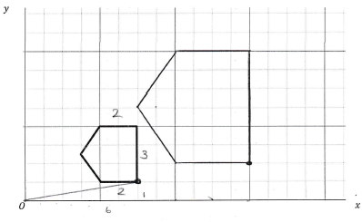 | 3 | B3 for correct enlargement in correct position  B2 for enlargement in incorrect position  B1 for three lines enlarged by sc 2 or enlargement not from 0, different scale factor
12 | 2.5 | 4 | B2 for trial between 2.5 and 2.6  B1 for trial between 2 and 3  B1 for different trial between 2.5 and 2.55  Values evaluated can be rounded or truncated  B1 for 2.5
13a | 450 m | 2 | M1 for mult. by 25000  A1 cao
13b | 20 cm | 2 | M1 for dividing by 25000  A1 cao
14a | 10 x + 7 | 2 | M1 for adding terms  A1
14b | 3.5 | 2 | M1 for putting perimeter = 42  A1
15 | 1464/80  18.3 | 4 | M1 for fx consistently within interval incluing ends( allow one error)  M1(dep) consistently using appropriate midpoints  M1 ( dep on first M) for total fx/ total f  A1 for answer within bounds
16 | 973 1/3 | 2 | M1 8760/9  A1 allow 973.3 oe
17 | y² -3y - 54 | 2 | M1 for 3 of the 4 terms from expanding brackets correct  A1
18 | 10.82 | 3 | M1 for squaring and adding  M1 for square rooting  A1
19a | 25,61,81,95,100 | 1 | B1
19b | Points plotted  Joined | 2 | B1  B1 can be joined with straight lines or curve
19c | 36-38 | 1 | B1
19d | 27-30 | 2 | M1  A1
20a | £2652.25 | 3 | M1 2500 x 1.03 ( 2575)  M1 ‘25750 x 1.03  A1 cao  Accept alternative methods
20b | 4 | 2 | M1 for an attempt to evaluate 3500 x 1.065^{n} for at least one value of n- not equal to 1 or 4502.63/ 1.065^{n}  A1 cao
21a | 38.9-38.95 | 3 | M1 for cos x = 7/9  M1 for using inverse cos  A1
21b | 9.2-9.4 ( 9.2829….) | 3 | M1 for tan 35 = 6/y  M1 12.5 x tan 35  A1
22a | 8 | 2 | M1  A1 cao
22b | 25 | 2 | M1  A1 cao
23 | 48 | 4 | M1 for ratio of area 32/200 oe  M1 for ratio of volume (0.4 ³) oe  M1 for 750 x ‘0.4³’)  A1 cao
24 | 20n with correct comment | 3 | M1 for correct expansion of either bracket  A1 for 20 n from correct expansion of both brackets  A1 for 20 n is a multiple of 2  NB Trial using different values for n score no marks.
25a | 41.8 | 2 | M1 for 0.5 x 7.8 x 12.5 x sin59  A1 for 41.7-41.8
25b | 10.8 | 3 | M1 use of cosine rule  M1 for correct order of evaluation  A1 for 10.8
26 | 1.05 as the LB and UB agree to that no of sig fig | 5 | B1 for either 8.235 or 8.225  B1 for 7.5135 or 7.5145  M1 for correct division for UB OR LB  A1 for 1.046913154.. and 1.046207692  A1 for 1.05 and both UB and LB round to 1.05 oe
27 | x = 8, y = -4  x =4, y = 8 | 5 | M1 for substituting y =20 - 3x  M1 for expanding (20-3x)² eg 400 – 60x – 60x + 9x (3 out of 4 terms correct).  A1 for 10x² - 120x + 400 = 80 oe  M1 for a correct attempt to solve the quadratic equation (10x² - 120x + 320 or x² - 12x + 32) eg by factorising or correct substitution into the quadratic formula.  A1 for x = 8, y = -4 and x =4, y = 8
28a | Sketch  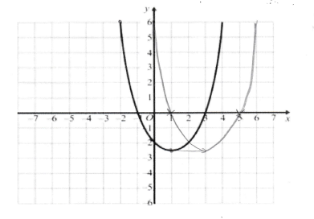 | 2 | M1 for horizontal translation with at least three of the points ( (-1,0) (1, -2.5) ,(3,0) translated by the same amount.  A1 for a curve through the points (0,6) (1,0) (3,-2.5) (5,0)(6,6) +/- ½ square
28b | Sketch  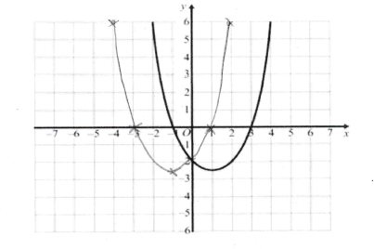 | 2 | M1 for a reflection in the y-axis through  A1 for a curve through the points  (-4,6) ( -1, -2.5) (0,-2) ( 1,0) ( 2,6)  +/- ½ square

