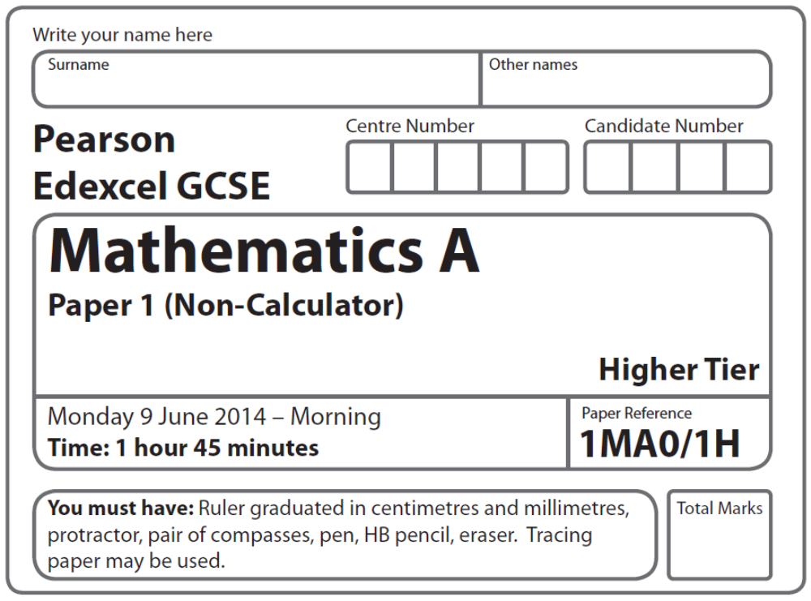
Practice Paper – Silver 3
Silver: 3 of 4

Instructions
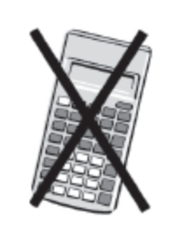
- Use black ink or ball-point pen.
- Fill in the boxes at the top of this page with your name,
centre number and candidate number.
- Answer all questions.
- Answer the questions in the spaces provided
– there may be more space than you need.
- Calculators must not be used.

Information
- The total mark for this paper is 102
- The marks for each question are shown in brackets
– use this as a guide as to how much time to spend on each question.
- Questions labelled with an asterisk (*) are ones where the quality of your
written communication will be assessed.

Advice
- Read each question carefully before you start to answer it.
- Keep an eye on the time.
- Try to answer every question.
- Check your answers if you have time at the end.

Suggested Grade Boundaries (for guidance only)
A* | A | B | C | D
98 | 82 | 62 | 44 | 28
GCSE Mathematics 1MA0

Formulae: Higher Tier

You must not write on this formulae page.
Anything you write on this formulae page will gain NO credit.

Volume of prism = area of cross section × length Area of trapezium = (a + b)h
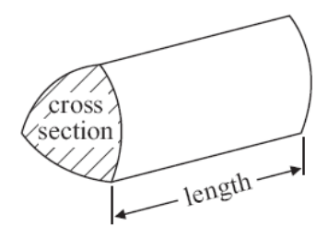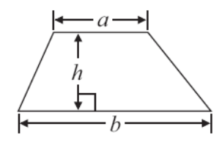

Volume of sphere πr³ Volume of cone πr²h
Surface area of sphere = 4πr² Curved surface area of cone = πrl

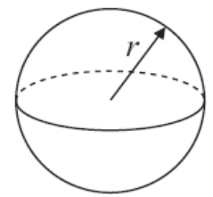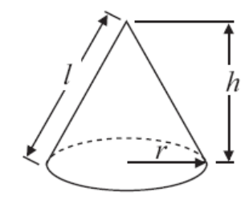

In any triangle ABC The Quadratic Equation
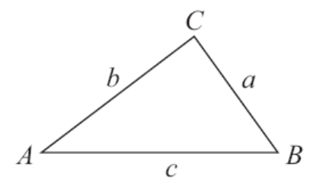
The solutions of ax²+ bx + c = 0
where a ≠ 0, are given by

x = 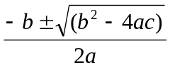

Sine Rule 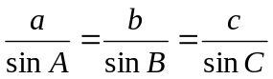

Cosine Rule a² = b²+ c²– 2bc cos A

Area of triangle = ab sin C
Answer ALL questions.
Write your answers in the spaces provided.
You must write down all stages in your working.
You must NOT use a calculator.

1. Theo earns £20 one weekend.
He gives £4 to his brother.

(a) Express £4 as a fraction of £20
Give your answer in its simplest form.

.....................................
(2)

Theo gives £6 to his mother.

(b) Express £6 as a percentage of £20

................................. %
(2)

Theo spent the remaining £10 on bus fares and food.
He spent £1.50 more on bus fares than on food.

(c) How much did he spend on bus fares?

£ ..................................
(2)
(Total 6 marks)
___________________________________________________________________________
2. Mr Mason asks 240 Year 11 students what they want to do next year.

15% of the students want to go to college.
 of the students want to stay at school.
The rest of the students do not know.

Work out the number of students who do not know.

..........................................
(Total 4 marks)
___________________________________________________________________________
3. Here are the heights, in cm, of 18 children.

98 | 90 | 84 | 102 | 115 | 91
88 | 91 | 108 | 110 | 97 | 93
90 | 89 | 103 | 95 | 92 | 106

Show this information in an ordered stem and leaf diagram.

(Total for Question 3 is 3 marks)
___________________________________________________________________________
4. Work out an estimate for 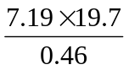.

.....................................
(Total 3 marks)
___________________________________________________________________________

5. Write 525 as a product of its prime factors.

..........................................
(Total 3 marks)
___________________________________________________________________________

6. You can use this conversion graph to change between pounds (£) and dollars ($).

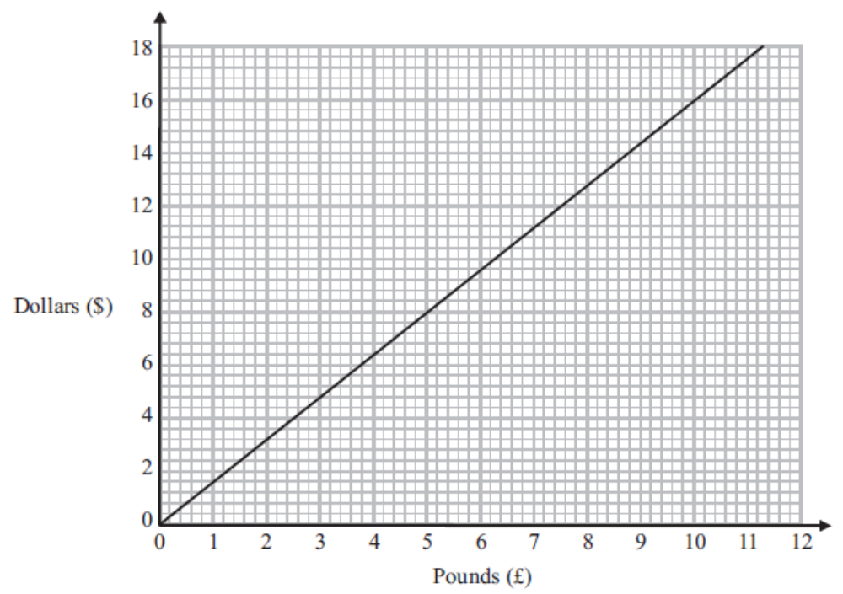

(a) Use the conversion graph to change £5 to dollars.

$ ....................................
(1)

Ella has $200 and £800
Her hotel bill is $600

Ella pays the bill with the $200 and some of the pounds.

(b) Use the conversion graph to work out how many pounds she has left.

£ ....................................
(4)
(Total 5 marks)
___________________________________________________________________________
7. Here is a diagram of Jim’s garden.

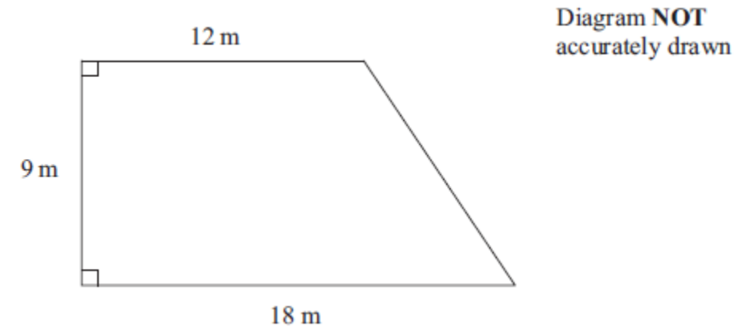

Jim wants to cover his garden with grass seed to make a lawn.

Grass seed is sold in bags.
There is enough grass seed in each bag to cover 20 m² of garden.

Each bag of grass seed costs £4.99

Work out the least cost of putting grass seed on Jim’s garden.

£ .........................................................
(Total 4 marks)
___________________________________________________________________________
8. Sophie wants to find out the amount of time people exercise.
She will use a questionnaire.

(a) Design a suitable question for Sophie to use in her questionnaire.
You must include some response boxes.

(2)

Sophie asks the people at her swimming pool to complete her questionnaire.
This may not be a suitable sample.

(b) Give a reason why.

...............................................................................................................................................

...............................................................................................................................................
(1)
(Total 3 marks)
___________________________________________________________________________
9.
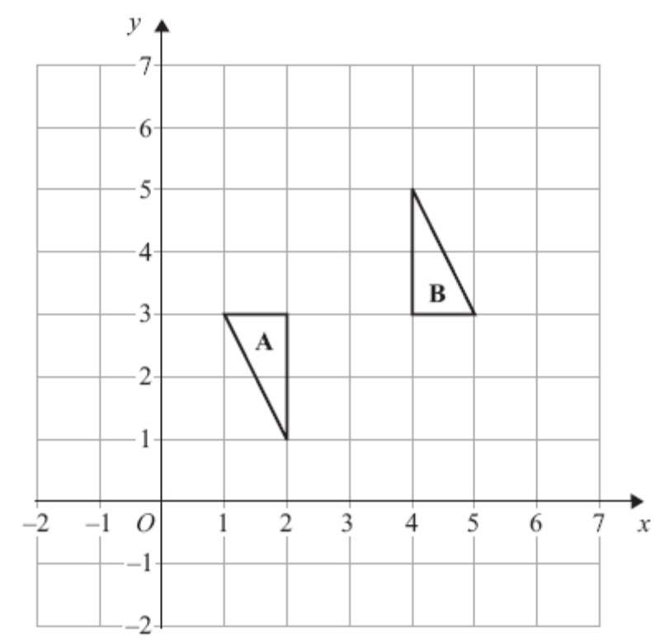

Describe fully the single transformation that maps triangle A onto triangle B.

......................................................................................................................................................

......................................................................................................................................................
(Total for Question 9 is 3 marks)
___________________________________________________________________________
*10 Railtickets and Cheaptrains are two websites selling train tickets.

Each of the websites adds a credit card charge and a booking fee to the ticket price.

Railtickets  Credit card charge: 2.25% of ticket price  Booking fee: 80 pence |  | Cheaptrains  Credit card charge: 1.5% of ticket price  Booking fee: £1.90

Nadia wants to buy a train ticket.
The ticket price is £60 on each website.
Nadia will pay by credit card.

Will it be cheaper for Nadia to buy the train ticket from Railtickets or from Cheaptrains?

(Total for Question 10 is 4 marks)
___________________________________________________________________________
11.
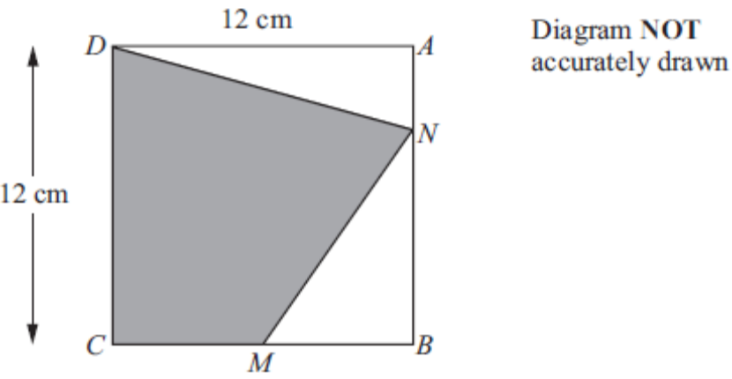

ABCD is a square of side 12 cm.
M is the midpoint of CB.
N is a point on AB.

AN = AB.

Calculate the area of the shaded region CDNM.

.................................... cm²
(Total 6 marks)
___________________________________________________________________________
12. On the grid, draw the graph of y = 3x + 2 for values of x from –2 to 2.

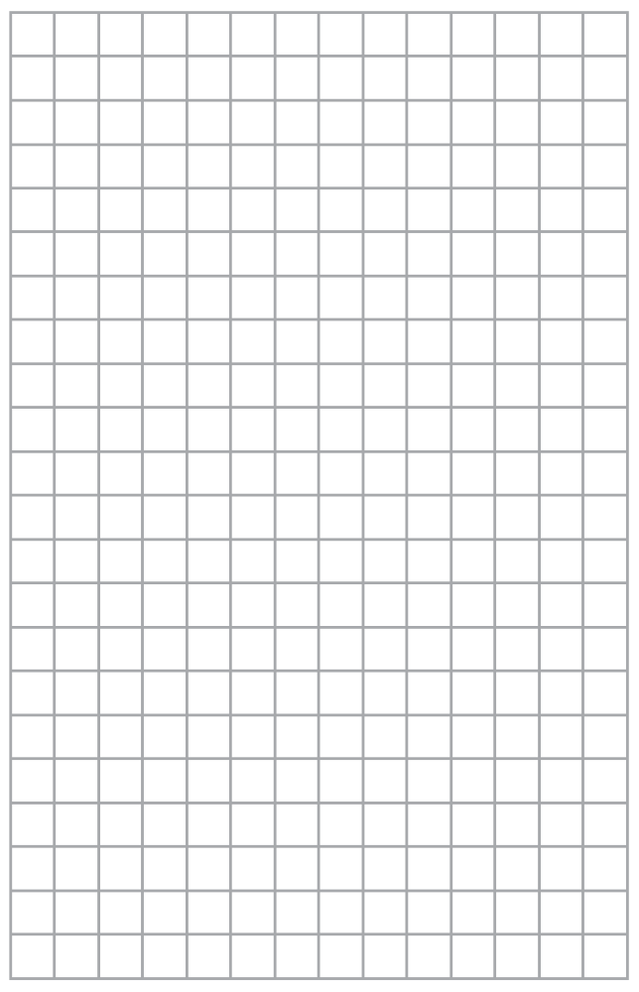

(Total 4 marks)
___________________________________________________________________________
13.
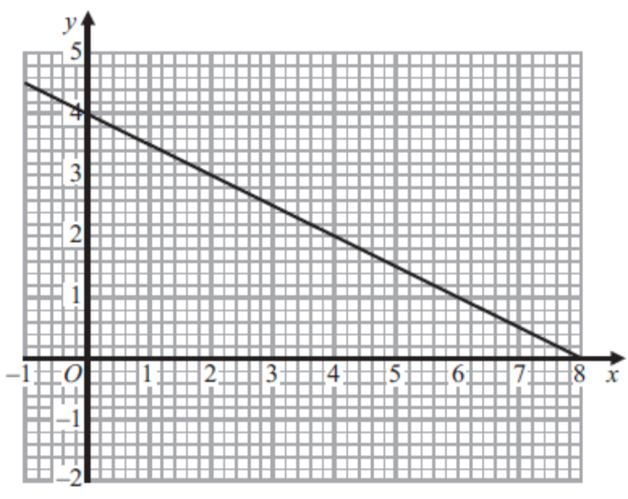

The graph of the straight line x + 2y = 8 is shown on the grid.

(a) On the grid, draw the graph of y = 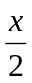 − 1

(3)

(b) Use the graphs to find estimates for the solution of

x + 2y = 8

y = − 1

x = ................... y = ..................
(1)
(Total 4 marks)
___________________________________________________________________________
14. (a) Write down the reciprocal of 5.

..........................................
(1)
(b) Evaluate 3^{–2}.

..........................................
(1)
(c) Calculate 9 × 10⁴ × 3 × 10³.
Give your answer in standard form.

....................................................................
(2)
(Total 4 marks)
___________________________________________________________________________
15. A garage keeps records of the costs of repairs to customers’ cars.

The table gives information about these costs for one month.

Cost (£C) | Frequency
0 < C ≤ 200 | 7
200 < C ≤ 400 | 11
400 < C ≤ 600 | 9
600 < C ≤ 800 | 10
800 < C ≤ 1000 | 8
1000 < C ≤ 1200 | 5

(a) Write down the modal class interval.
.....................................
(1)

(b) Complete the cumulative frequency table.

Cost (£C) | Frequency
0 < C ≤ 200 | 7
0 < C ≤ 400 | 11
0 < C ≤ 600 | 9
0 < C ≤ 800 | 10
0 < C ≤ 1000 | 8
0 < C ≤ 1200 | 5

(1)

(c) On the grid, draw a cumulative frequency diagram for your table.
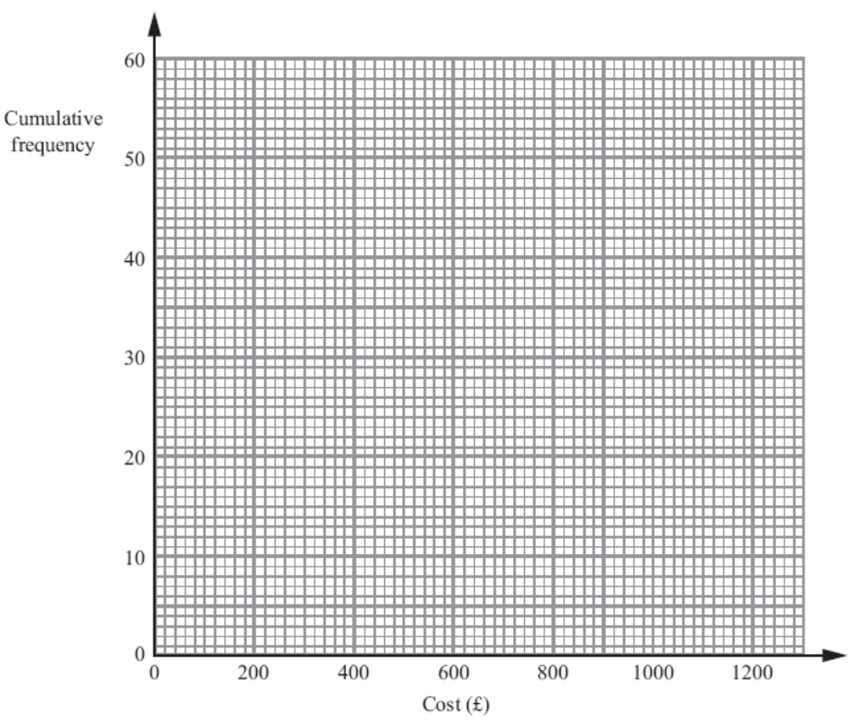
(2)

(d) Use the graph to find an estimate for the number of repairs which cost more than £700.

.....................................
(2)
(Total 6 marks)
___________________________________________________________________________
16. 16. The normal price of a television is reduced by 30% in a sale.

The sale price of the television is £350

Work out the normal price of the television.

£..............................................
(Total for 3 marks)
___________________________________________________________________________
17.

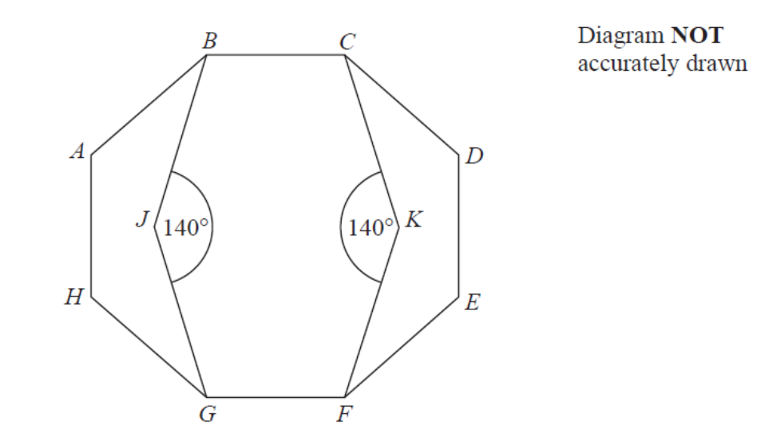

ABCDEFGH is a regular octagon.
BCKFGJ is a hexagon.

JK is a line of symmetry of the hexagon.
Angle BJG = angle CKF = 140°

Work out the size of angle KFE.
You must show all your working.

..........................................°

(Total 4 marks)
___________________________________________________________________________
18.
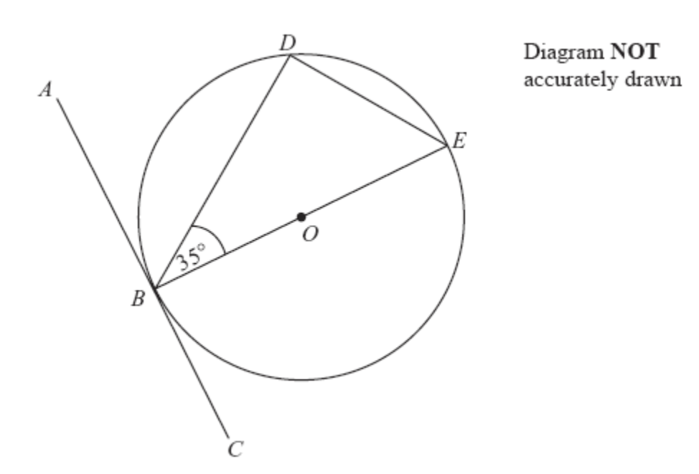

B, D and E are points on a circle centre O.
ABC is a tangent to the circle.
BE is a diameter of the circle.
Angle DBE = 35°.

(a) Find the size of angle ABD.

Give a reason for your answer.

............................ °
(2)

(b) Find the size of angle DEB.

Give a reason for your answer.

............................ °
(2)
(Total 4 marks)

19. Solve the simultaneous equations

4x + y =10
2x – 3y =19

x = ...............................

y = ...............................
(Total 3 marks)
___________________________________________________________________________
20. (a) Solve 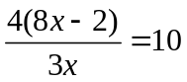

..............................................
(3)
(b) Write as a single fraction in its simplest form

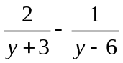

...........................................................................
(3)
(Total 6 marks)
___________________________________________________________________________
21. Solve the simultaneous equations

6x + 2y = −3
4x − 3y = 11

x = ..........................., y = ..........................
(Total 4 marks)
___________________________________________________________________________
*22.

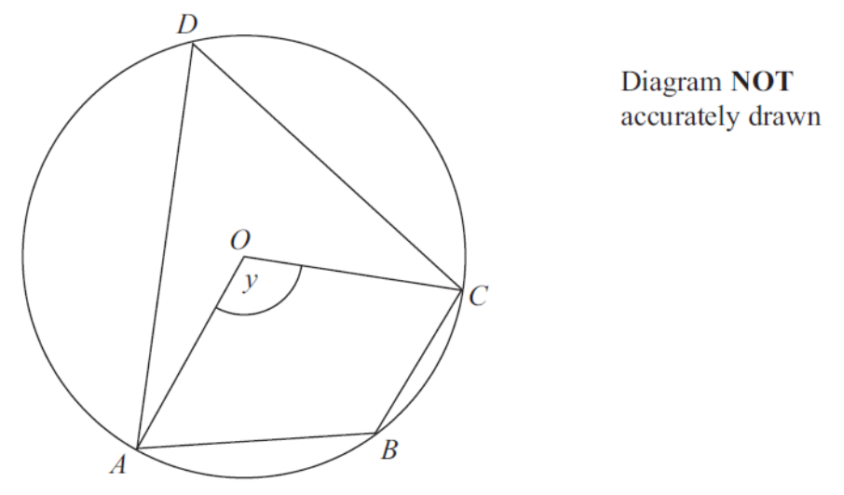

A, B, C and D are points on the circumference of a circle, centre O.

Angle AOC = y.

Find the size of angle ABC in terms of y.
Give a reason for each stage of your working.

(Total 4 marks)
___________________________________________________________________________
23. (a) Simplify fully 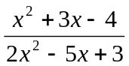

..............................................
(3)

(b) Write 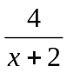 + 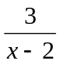 as a single fraction in its simplest form.

..........................................................................
(3)
(Total for Question 23 is 6 marks)
___________________________________________________________________________
24. OACB is a parallelogram.

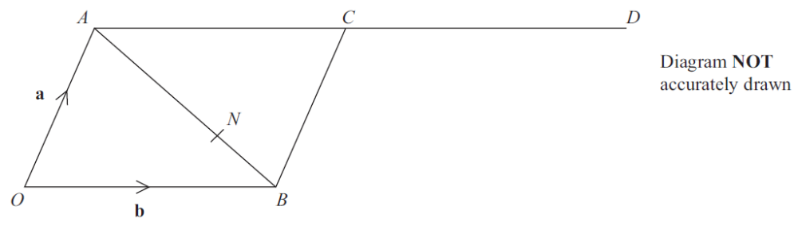

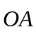 = a and 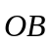 = b.
D is the point such that 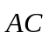 = .
The point N divides AB in the ratio 2 : 1.

(a) Write an expression for 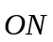 in terms of a and b.

..............................................
(3)
*(b) Prove that OND is a straight line.

(3)
(Total 6 marks)

TOTAL FOR PAPER IS 102 MARKS
1 | (a) | 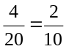 |  | 2 | M1 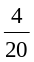 oe  A1 cao  [SC: B1 fo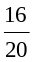 if M0 scored ]
 | (b) | 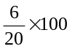  or  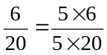 | 30 | 2 | M1  A1 cao  or  M1 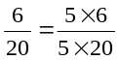  A1 cao
 | (c) | 10 – 1.50 = 8.50  8.50 ÷2 = 4.25  or  10 ÷ 2 = 5  1.50 ÷ 2 = 0.75 | 5.75 | 2 | M1 10 – 1.50 (= 8.50) and ‘8.50’ ÷ 2 (= 4.25)  or 10 + 1.50 (=11.50) and ’11.50’ ÷ 2  or 10 ÷ 2 and 1.50 ÷ 2  or 2x ± 1.5(0) = 10 oe  A1 cao

2 |  |  | 24 | 4 | M1 for 0.15 × 240 ( = 36) oe  M1 for × 240 ( = 180) oe  M1 (dep on both prev M1) for 240 – “180” – “36”  A1 cao

3 |  | 8│4 represents 84(cm) | correct stem and leaf with key | 3 | B2 for a fully correct ordered diagram  (B1 for a correct unordered diagram or ordered with at most two errors or omissions with stems 8, 9, 10 and 11 present)  B1 for a correct key (units not necessary)  Accept stem written as 80, 90, etc. but key only if consistent with this
  8 | 4 8 9
  9 | 0 0 1 1 2 3 5 7 8
  10 | 2 3 6 8
  11 | 0 5

4 |  | 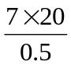 | 280 | 3 | M1 for any two of 7, 20 and 0.5 seen or 140 or 40 or 14  M1 for 14 × 20 or 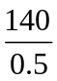 or 7 × 40 or7.2 × 40 or 144 ÷ 0.5 or 140 × 2  A1 for 280 – 300

5 |  | 5|525  5|105  3|21  7 | 3 × 5 × 5 × 7 | 3 | M1 for continual prime factorisation (at least first 2 steps correct) or first two stages of a factor tree correct  M1 for fully correct factor tree or list 3, 5, 5, 7  A1 3 × 5 × 5 × 7 or 3 × 52 × 7

6 | (a) |  | 8 | 1 | B1 for 8 (.00)
 | (b) |  | 550 | 4 | M1 for 600 – 200 ( = 400)  M1 for correct method to convert ‘$400’ to £  M1 (dep on the previous M1) for 800 – ‘$400’ in £s  A1 for value in the range 540 –560

7 |  | 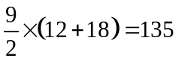  135 ÷ 20 = 6.75 (=7 bags)  7 × 4.99 | 34.93 | 4 | M1 for 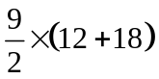 or 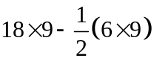  or 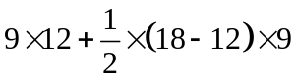 or 135 seen  M1 (dep) for ‘135’÷ 20 or 6 or 7 seen  M1 (dep on previous M1) for ‘6’ × 4.99 or ‘7’ × 4.99  A1 cao

8 | (a) |  | Question + response boxes | 2 | B1 for an appropriate question with a specific time frame e.g. each day  B1 for at least 3 non-overlapping boxes. Do not accept inequalities  N.B. Do not accept frequency tables or data collection sheets
 | (b) |  | e.g. biased (sample) | 1 | B1 for a correct reason, e.g. biased (sample) or more likely to exercise more oe

9 |  |  | Rotation  180°  Centre (3, 3)  or  Enlargement  Scale factor -1  Centre (3, 3) | 3 | B1 for rotation  B1 for 180°  B1 for (3, 3)  OR  B1 for enlargement  B1 for scale factor -1  B1 for (3, 3)  B0 for a combination of transformations

10 |  | 2.25 × 60 ÷ 100 = 1.35  1.35 + 0.80 = 2.15  1.5 × 60 ÷ 100 = 0.90  0.90 + 1.90 = 2.80 | Railtickets with correct calculations | 4 | NB. All work may be done in pence throughout  M1 for correct method to find credit card charge for one company  eg. 0.0225 × 60(=1.35) oe or 0.015 × 60 (=0.9) oe  M1 (dep) for correct method to find total additional charge or total price for one company  eg. 0.0225×60 + 0.80 or 0.015×60 + 1.90 or  2.15 or 2.8(0) or 62.15 or 62.8(0)  A1 for 2.15 and 2.8(0) or 62.15 and 62.8(0)  C1 (dep on M1) for a statement deducing the cheapest company, but figures used for the comparison must also be stated somewhere, and a clear association with the name of each company

11 |  | Area of ABCD = 12 ² = 144  AN = 3 cm  Area of AND = 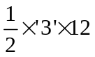 = 18 cm²  MB = 6 cm, NB = 9cm  Area of MBN = 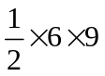 = 27 cm²  Area of shaded region = 144 – 27 – 18 | 99 cm² | 6 | B1 AN = 3 or BN = 9 or CM = 6 or MB = 6  M1 Area of ABCD = 12×12 (= 144)  M1 Area of AND = (=18)  M1 Area of MBN = 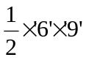 (=27)  M1 (dep on at least 1 previous M1) for (Area of CMND =) ‘144’ – ‘18’ – ‘27’  A1 cao

12 |  |  | y = 3x + 2  drawn | 4 | B1 for axes scaled and labelled  (Table of values)  M1 for at least 2 correct attempts to find points by substituting values of x  M1 ft for plotting at least 2 of their points (any points from their table must be correctly plotted)  A1 for correct line between x = –2 and x = 2
  x | –2 | –1 | 0 | 1 | 2
  y | –4 | –1 | 2 | 5 | 8

13 | (a) | c = -1; m = 0.5 | Correct line | 3 | Use of y = mx + c  M2 for line segment of y = 0.5x – 1 drawn (ignore any additional line segments)  (M1 for line drawn with gradient of 0.5 or line drawn with a y intercept of -1 and a positive gradient)  A1 for correct line between x = 0 and x = 7
  x | 0 | 1 | 2
  y | -1 | -0.5 | 0
 | (b) |  | 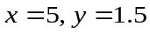 | 1 | B1 ft on pt of intersection if on a straight line segment

14 | (a) |  |  | 1 | B1 oe
 | (b) |  |  | 1 | B1 cao
 | (c) | 9×10⁴×3×10³ | 2.7 × 10⁸ | 2 | M1 27 × 10⁷ oe or 9×3×10⁴⁺³  A1 cao

15 | (a) |  | 200 < C ≤ 400 | 1 | B1 cao
 | (b) |  | 7, 18, 27, 37, 45, 50 | 1 | B1 cao
 | (c) |  | correct cumulative frequency diagram | 2 | B1 ft for all 6 points plotted correctly ( 1 sq) at top end  of intervals dep on sensible table  B1 ft (dep on previous B1) for points joined by curve/line  segments  [SC: B1 ft from sensible table for 6 points plotted not at ends  but consistently within each interval and joined  or 5 ‘points’ correctly plotted at the top end of intervals]
 | (d) | 50 – 32 | 17 – 19 | 2 | M1 Line drawn up to the cumulative frequency graph at 700  or correct reading at 700 ± ½ square or 31 – 33 seen  A1 ft graph

16 |  |  | £500 | 3 | M1 for 70% = 350 or  M1 for × 100 oe  A1 cao

17 |  |  | 25 | 4 | M1 for complete method to work out interior angle of a regular octagon or 135º identified as an interior angle of the octagon  M1 for complete method to work out angle KFG or angle KFG identified as 110º  M1 (dep on M2) for complete method to work out angle KFE, eg "135" − "110" or (8×"135" − 4×"135" − 4×"110") ÷ 4  or (3×180 − 2×”135” − 2×”110”) ÷ 2  A1 for 25 with supporting working

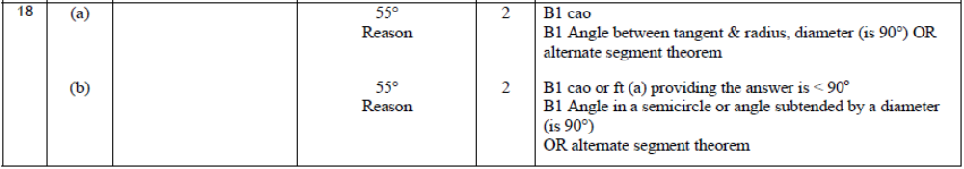

19 |  | 4x + y = 10  4x – 6y = 38 –  7y = –28, y = – 4  4x – 4 = 10, x = 3.5  or  12x + 3y = 30  2x – 3y = 19 +  14x = 49, x = 3.5  7 – 3y = 19, y = –4 | x = 3.5  y = – 4 | 3 | M1 for full method to eliminate x or y, allow one error in calculation  M1(dep) for substitution of one variable into one of the equations, or by appropriate method after starting again  A1 3.5 and –4

20 | (a) |  | 4 | 3 | M1 for correct expansion to 32x − 8 or multiplying both sides by 3x or dividing both sides by 4  M1 for a compete and correct method to isolate the x terms and the number terms (condone one arithmetic error in multiplying out the bracket)  A1 cao
 | (b) | 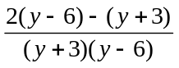 | 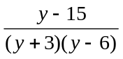 | 3 | M1 for common denominator of 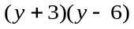  M1 for 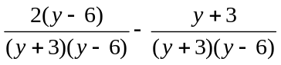oe  or oe  A1 for or 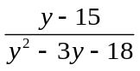

21 |  | Equation (1) × 3 then add equation (2) × 2 leads to 26x = 13  3 + 2y = − 3 | x =  y = − 3 | 4 | M1 for coefficients of x or y the same followed by correct operation, condone one arithmetic error  A1 for one correct answer  M1 (dep) for substituting found value in one equation  A1 cao for other correct answer  (SC: B2 for one correct answer only if M’s not awarded)

*22 |  | 360 − y | 180 − 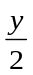 | 4 | M1 ADC =  A1 180 −  C2 (dep on M1) for both reasons  Angle at centre is twice the angle at the circumference  Opposite angles in cyclic quadrilateral add to 180˚  (C1 (dep on M1) for one appropriate circle theorem reason)

23 | (a) | 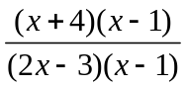 | 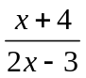 | 3 | M1 for (x + 4)(x – 1)  M1 for (2x – 3)(x – 1)  A1 cao
 | (b) | 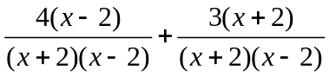 | 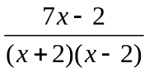 | 3 | M1 for denominator (x + 2)(x – 2) oe or x² – 4  M1 for 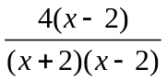 oe or 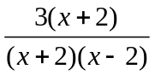oe  (NB. The denominator must be (x + 2)(x - 2) or x² – 4 or another suitable common denominator)  A1 for or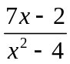  SC: If no marks awarded then award B1 for 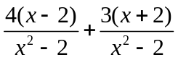oe

24 | (a) | = −a + b  = +  = a + (–a + b)  =a + b  OR  = +  = b +(−b + a)  =a+b | a + b | 3 | M1 for correct vector equation involving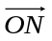, eg. 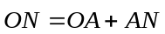, may be written, partially or fully, in terms of a and b, e.g. (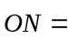) a + 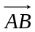  M1 for showing answer requires 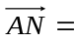or 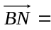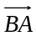  A1 a + b oe
 | (b) | =++  = a + b + b  = a + 2b  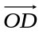= 3(a+b )  = 3 | Proof | 3 | M1 for a correct vector statement for 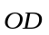or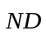in terms of a and b, e.g. = a + b + b oe or = (−b + a) + b + b oe  A1 for correct and fully simplified vectors for 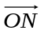(may be seen in (a)) and for 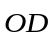(= a + 2b) or 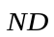(=a + b)  C1 (dep on A1) for statement that or is a multiple of (+ common point)

Examiner report: Silver 4

Question 1
Part (a) proved to be a good starter question with over 80% of the candidates scoring both marks. Some candidates failed to cancel their fraction to its simplest form. It was pleasing to note that only 8% of the candidates failed to score.

The most common error in part (b) was to give their answer as a fraction although 65% of the candidates could provide the correct answer of 30%. Many found 10% to be £2, but then were often not able to write 30% for £6.

Part (c) was poorly answered with over 68% of the candidates failing to score. A large proportion halved 10 then added £1.50 to get £6.50 whilst others managed to subtract £1.50 from £10 but then went no further. Only a small handful of candidates used the approach of setting up an equation. There were many attempts at trial and improvement. Candidates need to be encouraged to check their answers; had they done so they would have realised that £6.50 and £3.50 do not have a difference of £1.50. Only 29% scored both marks.

Question 2
Most candidates found this question straightforward and scored full marks. The normal route taken by candidates was to work out 15% of 240 and ¾ of 240, add the answers and subtract from 240. Some candidates took the easier route and converted ¾ to a percentage, added 15% to 75% and so were left to work out 10% of 240 to get the answer. A significant number of candidates left the answer as “10%”. Very few candidates worked in decimals. One of the most common errors see was “240 – 216 = 34”. A check of their arithmetic might have helped many candidates to avoid a loss of marks here. Some candidates subtracted the 36 from 240 then calculated ¾ of their answer so 153 was a commonly seen incorrect answer. An incorrect final answer of 51 (204 − 153) was also seen often.

Question 3
This question was answered quite well with many students able to produce a correct ordered stem and leaf diagram with an appropriate key. A significant number of students did not know how to deal with the stem. A common incorrect answer for the stem was 8, 9, 1, i.e. omitting both 10 and 11. Other common errors include not using all 18 of the given heights and, perhaps more significantly, omitting to write down a key.

Question 4
Part (a) was done well by the vast majority of candidates. Common correct approaches were 6.20 + 6.20 + 6.20 + 6.20, 12.40 + 12.40 and 6.20 × 4. A common incorrect answer for those candidates attempting to multiply 6.20 by 4 was 24.84. It was encouraging to see so many candidates use the correct money notation in their answers. In part (b), many candidates were able to score 1 mark for writing 15.50÷6.20, but many were unable to deal with this division. Most successful approaches involved either repeated addition, such as 2 × 6.20 + 3.10, or repeated subtraction, such as 15.50 − 12.40 = 3.10 = half an hour. 2.5 was a very common correct answer. Candidates should be advised that there is a significant difference between 2.3 or 2.30 as a final answer and 2hrs 30mins. A significant number of candidates having found 2.5 (hours) as an answer in their working then went on to round this to 3 (or 2) on the answer line.
Question 5
Most candidates used the factor tree method in their responses to this question. Though candidates appeared to understand what they needed to do, regrettably many of their attempts were spoiled by their inability to find correct pairs of factors, that is, they were let down by weak arithmetic. Candidates who completed the factor tree diagram successfully sometimes listed the prime factors but did not express their answer as a product so could not be awarded the mark assigned for a fully correct answer. “1” was sometimes included as a prime factor.

Question 6
Almost every candidate was able to give the correct answer to part (a) but many struggled with the complexity of part (b). Although a third scored full marks in this part, many scored just 1 mark either for establishing that $400 needed to be subtracted from £800 or for a correct method to change £800 into dollars. A variety of methods were adopted and some candidates were able to make some progress towards a solution and scored 2 or 3 marks.
There was much confusion between dollars and pounds, often shown by incorrect readings from the graph. Even when using a correct method, many failed to read accurately from the graph. Many candidates would have gained more marks if they had stated their method more explicitly.
Question 7
Most candidates understood they needed to find an area, divide by 20, and round appropriately to find the number of bags, then lead on to a money calculation. Many fell at the first hurdle: there were some disappointing attempts at finding the area. Few used the formula for a trapezium provided at the front of the paper, preferring instead to make an attempt to divide up the shape which was frequently done very badly. This was another question in which poor arithmetic skills spoilt many solutions. Some candidates failed to work with full bags (e.g. 6.75 bags) and others tried to work out the number of bags needed for each section, which was not efficient.

Question 8
Part (a) was done quite well. Many candidates were able to write down the square root of 6. Common incorrect answers here were 18 and 6². In part (b), only the better candidates were able to write down an acceptable estimate for the square root of 200. Most candidates were unable to write down the squares of 13, 14 or 15, or calculate them correctly. A significant number of candidates thought that because the square root of 100 is 10 then the square root of 200 must be 20.

Question 9
The question asks for a single transformation. Answers that gave more than one transformation, quite commonly seen, automatically gained no marks. Common errors were using the word ‘turn’ rather than ‘rotation’, writing the centre of the rotation as a vector rather than a coordinate and getting the angle of rotation wrong. It is expected that candidates give the turn in degrees rather than as a fraction of a turn.

Question 10
This question was testing quality of written communication so it was pleasing to see the vast majority of candidates supporting their decision with working. Most working was well laid out but there was still some confused working in evidence which made the awarding of marks more difficult. Many struggled with finding 2.25% of £60; often the starting premise was incorrect with a statement linking, for example, 1% of £60 with 6. When a build up method is used for percentages it is vital that candidates either get their initial statement correct or show full working if they are to gain any method marks. More success was evident with the calculation of 1.5% of £60. The starting point of 1%, 0.5%, 0.25% was more successful than 10%, 5%, 2.5%. In questions testing quality of written communication where a decision needs to be made, this must be communicated by means of a written statement, it is not sufficient to circle the right answer. The vast majority realised this and concluded with a statement that was correct for their figures.

Question 11
Many attempts at the correct method of solution whether or not these were successful generally depended on the candidate’s ability to use the correct formula to work out the area of a triangle and correct arithmetic. Too often, base × height without the division by 2 was used for the area of a triangle and calculations such as 12 × 12, 54 ÷ 2, 9 × 6, 27 + 18 and 144 – 45 were worked out incorrectly. Candidates do need to make their method of solution clear in questions like this where there are a number of calculations and would do well to present working in clear ordered stages. The unnecessary use of Pythagoras’ theorem was occasionally seen. Many candidates failed to pick up marks for not labelling or identifying which sides had a length of 3, 6 or 9.

Question 12
The majority of candidates gained 3 marks for plotting and drawing the correct line segment. It was very encouraging to see a substantial number of correct tables of values prior to the drawing of the graph. Most errors in the table were incorrect values of y for negative values of x. It was disappointing that relatively few candidates managed to get the additional mark for correctly scaling and labelling the axes. The absence of 0 at origin or the absence of x and y on the appropriate axes or the use of a non-linear scale meant that this mark could often not be awarded. When the scaling on the axes was inconsistent further marks were usually lost as it became difficult for the candidate to draw the correct line segment through the points plotted. It was disconcerting to see a small proportion of candidates drawing axes on the left of the grid and at the bottom instead of drawing axes that intersected at the origin.

Question 13
Candidates who were able to draw the correct graph (or any graph in part (a)) frequently were unable to make the connection between (a) and (b).

The majority of candidates who drew a correct graph in part (a) did so without the aid of a table of values. Either plotting points directly onto the graph or using the properties of y = mx + c.

Question 14
In part (a) many candidates did not know the meaning of the word ‘reciprocal’. A variety of incorrect answers were seen with the most common being 25.

Part (b) was poorly answered. The most common incorrect answers were –9 and 0.03. Some candidates with the right idea failed to evaluate 3^{–2} and gave the answer as .

In part (c) Many candidates were able to gain one mark for evaluating 9 × 10⁴ × 3 × 10³ as 270 000 000 or as 27 × 10⁷. The difficulty for many was changing their answer to standard form. Many thought 27 × 10⁷ was in standard form and failed to do the final step. Candidates who first converted the numbers in the question to ordinary numbers often ended up with too many or too few zeros. Some evaluated 9 × 3 incorrectly.

Question 15
66% of candidates spotted the correct class. Some candidates lost the mark by giving the frequency that corresponds to the correct class. There were also incomplete answers when candidates gave the lower or the upper limit of the class.

71% of the candidates completed the cumulative frequency table correctly. The most popular incorrect answer to (b) was to use the frequency in each group as the cumulative frequency. Some made an error with one or more additions and followed that through to give various incorrect final values. A few thought that the first cumulative frequency value had to be zero whilst others used multiples of 10 for the cumulative frequencies.

On the whole part (c) was well done with most candidates correctly plotting their values from an acceptable cumulative frequency table correctly, mostly at the top of the class intervals. Common errors were not joining the points together and not placing points at the ends of intervals. Bar charts were also evident and there were many lines of best fit drawn. In part (d) many candidates did not subtract their reading from 50 to get the correct answer. Just under 20% of the candidates got parts (c) and (d) fully correct with 30% failing to score in either part.

Question 16
This reverse percentage question provided a straightforward test for many of the more able candidates who found the calculation routine. There was however a large proportion of candidates who did not understand what they needed to do and merely added 30% on to the sale price so £455 was a very commonly seen incorrect answer. Although candidates who equated £350 with 70% usually went on to get the correct answer, some of them then seemed to ignore the statement they had just written down and instead calculated 10% of 350 leading to an incorrect answer. Candidates who wrote £350 = 70% then £50 = 10% were generally more successful than candidates who attempted to calculate £350 ÷ 0.7 Candidates who gave incorrect answers such as £50 or £150 might have found their error if they had carried out a common sense check on the size of their answer after reading the question again.

Question 17
Many students were able to score at least 1 mark for calculating the exterior/ interior angle of the octagon or for finding the angle KFG (110°) in the hexagon. A common error here was to treat the hexagon as a regular hexagon, or to incorrectly state the sum of the interior angles of the hexagon as 360°. A significant number of students had difficulty in working out 360 ÷ 8 or 1080 ÷ 8.

Question 18
Many candidates managed to score at least one mark, sometimes two. However, the clarity of the reasons for their answers was poor. There was often imprecision in the language – for example ‘a tangent is perpendicular to a centre’ in both parts. Candidates have to learn the correct technical language and not think that vague descriptions are good enough.

Question 19
This question was not done well. Few candidates could work through the problem in an organised way. Calculations were often seen all over the page, some processing the numbers in ways that bore little relation to the demands of the question. Having said this, a large number of candidates were able to score a mark for writing 160 × 50, even if they were then unable to calculate this correctly. Only a small number of candidates were able to find 35% of their total correctly. This was generally done by a method of composition such as 3 × 10% + 5%. Candidates should be advised that when they are using a method of decomposition to work out percentages they should show all the stages in their work in detail, e.g. when working out 10% of 800 they should write down the complete process (for example 800 ÷ 10). Having reached the total cost for the computers few candidates attempted to divide this by 400. The most common approach was to build up multiples of 400 to reach the target amount, e.g. 10 × 400 = 4000, 4000 + 4000 = 8000, 8000 + 2800 = 10800, so 27 computers.

Question 20
The majority of candidates made an attempt at this question and most managed to gain the first mark for multiplying out the bracket. Many, though, were then unable to rearrange the equation correctly. Common errors were to add 8 to both sides before multiplying by 3x or to subtract 3x from the RHS. Some candidates who did multiply both sides by 3x to give 32x – 8 = 10 × 3x then subtracted 3x from 32x. Those who did get as far as 32x – 8 = 30x usually completed the solution to x = 4 and gained full marks. A few candidates slipped up when multiplying out the bracket (e.g. 24x or 36x) but then rearranged correctly to get two marks.

Those candidates who were able to attempt part (b) often gained the first mark for using a common denominator of (y + 3)(y – 6) or y² – 3y – 18. Many of the candidates who used the correct denominator gained the second mark for dealing with the numerators correctly. At this stage the subtraction was often written as two separate fractions. A very common error was to then simplify 2(y – 6) – (y + 3) to y – 9. It was a shame that some candidates with the correct answer lost the accuracy mark because they went on to do further incorrect algebra. Inappropriate cancelling was a feature of many candidates work.

Question 21
There were disappointingly few fully correct solutions seen even from more able candidates. Those students who could multiply both equations appropriately and then chose the correct operation were frequently let down by their arithmetic. A commonly seen error was to follow the correct statement of, for example, 26x = 13 with the incorrect solution of x = 2; this type of error was seen on numerous occasions. The incorrect subtraction of negative numbers was also frequently seen.

Question 22
This question was not answered very well and many candidates did not even attempt it. Many candidates appeared unable to cope with an angle of y and although some knew that angle ADC was half of y they were unable to express it as such. Often candidates gave y a value and worked with numbers. These candidates gained no credit even if their reasons were correct. Those who did attempt to answer it using algebraic terms often gained one mark for identifying angle ADC as with some also then working out angle ABC as 180 – . Fewer candidates used the solution involving the reflex angle AOC. Many candidates incorrectly thought OABC was a cyclic quadrilateral leading to an answer of angle ABC being 180 – y. Some thought that angles BAD and BCD were 90°. It was pleasing to see candidates using the correct terminology but there were still many who lost the QWC marks through the use of the wrong words. Angle at the ‘edge’ rather than at the ‘circumference’, and ‘arrow’ or ‘arrow head’ occurred regularly. Many quoted ‘quadrilateral’ and not ‘cyclic quadrilateral’. Some candidates listed any theorem or rule they could think of that related to angles or circles in the hope of finding the right one without actually offering an expression for ADC or a final answer. These candidates gained no credit since the QWC marks could only be awarded if the reasons given were appropriate to the method shown.

Question 23
In both parts of this question there was clear evidence of incorrect cancelling. This was also seen at the conclusion of a solution, often following the correct answer, in which case the candidate could not be awarded the final accuracy mark. In part (a) the numerator was correctly factorised more often than the denominator. Those that factorised both correctly generally went onto gain full marks. Except for those candidates who spoilt a correct answer by incorrect cancelling, most of those who found the correct common denominator in part (b) went on to score full marks. The exception to this were those candidates who wrote down the common denominator incorrectly straight away as x² – 2 without showing (x – 2)(x + 2) and others who made errors in expanding brackets, particularly where this involved negative numbers. A significant number of students calculated the numerator correctly, but failed to give a denominator at all.

Question 24
The biggest difficulty for those who made a serious attempt at part (a) was getting the direction signs of the vectors correct. Relatively few candidates chose to write a simple vector equation such as ON = OA + AN or ON = OB + BN as their starting point. Candidates who worked with a + AB were generally more successful. Those who started their path with vector b frequently used b + AB instead of b + BA. Difficulty in expanding brackets or omitting brackets altogether prevented some candidates from gaining marks even though their reasoning appeared to be correct.

In part (b), relatively few candidates achieved any marks. Some candidates were able to find a correct expression (usually simplified) for OD. A smaller number were able to give a correct expression for ND. Often, however, unsimplified or incorrectly simplified answers for ON meant that candidates were unable to prove a straight line relationship. Those candidates obtaining all 3 marks were generally very coherent in their justification though few were actually explicit in their recognition of a common point. Some explanations were unclear with candidates mentioning ‘gradient’ or ‘same amounts of a and b’ rather than stating that one vector was a multiple of the other. Some candidates set about proving ON + ND = OD.
Practice paper: Silver 4
 |  |  |  |  |  |  |  | Mean score for students achieving Grade:
Spec | Paper | Session  YYMM | Question | Mean score | Max score | Mean  % | ALL | A* | A | % A | B | C | % C | D | E
1380 | 1H | 1111 | Q01 | 3.67 | 6 | 61 | 3.67 | 5.64 | 5.08 | 84.7 | 4.45 | 3.56 | 59.3 | 2.63 | 2.04
1MA0 | 1H | 1306 | Q02 | 2.98 | 4 | 75 | 2.98 | 3.84 | 3.67 | 91.8 | 3.47 | 2.98 | 74.5 | 1.97 | 0.86
1MA0 | 1H | 1411 | Q03 | 1.91 | 3 | 64 | 1.91 | 2.76 | 2.67 | 89.0 | 2.41 | 2.11 | 70.3 | 1.70 | 1.08
1380 | 1H | 1106 | Q04 | 1.91 | 3 | 64 | 1.91 | 2.77 | 2.45 | 81.7 | 2.05 | 1.51 | 50.3 | 0.81 | 0.32
1MA0 | 1H | 1306 | Q05 | 1.39 | 3 | 46 | 1.39 | 2.84 | 2.48 | 82.7 | 1.85 | 1.03 | 34.3 | 0.36 | 0.08
1MA0 | 1H | 1303 | Q06 | 3.11 | 5 | 62 | 3.11 | 4.62 | 4.21 | 84.2 | 3.76 | 3.06 | 61.2 | 2.11 | 1.30
1MA0 | 1H | 1211 | Q07 | 1.79 | 4 | 45 | 1.79 | 3.78 | 3.54 | 88.5 | 3.05 | 1.64 | 41.0 | 0.41 | 0.06
1380 | 1H | 1106 | Q08 | 2.09 | 3 | 70 | 2.09 | 2.43 | 2.37 | 79.0 | 2.19 | 1.91 | 63.7 | 1.51 | 1.09
1MA0 | 1H | 1206 | Q09 | 1.76 | 3 | 59 | 1.76 | 2.89 | 2.59 | 86.3 | 2.08 | 1.37 | 45.7 | 0.70 | 0.38
1MA0 | 1H | 1206 | Q10 | 2.19 | 4 | 55 | 2.19 | 3.64 | 3.20 | 80.0 | 2.70 | 1.78 | 44.5 | 0.54 | 0.16
1380 | 1H | 1203 | Q11 | 2.74 | 6 | 46 | 2.74 | 5.61 | 4.93 | 82.2 | 3.63 | 1.84 | 30.7 | 0.72 | 0.41
1MA0 | 1H | 1311 | Q12 | 2.24 | 4 | 33 | 2.24 | 3.29 | 3.16 | 79.0 | 2.94 | 2.21 | 55.3 | 1.08 | 0.30
1380 | 1H | 1203 | Q13 | 1.26 | 4 | 32 | 1.26 | 3.64 | 2.73 | 68.3 | 1.52 | 0.63 | 15.8 | 0.27 | 0.16
1MA0 | 1H | 1311 | Q14 | 1.33 | 4 | 60 | 1.33 | 3.55 | 2.77 | 69.3 | 1.75 | 0.81 | 20.3 | 0.30 | 0.10
1380 | 1H | 1111 | Q15 | 3.27 | 6 | 55 | 3.27 | 5.58 | 5.08 | 84.7 | 4.28 | 3.13 | 52.2 | 1.94 | 1.27
1MA0 | 1H | 1306 | Q16 | 1.02 | 3 | 34 | 1.02 | 2.79 | 2.07 | 69.0 | 1.28 | 0.60 | 20.0 | 0.20 | 0.10
1MA0 | 1H | 1411 | Q17 | 0.42 | 4 | 11 | 0.42 | 3.34 | 2.40 | 60.0 | 1.08 | 0.25 | 6.3 | 0.06 | 0.02
1380 | 1H | 911 | Q18 | 1.50 | 4 | 38 | 1.50 | 3.38 | 2.59 | 64.8 | 1.78 | 1.02 | 25.5 | 0.45 | 0.21
1380 | 1H | 1106 | Q19 | 1.11 | 3 | 37 | 1.11 | 2.86 | 2.16 | 72.0 | 0.96 | 0.22 | 7.3 | 0.03 | 0.01
1MA0 | 1H | 1311 | Q20 | 1.60 | 6 | 61 | 1.60 | 5.09 | 3.73 | 62.2 | 1.86 | 0.82 | 13.7 | 0.41 | 0.18
1380 | 1H | 1011 | Q21 | 0.91 | 4 | 23 | 0.91 | 3.63 | 2.34 | 58.5 | 0.90 | 0.22 | 5.5 | 0.05 | 0.01
1MA0 | 1H | 1311 | Q22 | 0.65 | 4 | 65 | 0.65 | 3.19 | 1.98 | 49.5 | 0.65 | 0.09 | 2.3 | 0.01 | 0.00
1MA0 | 1H | 1206 | Q23 | 1.03 | 6 | 17 | 1.03 | 4.84 | 2.39 | 39.8 | 0.70 | 0.12 | 2.0 | 0.03 | 0.01
1MA0 | 1H | 1311 | Q24 | 0.74 | 6 | 32 | 0.74 | 4.68 | 2.28 | 38.0 | 0.53 | 0.05 | 0.8 | 0.00 | 0.00
 |  |  |  | 42.62 | 102 | 41 | 42.62 | 90.68 | 72.87 | 71.44 | 51.87 | 32.96 | 32.31 | 18.29 | 10.15

