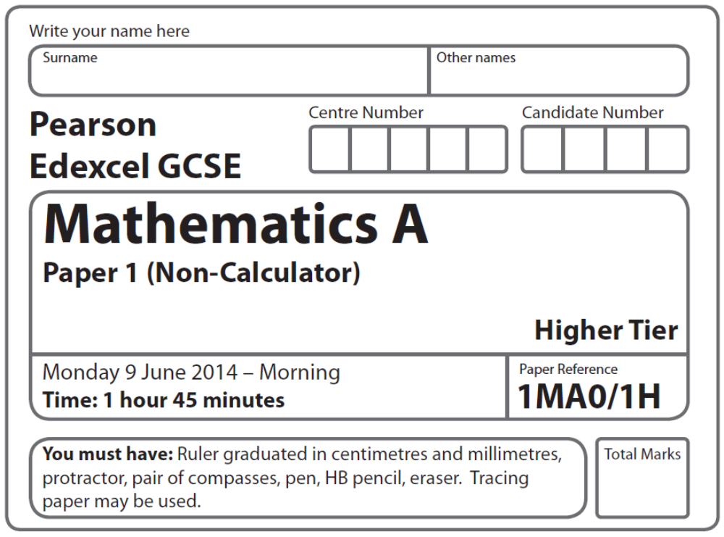
Practice Paper – Bronze 4
Bronze: 4 of 4

Instructions
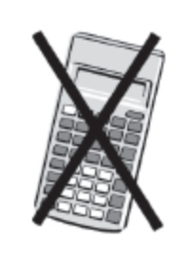
- Use black ink or ball-point pen.
- Fill in the boxes at the top of this page with your name,
centre number and candidate number.
- Answer all questions.
- Answer the questions in the spaces provided
– there may be more space than you need.
- Calculators must not be used.

Information
- The total mark for this paper is 100
- The marks for each question are shown in brackets
– use this as a guide as to how much time to spend on each question.
- Questions labelled with an asterisk (*) are ones where the quality of your
written communication will be assessed.

Advice
- Read each question carefully before you start to answer it.
- Keep an eye on the time.
- Try to answer every question.
- Check your answers if you have time at the end.

Suggested Grade Boundaries (for guidance only)
A* | A | B | C | D
99 | 90 | 74 | 56 | 38
GCSE Mathematics 1MA0

Formulae: Higher Tier

You must not write on this formulae page.
Anything you write on this formulae page will gain NO credit.

Volume of prism = area of cross section × length Area of trapezium = (a + b)h
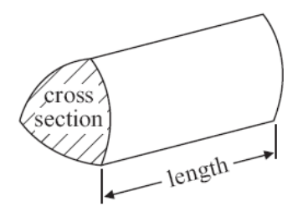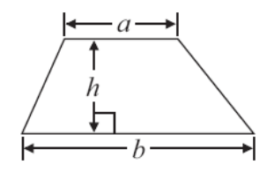

Volume of sphere πr³ Volume of cone πr²h
Surface area of sphere = 4πr² Curved surface area of cone = πrl

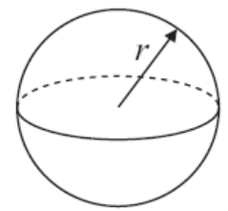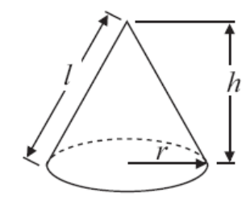

In any triangle ABC The Quadratic Equation
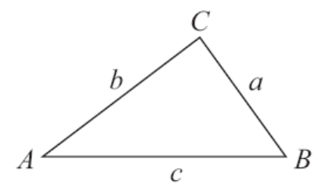
The solutions of ax²+ bx + c = 0
where a ≠ 0, are given by

x = 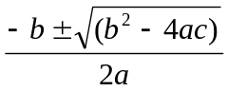

Sine Rule 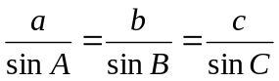

Cosine Rule a² = b²+ c²– 2bc cos A

Area of triangle = ab sin C
Answer ALL questions.
Write your answers in the spaces provided.
You must write down all stages in your working.
You must NOT use a calculator.

1. This is a list of ingredients for making chicken soup for 4 people.

Ingredients for 4 people
60 g butter
300 g chicken
150 ml cream
1 onion
640 ml chicken stock

Bill is going to make chicken soup for 6 people.

Work out the amount of each ingredient he needs.

.......................................... g butter
.......................................... g chicken
.......................................... ml cream
.......................................... onion
.......................................... ml chicken stock
(Total 3 marks)
___________________________________________________________________________
2. Here are the weights, in grams, of 16 eggs.

47 45 50 53 43 61 53 62

58 56 57 47 55 62 58 58

Draw an ordered stem and leaf diagram to show this information.
You must include a key.

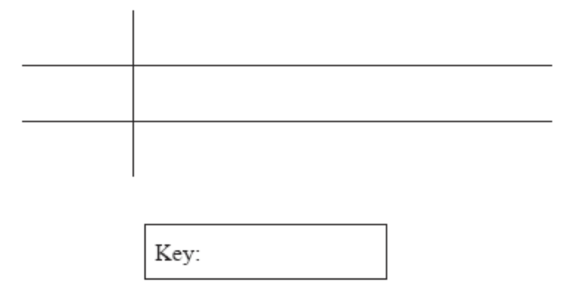

(Total 3 marks)
___________________________________________________________________________
3. Sixteen babies are born in a hospital.

Here are the weights of the babies in kilograms.

2.4 2.7 3.5 4.4 4.5 4.1 4.4 2.8
4.1 3.8 3.8 4.2 3.3 3.0 3.7 3.3
Show this information in an ordered stem and leaf diagram.

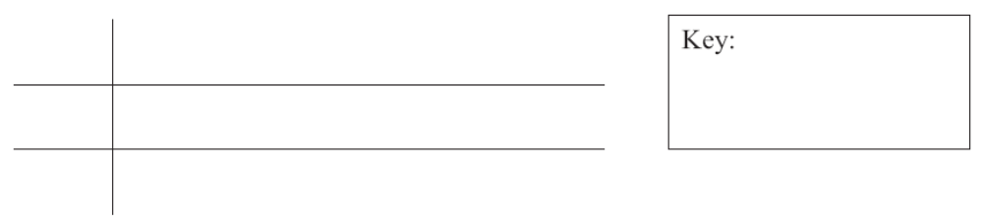
(Total 3 marks)
___________________________________________________________________________
4. Nigel travelled from his home to his friend’s house 40 km away.
Nigel stayed for some time at his friend’s house before returning home.

Here is a distance-time graph for Nigel’s journey.

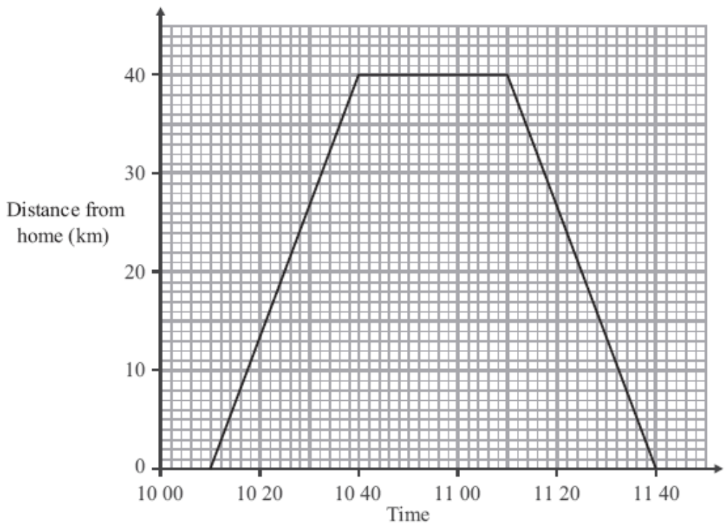

(a) At what time did Nigel leave home?

.....................................
(1)
(b) How far was Nigel from home at 10 20?

...................................... km
(1)

(c) How many minutes did Nigel spend at his friend’s house?

.......................................... minutes
(1)
(Total 3 marks)
___________________________________________________________________________
5. h = 5t² + 2

(a) (i) Work out the value of h when t = –2

.....................................

(ii) Work out a value of t when h = 47

.....................................
(3)

(b) –1 ≤ n < 4

n is an integer.

Write down all the possible values of n.

........................................................
(2)
(Total 5 marks)
___________________________________________________________________________

6. Here are the ingredients needed to make 12 shortcakes.

Shortcakes
Makes 12 shortcakes
50 g of sugar
200 g of butter
200 g of flour
10 ml of milk

Liz makes some shortcakes.
She uses 25 ml of milk.

(a) How many shortcakes does Liz make?

..............................................
(2)

Robert has 500 g of sugar
1000 g of butter
1000 g of flour
500 ml of milk

(b) Work out the greatest number of shortcakes Robert can make.

..............................................
(2)
(Total for Question 23 is 4 marks)
___________________________________________________________________________
*7. The diagram shows the floor of a small field.

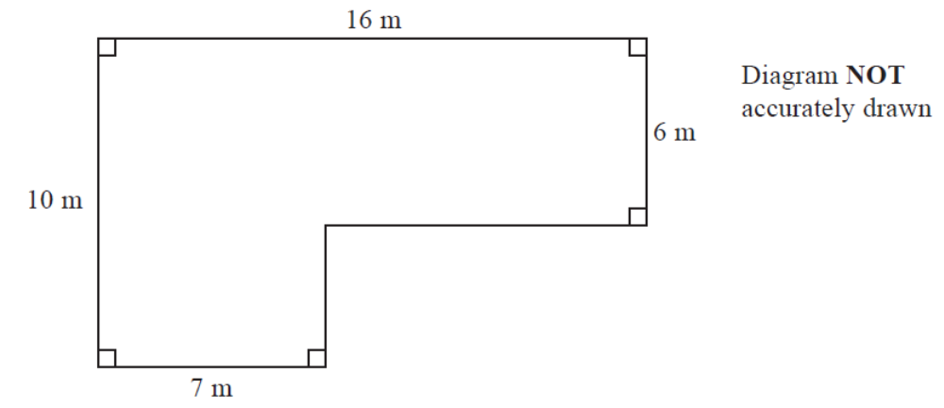

Kevin is going to keep some pigs in the field.
Each pig needs an area of 36 square metres.

Work out the greatest number of pigs Kevin can keep in the field.

(Total for Question 7 is 4 marks)
___________________________________________________________________________
8. Simon wants to find out how much people spend using their mobile phone.

He uses this question on a questionnaire.

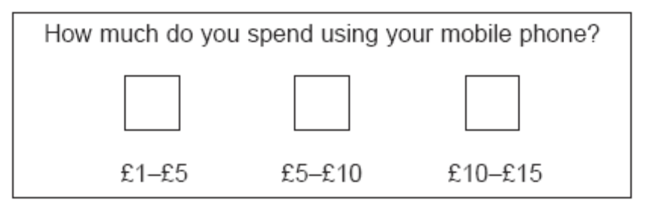

(a) Write down two things that are wrong with this question.

1 ..........................................................................................................................................

..............................................................................................................................................

2 ..........................................................................................................................................

..............................................................................................................................................
(2)

(b) Design a better question for his questionnaire to find out how much people spend using their mobile phone.
You should include some response boxes.

(2)
(Total 4 marks)
9. Matt and Dan cycle around a cycle track.

Each lap Matt cycles takes him 50 seconds.
Each lap Dan cycles takes him 80 seconds.

Dan and Matt start cycling at the same time at the start line.

Work out how many laps they will each have cycled when they are next at the start line together.

Matt .......................................... laps
Dan .......................................... laps
(Total 3 marks)
___________________________________________________________________________
*10. The diagram shows the floor of a village hall.

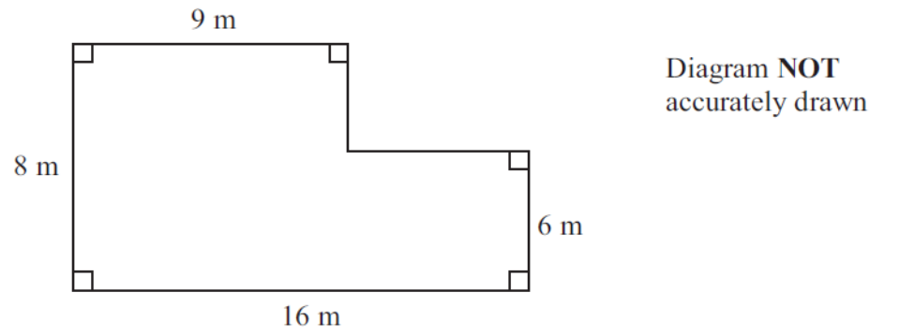

The caretaker needs to polish the floor.

One tin of polish normally costs £19.
One tin of polish covers 12 m² of floor.

There is a discount of 30% off the cost of the polish.

The caretaker has £130.

Has the caretaker got enough money to buy the polish for the floor?
You must show all your working.

(Total 5 marks)
___________________________________________________________________________
11. There are 300 people in the cinema.
 of the 300 people are boys.
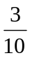 of the 300 people are girls.
The rest of the people are adults.

Work out how many people are adults.

.....................................
(Total 4 marks)
___________________________________________________________________________
12. Solve the simultaneous equations

3x + 4y = 200
2x + 3y = 144

x = ...............................

y = ...............................
(Total 4 marks)
___________________________________________________________________________
*13. Here is a map.
The position of a ship, S, is marked on the map.

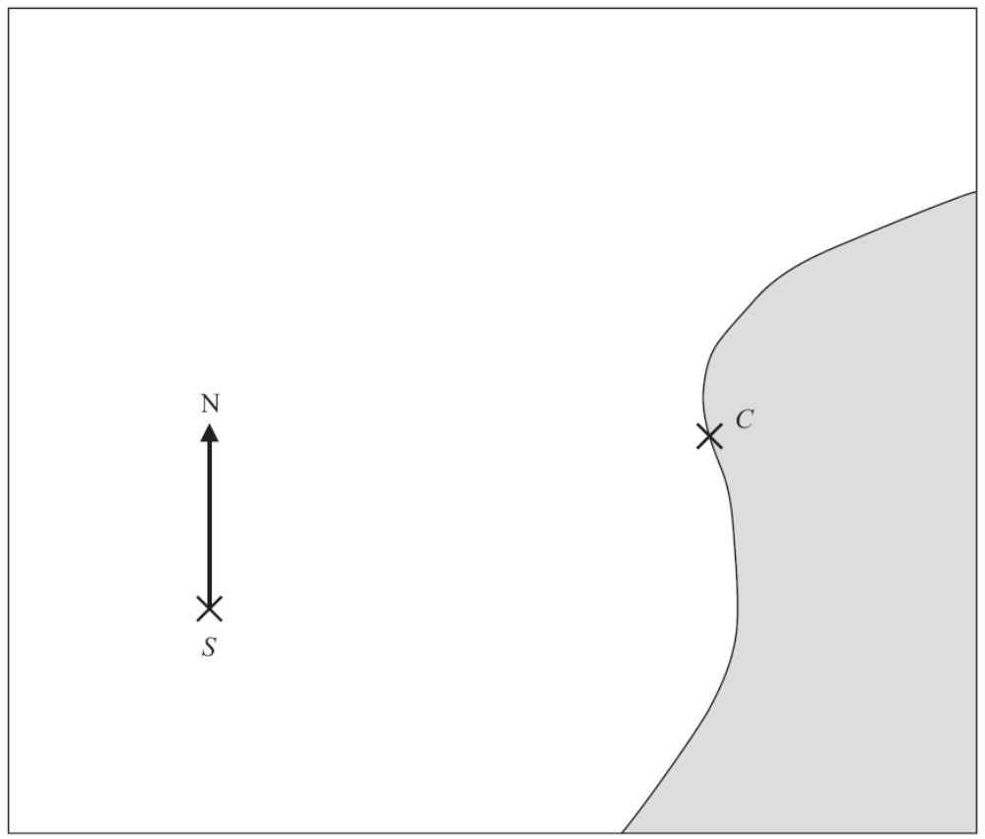
Scale 1 cm represents 100 m

Point C is on the coast.
Ships must not sail closer than 500 m to point C.

The ship sails on a bearing of 037°

Will the ship sail closer than 500 m to point C?
You must explain your answer.

(Total 3 marks)
___________________________________________________________________________
14. Suha has a full 600 ml bottle of wallpaper remover.
She is going to mix some of the wallpaper remover with water.

Here is the information on the label of the bottle.

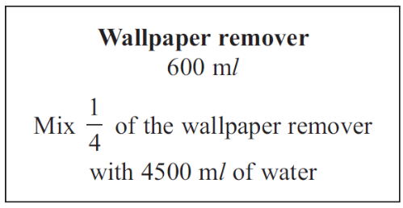

Suha is going to use 750 ml of water.

How many millilitres of wallpaper remover should Suha use?
You must show your working.

..........................................ml

(Total 4 marks)
___________________________________________________________________________
*15. One sheet of paper is 9 × 10^{–3} cm thick.

Mark wants to put 500 sheets of paper into the paper tray of his printer.
The paper tray is 4 cm deep.

Is the paper tray deep enough for 500 sheets of paper?
You must explain your answer.

(Total 3 marks)
___________________________________________________________________________
16. Make q the subject of the formula 5(q + p) = 4 + 8p
Give your answer in its simplest form.

q = .....................................................
(Total 3 marks)

17. (a) Write down the value of 10⁰

..............................................
(1)

(b) Write 6.7 × 10^{–5} as an ordinary number.

..........................................................................
(1)

(c) Work out the value of (3 × 10⁷) × (9 × 10⁶)
Give your answer in standard form.

..........................................................................
(2)
(Total for Question 17 is 4 marks)
___________________________________________________________________________
18. Solve the simultaneous equations
4x + 7y = 1
3x + 10y = 15

x = ..........................................
y = ..........................................
(Total 4 marks)
___________________________________________________________________________
19.
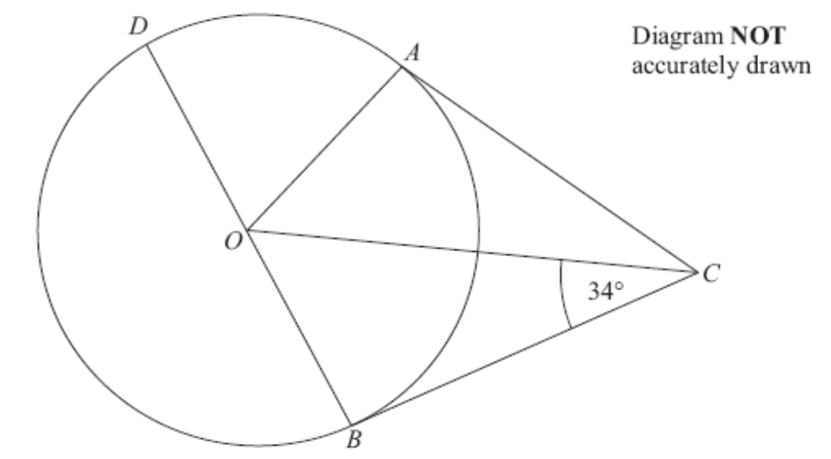

A, B and D are points on the circumference of a circle, centre O.
BOD is a diameter of the circle.
BC and AC are tangents to the circle.
Angle OCB = 34°.

Work out the size of angle DOA.

.......................................... °
(Total 3 marks)
___________________________________________________________________________
20. Mr Green measured the height, in cm, of each tomato plant in his greenhouse.
He used the results to draw the box plot shown below.

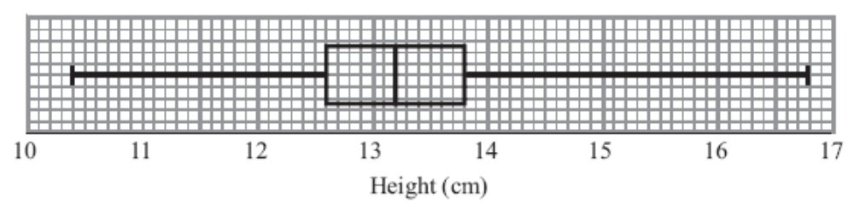

(a) Write down the median height.

................................cm
(1)

(b) Work out the interquartile range.

................................cm
(2)

(c) Explain why the interquartile range may be a better measure of spread than the range.

...............................................................................................................................................

...............................................................................................................................................
(1)
(Total 4 marks)
___________________________________________________________________________
21. The table below shows information about the heights of 60 students.

Height (x cm) | Number of students
140 < x ≤ 150 | 4
150 < x ≤ 160 | 5
160 < x ≤ 170 | 16
170 < x ≤ 180 | 27
180 < x ≤ 190 | 5
190 < x ≤ 200 | 3

(a) On the grid opposite, draw a cumulative frequency graph
for the information in the table.
(3)
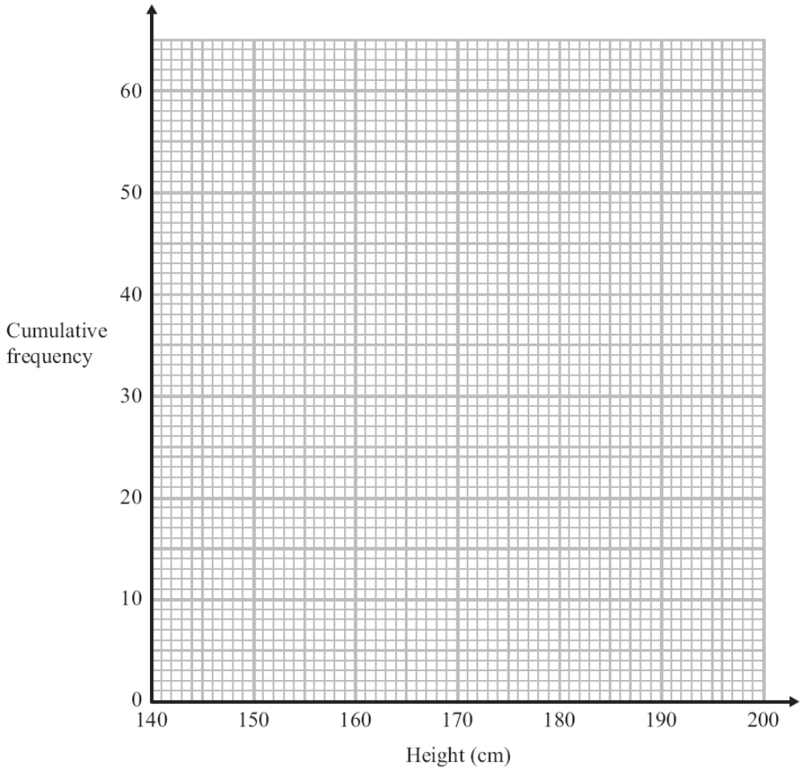

(b) Find an estimate

(i) for the median,

.............................................. cm
(ii) for the interquartile range.

.............................................. cm
(3)
(Total 6 marks)
___________________________________________________________________________
22. The table gives some information about the speeds, in km/h, of 100 cars.

Speed(s km/h) | Frequency
60 < s ≤ 65 | 15
65 < s ≤ 70 | 25
70 < s ≤ 80 | 36
80 < s ≤ 100 | 24

(a) On the grid, draw a histogram for the information in the table.

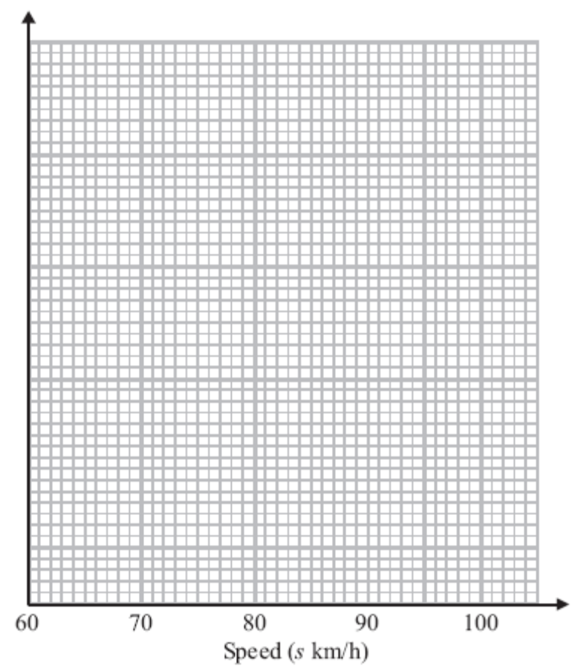
(3)

(b) Work out an estimate for the number of cars with a speed of more than 85 km/h.

..............................................
(2)
(Total for Question 22 is 5 marks)
___________________________________________________________________________
23.
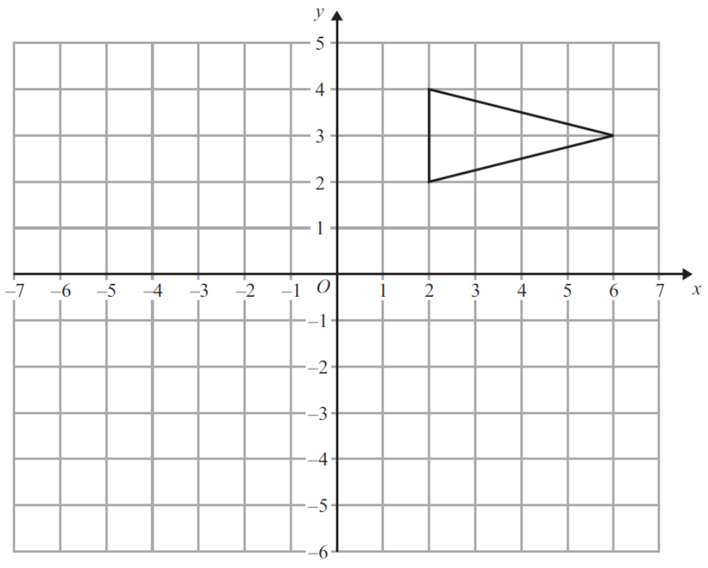

On the grid, enlarge the triangle by scale factor 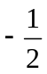, centre (0, –2).

(Total 2 marks)
___________________________________________________________________________
*24.
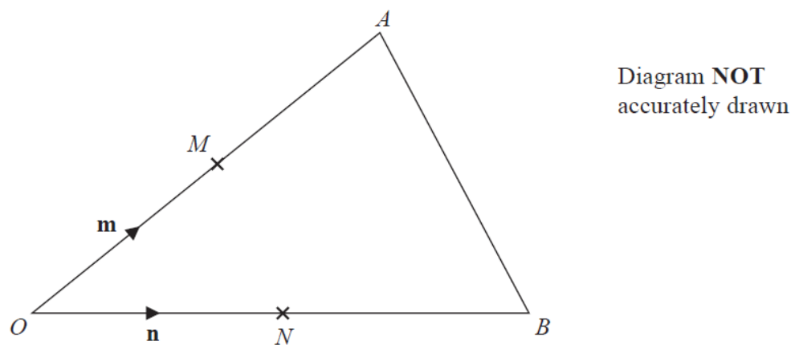

OAB is a triangle.
M is the midpoint of OA.
N is the midpoint of OB.
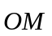 = m
 = n

Show that AB is parallel to MN.

(Total for Question 24 is 3 marks)
___________________________________________________________________________
25. y = f(x)

The graph of y = f(x) is shown on the grid.

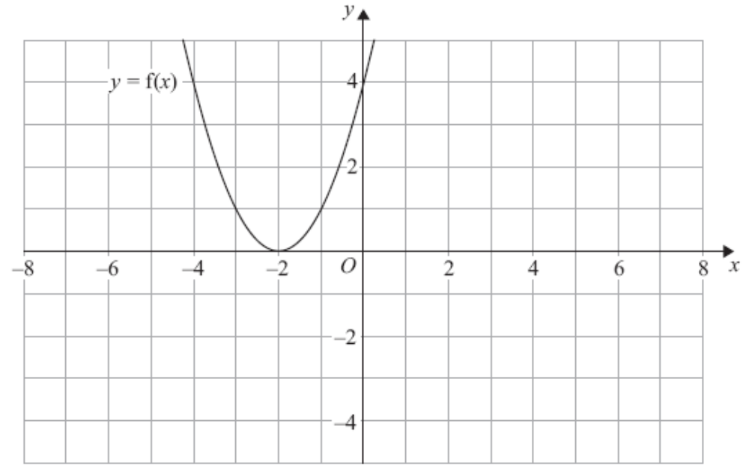

(a) On the grid above, sketch the graph of y = –f(x).
(2)

The graph of y = f(x) is shown on the grid.

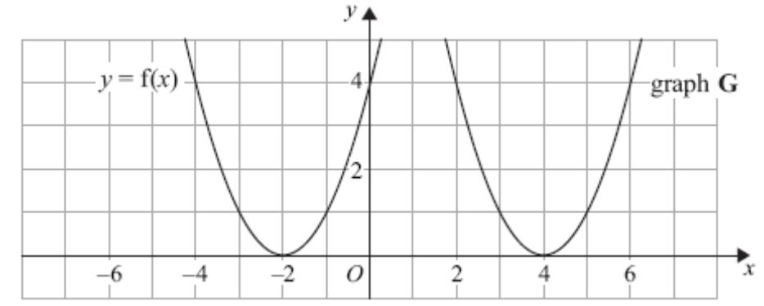

The graph G is a translation of the graph of y = f(x).

(b) Write down the equation of graph G.

....................................................................
(1)
(Total 3 marks)
___________________________________________________________________________
26. (a) Rationalise the denominator of 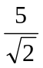

.....................................................
(2)

(b) Expand and simplify (2 + )² – (2 – )²

......................................................................................................
(2)
(Total 4 marks)
___________________________________________________________________________

27.
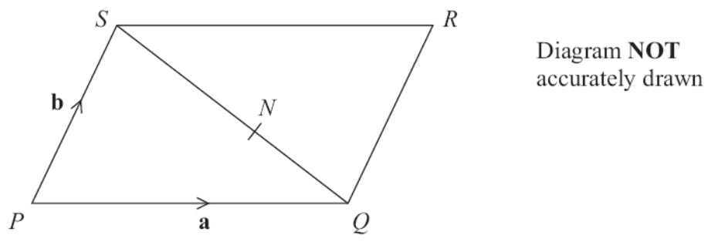

PQRS is a parallelogram.
N is the point on SQ such that SN : NQ = 3 : 2

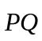 = a
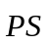 = b

(a) Write down, in terms of a and b, an expression for .

= ..........................................
(1)
(b) Express  in terms of a and b.

= ..........................................
(3)
(Total 4 marks)

TOTAL FOR PAPER IS 100 MARKS
1 |  |  | 90  450  225  1.5  960 | 3 | M1 for 6 ÷ 4 (= 1.5) or 4 ÷ 6 (= 0.66..) or ÷4 × 6 oe or sight of any one of the correct answers  A1 for three correct  A1 for all correct

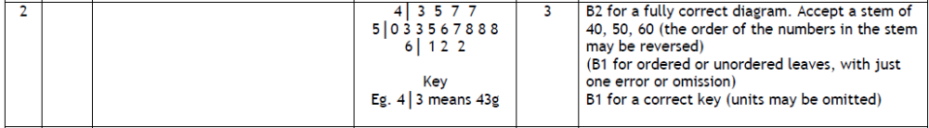

3 |  |  | 2| 4 7 8  3| 0 3 3 5 7 8 8  4| 1 1 2 4 4 5  Key, e.g.  4|1 is 4.1(kg) | 3 | B2 for correct ordered stem and leaf  (B1 for fully correct unordered or ordered with one error or omission)  B1 (indep) for key (units not required)

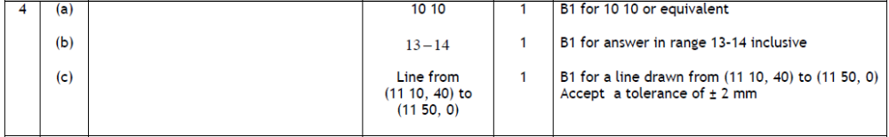

5 | (a)(i) | 5 × (–2)² + 2  = 5 × 4 + 2 | 22 | 1 | B1 cao
 | (ii) | 47 – 2 = 45  45 ÷ 5 = 9 | 3 | 2 | M1 for 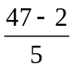or 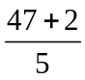  A1 for 3 or −3 (accept ±3)
 | (b) |  | –1, 0, 1, 2, 3 | 2 | B2 cao  (B1 for at least 4 correct and not more than one incorrect integer)

6 | (a) |  | 30 | 2 | M1 for 25 ÷ 10 or 2.5 seen or 10 ÷ 25 or 0.4 seen or  12 + 12 + 6 oe or  a complete method eg. 25 × 12 ÷ 10 oe  A1 cao
 | (b) | 1000 ÷ 200 × 12 | 60 | 2 | M1 for 500÷50 or 1000÷200 or 500÷10 OR  correct scale factor clearly linked with one ingredient eg. 10 with sugar or 5 with butter or flour or 50 with milk OR  answer of 120 or 600  A1 cao

*7 |  |  | 3 | 4 | M1 for a method to calculate at least one area eg 10 × 7 (=70) or 16 × 10 (=160)  M1 for a method to find the total area (=124)  M1 (dep on M1) for “124” ÷ 36  C1 (dep on M3) for 3 (pigs) clearly identified and supported by correct calculations

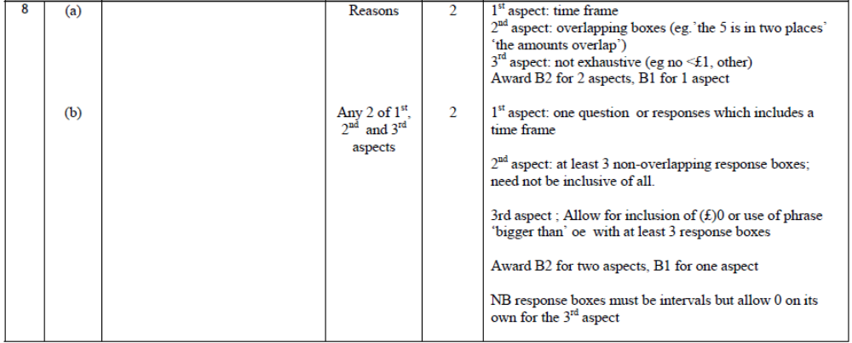

9 |  | LCM (80, 50) = 400  Matt 400 ÷ 50 = 8  Dan 400 ÷80 = 5 | Matt 8  Dan 5 | 3 | M1 lists multiples of both 80 (seconds) and 50 (seconds)  (at least 3 of each but condone errors if intention is clear, can be in minutes and seconds) or use of 400 seconds oe.  M1 (dep on M1) for a division of "LCM" by 80 or 50 or counts up “multiples”  (implied if one answer is correct or answers reversed)  A1 Matt 8 and Dan 5

*10 |  |  | Not enough,  needs £133 | 5 | M1 for splitting the shape (or showing recognition of the “absent” rectangle) and using a correct method to find the area of one shape  M1 for a complete and correct method to find the total area  M1 for a complete method to find 70% of 19 (= 13.3) or 70% of their total cost or 70% of their area  A1 114(m²) and (£)133 or 114(m²) and (£)13.3(0) and 108(m²)  C1 (dep on M2) for a conclusion supported by their calculations

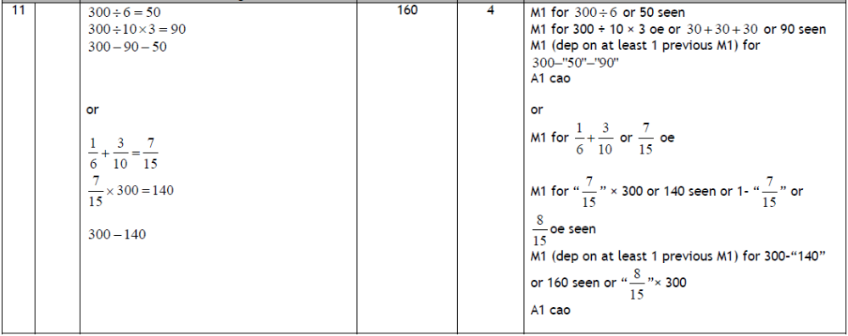

12 |  | 9x + 12y = 600  8x + 12y = 576  x = 24  3 × 24 + 4y = 200  6x + 8y = 400  6x + 9y = 432  y = 32  3x + 4 × 32 = 200 | x = 24  y = 32 | 4 | M1 correct process to eliminate either x or y  (allow one arithmetical error)  A1 either x = 24 or y = 32  M1 (dep on 1st M1) correct substitution of their value of x  or y into one of the equations  OR  M1 (indep of 1st M1) correct process to eliminate the other  variable (allow one arithmetical error)  A1 cao for both x = 24 and y = 32

*13 |  |  | Yes with explanation | 3 | M1 for bearing ± 2 ° within overlay  M1 for use of scale to show arc within overlay or line drawn from C to ship’s course with measurement  C1(dep M1) for comparison leading to a suitable conclusion from a correct method

14 |  |  | 25 | 4 | M1 for 600 ÷ 4 (=150)  M1 for 4500 ÷ “150” (=30)  M1 for 750 ÷ “30”  A1 for 25 with supporting working

*Q15 |  |  | No + explanation | 3 | M1 for 500 × 9 × 10⁻³ oe  A1 for 4.5  C1 (dep M1) for correct decision based on comparison of their paper height with 4

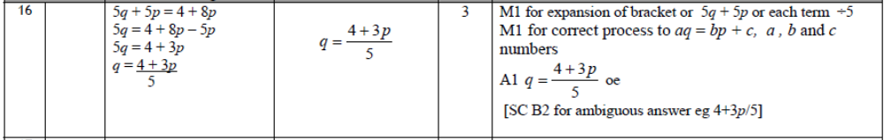

17 | (a) |  | 1 | 1 | B1 cao
 | (b) |  | 0.000067 | 1 | B1 cao
 | (c) |  | 2.7 × 10¹⁴ | 2 | M1 for 27 × 10⁷ ⁺ ⁶ or 27 × 10¹³ oe or  an answer of 2.7 × 10^{n} where n is an integer or  an answer of a × 10¹⁴ where 1 ≤ a < 10  A1 cao

18 |  | 12x + 21y = 3  12x + 40y = 60  19y = 57  y = 3  3x + 10× 3 = 15  3x = – 15 | X = –5, y = 3 | 4 | M1 for a correct process to eliminate either x or y or rearrangement of one equation leading to substitution (condone one arithmetic error)  A1 for either x = −5 or y = 3  M1 (dep) for correct substitution of their found value  A1 cao

19 |  |  | 68 | 3 | M1 for angle OBC = 90° or angle OAC = 90° (may be marked on the diagram or used in subsequent working)  M1 for correct method to find angle BOC or AOC or AOB  e.g. angle BOC = 180 – 90 – 34 (= 56)  or angle AOC = 180 – 90 – 34 (=56)  or angle AOB = 180 – 2 × 34 (= 112)  A1 cao  NB (68 must be clearly stated as an answer and not just seen on diagram)

20 | (a) |  | 13.2 | 1 | B1 cao
 | (b) | 13.8 − 12.6 | 1.2 | 2 | M1 for 13.8 – k or k – 13.8 or k – 12.6 or 12.6 – k where k can be any value  A1 cao
 | (c) |  | Reason | 1 | B1 for correct reason e.g. because the IQR ignores extreme values.

21 | (a) | Cf table: 4, 9, 25, 52, 57,60  cf graph | Correct Cf graph | 3 | B1 Correct cumulative frequencies (may be implied by correct heights on the grid)  M1 for at least 5 of “6 points” plotted consistently within each interval  A1 for a fully correct CF graph
 | (b)(i)  (ii) | IQR = UQ – LQ | 172  12 – 14 | 3 | B1 for 172 or read off at cf = 30 or 30.5 from a cf graph, ft provided M1 is awarded in (a)  M1 for readings from graph at cf = 15 or 15.25  and cf = 45or 45.75 from a cf graph with at least one of LQ or UQ correct from graph (± ½ square).  A1ft provided M1 is awarded in (a)

22 | (a) |  | Correct histogram | 3 | B3 for fully correct histogram (overlay)  (B2 for 3 correct blocks)  (B1 for 2 correct blocks of different widths)  SC : B1 for correct key, eg. 1 cm² = 5 (cars) or  correct values for (freq ÷ class interval) for at least 3 frequencies (3, 5, 3.6, 1.2)  NB: The overlay shows one possible histogram, there are other correct solutions.
  F | 15 | 25 | 36 | 24
  Fd | 3 | 5 | 3.6 | 1.2
 | (b) | × 24 | 18 | 2 | M1 for × 24 (=18) oe or 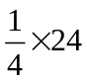(=6) oe  A1 cao

23 |  |  | Triangle with vertices at  (−1,−4),  (−1,−5),  (−3,−4.5) | 2 | M1 for correct shape and size and the correct orientation in the wrong position or two vertices correct  A1 cao

*24 |  |  | Proof | 3 | M1 for (= n – m)  or (= m – n)  or (= 2n – 2m) or (= 2m – 2n)  M1 for = n – m and = 2n – 2m oe  C1 (dep on M1, M1) for fully correct proof, with = 2 or 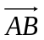is a multiple of  [SC M1 for = 0.5n – 0.5m  and = n – m  C1 (dep on M1) for fully correct proof, with = 2 or is a multiple of of ]

25 | (a) |  | sketch |  | M1 for inverting the parabola, so maximum is at ( –2, 0 )  A1 for parabola passing through all three of the points  (–2, 0), (0, –4), ( –4, –4)
 | (b) |  | y = f (x – 6) | 1 | B1 for y = f (x – 6) or y = (x – 4)² oe

26 | (a) |  | 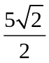 | 2 | M1 for oe  A1 for oe
 | (b) |  | 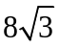 | 2 | M1 for 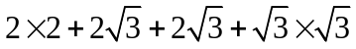  or 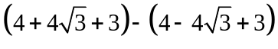  or 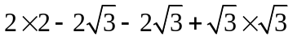  at least three terms in either correct; could be in a grid.  A1 cao

27 | (a) |  | a - b | 1 | B1 for a - b oe
 | (b) |  | a + b | 3 | M1 for a correct vector statement for  eg. ( =) + or ( =) +  M1 for SQ (+ QR) or QS (+ SR)  (SQ, QR, QS, SR may be written in terms of  a and b)  A1 for (a ‒ b) + b oe or (b – a) + a oe

BLANK PAGE
Examiner report: Bronze 4

Question 1
This question was answered well with most candidates scoring at least two of the three marks. Marks were generally lost through arithmetic errors rather than for using an incorrect method. The calculations caused difficulties for some candidates, particularly if they were attempting to divide by 4 and then multiply by 6. An answer of 2 onions was only accepted if it was clear from the working that the candidate had rounded 1 onions to 2 onions.

Question 2
Most candidates gained full marks for a correct diagram; any error here tended to be the omission of one of the repeated values usually 58 or 62. Although a key was usually correct, there were a significant number of errors, often simply describing the notation as “tens” and “units”. The majority of candidates did not make use of the extra space provided to complete an unordered diagram first but instead used a possibly more onerous method of searching through the data for ascending values to put it into an ordered diagram straight away.

Question 3
This question was well answered by the great majority of candidates. The stem and leaf diagrams seen were generally accurate with a relatively small minority making an error, usually missing one weight out of their diagram. Some candidates did not order the data. Candidates are advised to check that the number of entries in the diagram corresponds to the number of pieces of data given in the question. Keys were nearly always given but a significant number of students left out the decimal point and so could not be awarded the mark for the key. Other candidates unnecessarily included decimal points in their diagram.

Question 4
The great majority of candidates gained full marks in all parts of this question. 10 30, 10 05 were answers sometimes seen in part (a). A range of 13 to 14 enabled most candidates to gain the mark in part (b). In part (c), a significant number of candidates tried to complete the journey above the graph on the given grid and some had difficulty reading the scales.

Question 5
Substituting negative values into a quadratic was correctly answered by only 25% of candidates as many gave a negative answer, thinking that –2² was –4 and some multiplied before squaring whilst the reverse process was even less successful with only 17% gaining the marks.

Part (b) was much more successful with 78% of candidates gaining both marks and only 8% gaining no marks. One mark was awarded to the many who only failed to find the square root at the end or who thought √9 was 4.5.

Question 6
Part (a) was generally very well answered. Those candidates who attempted to find the amount of milk for 1 shortcake and then scale up did, however, often make arithmetic errors.

In part (b) the usual method employed was to find the number of quantities for each ingredient and then work with the found scale factor. Some candidates forgot to multiply their scale factor by 12 and just gave the answer as 5. Other candidates gave 120 or 600 as their answer from the number of shortcakes that could be made from the other ingredients, not realising the need to use the lowest of the scale factors. Another common error was to add the scale factors 10 + 5 + 5 + 50 = 70 clearly not understanding what had been found. Some also found the amount of ingredients for one shortbread and then proceeded no further. Again, arithmetical errors were frequently seen.

Question 7
Most candidates realised that they were expected to display suitable working out and declare their answer in a clear form. The vast majority of candidates proceeded by working out the area of the L shaped field. This was generally done successfully by dividing the shape into 2 parts, calculating those areas and summing them. Area by subtraction was very rare. Thankfully there were few perimeters found on this paper. However, a common error was to ignore the overlap between the 16 by 6 and the 10 by 7 rectangles so getting an area of
166 m². Once the area had been found, most candidates demonstrated in some form that they had to find how many times 36 goes into 124. This was sometimes done by division, but often by counting up in 36s until 108 was reached. Some candidates displayed their lack of arithmetical skills by failing to do this accurately – for example 36, 62, 98. Candidates who tried to draw out areas of 36m² on the diagram were rarely successful.

Question 8
There were many good critiques seen in part (a). Most candidates identified that there was a missing time period and then answers were divided between those who pointed out that the given time periods were not fully inclusive of all possible answers and those who noted that the intervals overlapped at the endpoints. Those who did identify such deficiencies were able to give a good solution to part (b).

Question 9
This question was answered quite well and about two thirds of candidates scored full marks. Most candidates wrote out multiples of 50 and multiples of 80 in order to find the lowest common multiple – they were generally successful. Examiners were able to give some credit to candidates who showed a clear intention to do this but who made arithmetic errors on the way. Some candidates did not count the first pair of numbers and gave 7 and 4 as their answers. Candidates sometimes converted their times to minutes and seconds. This was unnecessary and made the task more difficult. A significant number of candidates identified 800 as their common multiple and went on to give 16, 10 as their answers. This gained partial credit. Candidates who expressed each of 50 and 80 as a product of prime factors often made no further progress; they could not use this to identify the lowest common multiple and subsequently give a correct solution.

Question 10
The majority of candidates were able to split the shape into two rectangles in order to find the total area. Some failed to calculate the missing lengths correctly and if no working was shown the opportunity to gain a second method mark was lost. Those using the 'missing rectangle' approach were generally successful though some failed to recognise the missing rectangle and just did 16 × 8, gaining no credit. Having obtained an area there was usually an attempt to to find the number of tins of paint needed by dividing by 12. A common error was 114 ÷ 12 = 12. Some candidates used 9.5 tins of polish and lost the accuracy mark as well as presenting themselves with some awkward calculations. Many candidates were able to gain the method mark for reducing either £19 or their total cost by 30%. Errors were often made (e.g. in 1.9 × 3 or 19 – 5.7) but the mark could be awarded when a clear method was shown. A good number of candidates were able to communicate their conclusion in a suitable way to be awarded the final mark but a few just wrote ‘no’ or ‘yes’ which was not sufficient. Some candidates confused area with perimeter and thus limited themselves to scoring a maximum of one mark. As always, centres should try to impress upon candidates the need to set their work out carefully. The vast majority of those scoring full marks did so with well-structured answers and the minimum necessary working shown for calculations. This question showed lots of arithmetic errors being made but credit could be given for correct methods if they were shown.

Question 11
The greater proportion of candidates followed the first method described in the mark scheme and tried to work out one sixth of 300 and three tenths of 300. This method usually led to the correct 50 boys but many made mistakes in their calculation of the number of girls, 30 (one tenth of 300) being the most common error. Candidates were, however, still able to pick up a further mark for the sum of their numbers of boys and girls subtracted from 300. Candidates choosing the addition of fractions route often made mistakes in their method of working out 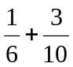usually making mistakes in their attempts to convert to fractions with a common denominator of 60. Those candidates who did manage the addition of fractions often gave 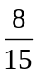 as their final answer thinking that they are working out the fraction of adults.

Question 12
There were some good starting points with the realisation that the equations needed multiplying to make either the x or y terms the same. Nearly 30% of the candidates continued to find both correct values. It was encouraging to note that the majority appreciate they are being asked to perform algebraically rather than an endless testing of values. However, many candidates had no idea what to do or added their new equations rather than subtract. As a result 58% of candidates did not score on this question.

Elimination followed by substitution was the favoured method but there were lots of arithmetic errors when multiplying through the equations and difficulties when trying to eliminate one of the variables. There was confusion over whether to add or subtract the equations. If subtraction was chosen then some could not cope with the solution of –y = –32 and went on to substitute y = –32.

Question 13
It is disappointing to report that many candidates could not show a bearing of 037° and so were unable to access the first mark in this question. Many students drew 053° (drawing 37° from the horizontal). However most candidates appeared to know what they needed to show and a good proportion of candidates drew the arc of a circle with radius 5 cm, centre C. Other candidates showed that a point on the ship’s course would lie less than 5cm from C and explained that the ship would therefore sail closer than 500m from C. Explanations were usually given in a clear statement drawing on evidence from the candidate’s accurate drawing. This was not always the case though and some candidates either left the question unanswered or provided inadequate diagrams, for example drawing lines 5 cm long from C without any explanation.

Question 14
Dealing with the fractions in this question proved to be an issue for many students. A common approach to answering this question was to work out 600 ÷ 4 = 150 followed by 4500 ÷ 750 = 6, but then not being able to go any further. Many of those students attempting to work out 4500 ÷ 750 did this by repeated subtraction, often arriving at an incorrect answer of 5 (rather than 6). Some students attempting to work out 150 ÷ 6 did this by
((150 ÷ 2) ÷ 2) ÷ 2, i.e. by incorrectly dividing by 2 three times.

Question 15
Most candidates made a good attempt at this question. Their approach was usually to find the total thickness of the 500 sheets of paper and compare this with the depth of the paper tray. This was often done successfully with a clear statement made in conclusion. A common error was to write 9 × 10^{–3} either as 0.0009 or as 0.09. Candidates who had previously shown the product 500 × 9 × 10^{–3} had already gained some credit and could score a further communication mark but candidates who had just written 0.0009 or 0.09 could not access these marks. Few candidates used the alternative approach of working out the thickness of each sheet of paper if exactly 500 could be stored in the tray and then comparing their answer with the thickness of a sheet of paper as stated in the question.

Question 16
There were many pleasing attempts at this question. Most successful methods started with the expansion of the left hand side. Competent candidates could then see that they could subtract the p term off to isolate the term in q on the left hand side. A few candidates did start by dividing through by 5, although they were generally less successful.

Question 17
At this stage in the paper it was disappointing to see, in part (c), candidates who were able to deal with the multiplication of numbers in standard form but were unable to work out 3 × 9 correctly, 18 was a popular incorrect answer for this multiplication. Another error that was seen was to write the initial answer as 27 × 100¹³ or 27¹³ rather than 27 × 10¹³ showing a lack of understanding of the relevant index laws and/or standard form.

Question 18
This question was quite well attempted. About one third of candidates gave a fully correct answer and about one half of candidates gained some marks for a correct method. Generally, the accuracy in working was good though many candidates made errors involving multiplication or division with negative numbers, such as –19y = −57 followed by y = −3. The alternative method of rearranging one equation and substituting into the other was rarely seen. Methods involving trial and improvement were more commonly seen but were rarely successful.

Question 19
This question testing circle geometry gave a good distribution of marks, with some candidates being able to recognise that the angle between a radius and a tangent is 90°, mostly seen on the diagram. A further small percentage were able to establish, by using a correct method, that angle AOC or angle BOC was 56° or that angle AOB was 112°, while only a quarter could gain all 3 marks for a fully correct solution and identify the answer as 68°.
Some candidates incorrectly assumed OC = BC and tried to use an isosceles triangle. Most candidates were not good at naming the angles that they were finding and as a consequence some lost marks by not identifying correctly which angle they were trying to calculate.

Question 20
Part (a) was well done with candidates showing a good understanding of how to find the median from a box plot. There was some evidence of inaccurate reading from the box plot in (a) and (b). In (b) those candidates who knew how to find the interquartile range generally gained at least one mark. However, a number of candidates either gave the range instead of the interquartile range or just listed the upper and lower quartile. Part (c) was a good discriminator; it was pleasing to see a number of candidates referring to outliers, extreme values or anomalous values. Common incorrect responses included ‘it’s more accurate’ and ‘most of the values are in the interquartile range’ or candidates simply stated some facts about either range or IQR.

Question 21
This question acted as a good discriminator between candidates. Well over a half of candidates were able to gain at least 2 of the marks for completing the cumulative frequencies accurately and making a good attempt at drawing the graph. However there is still a group of candidates who plot frequencies rather than cumulative frequencies and a surprisingly large number of candidates drew a bar chart. Despite the fact that it was stated in the question that the total number of students was 60, some candidates did not check their final cumulative frequency against this and so severely restricted the number of marks available to them for their responses. A minority of candidates plotted the cumulative frequencies against the midpoint or lower boundary of each interval instead of the upper boundary. Part (b) of the question was less well answered, particularly the part requiring candidates to estimate the interquartile range. Less than a half of the candidates gained any credit for their responses to this part of the question.

Question 22
When candidates are drawing histograms they should be encouraged to show their frequency densities or key. A number of candidates went straight into drawing a histogram but, when their chosen scale was very small or some bars of the wrong height it was difficult to award marks without sight of their overall method. Candidates who realised that area had to be taken into consideration rather than just the heights of the bars generally did go on to gain full marks in part (a). In part (b) some candidates who had not drawn a histogram in (a) still gave the correct method and answer from using the given frequency table. Those who mistakenly drew a cumulative frequency diagram in (a) were able to use this successfully in order to answer part (b). A small minority of students found answers to this question which were above 24 which was the total for the interval.

Question 23
This was a challenging question that was attempted by most candidates but poorly done by many. Those who drew guide lines from the correct centre often got full marks. Many of the incorrect responses were due to candidates using the wrong scale factor (often ½) or using the wrong centre of enlargement.

Question 24
Candidates who had some idea of how to find the vectors 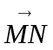 and 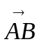in terms of m and n, generally scored at least two of the three marks. The third mark was to give a reason based on the forms for and of why the two lines are parallel. Generally candidates earned the final mark by stating that 2n – 2m was a multiple of n – m. In general, notation was poor, with arrows above vectors rarely shown and with underling of m and n usually absent.

Some candidates did not read the information carefully enough and found that and were half the values given in the answer. These candidates could score a maximum of two marks.

Question 25
Candidates in GCSE Mathematics usually struggle with transformation of functions and this question was no exception. In part (a), less than a quarter could show that they understood that −f(x) was a reflection of the curve in the x-axis and that (0, 4) and (−4, 4) reflected to (0, −4) and (−4, −4) respectively, but half of these could show an inverted parabola with a maximum point shown at (−2, 0). Many candidates lost a mark as their inverted parabola was hastily drawn and did not pass through the required points.
In part (b), very few candidates could write y = f(x − 6) as the required equation of the translation with y = f(x + 6) and y = f(x) + 6 being the most common wrong answers, with a few gaining the mark for writing y = (x − 4)².

Question 26
In part (a), common errors included candidates squaring the numerator and denominator or just multiplying 5 by √2, but many of those who attempted it did get the correct answer.
Part (b) was attempted far less frequently. There were some marks given for correct expansion of brackets, but in only a few cases were candidates then able to simplify their expressions correctly. It was disappointing to find many who missed the middle terms in the expansion. There were many errors with signs. Very few candidates recognised this as the difference of two squares.

Question 27
A significant proportion of candidates could express SQ correctly in terms of a and b though there were a substantial number of candidates who had no idea how to tackle this question. Pythagoras rule, the formula for the area of a triangle and other formulae were used to give incorrect expressions such as a² + b² and ab. Some candidates’ responses in both parts of the question consisted of numerical ratios. There were some good answers to part (b) of the question but candidates often showed poor communication skills in writing vectors by omitting brackets – for example expressions such as ‒ b + a + b were commonplace. Attempting to simplify vector expressions also caused difficulties for many candidates. It would seem that many candidates could benefit from further practice in the manipulation of vectors.
Practice paper: Bronze 4

 |  |  |  |  |  |  |  | Mean score for students achieving Grade:
Spec | Paper | Session  YYMM | Question | Mean score | Max score | Mean  % | ALL | A* | A | % A | B | C | % C | D | E
1MA0 | 1H | 1311 | Q01 | 2.55 | 3 | 85 | 2.55 | 2.95 | 2.89 | 96.3 | 2.81 | 2.63 | 87.7 | 2.17 | 1.32
1380 | 1H | 1006 | Q02 | 2.68 | 3 | 89 | 2.68 | 2.96 | 2.89 | 96.3 | 2.77 | 2.54 | 84.7 | 2.07 | 1.50
1MA0 | 1H | 1306 | Q03 | 2.55 | 3 | 85 | 2.55 | 2.89 | 2.80 | 93.3 | 2.70 | 2.55 | 85.0 | 2.29 | 1.76
1380 | 1H | 1006 | Q04 | 2.79 | 3 | 93 | 2.79 | 2.96 | 2.90 | 96.7 | 2.82 | 2.72 | 90.7 | 2.54 | 2.25
1380 | 1H | 1106 | Q05 | 3.58 | 5 | 72 | 3.58 | 4.91 | 4.62 | 92.4 | 3.98 | 2.78 | 55.6 | 1.37 | 0.67
1MA0 | 1H | 1206 | Q06 | 3.05 | 4 | 76 | 3.05 | 3.79 | 3.58 | 89.5 | 3.33 | 2.91 | 72.8 | 2.07 | 1.30
1MA0 | 1H | 1406 | Q07 | 3.13 | 4 | 78 | 3.13 | 3.91 | 3.82 | 95.5 | 3.69 | 3.12 | 78.0 | 1.63 | 0.47
1380 | 1H | 911 | Q08 | 3.26 | 4 | 82 | 3.26 | 3.84 | 3.68 | 92.0 | 3.48 | 3.15 | 78.8 | 2.73 | 2.30
1MA0 | 1H | 1306 | Q09 | 2.31 | 3 | 77 | 2.31 | 2.88 | 2.74 | 91.3 | 2.58 | 2.31 | 77.0 | 1.77 | 0.94
1MA0 | 1H | 1311 | Q10 | 3.21 | 5 | 93 | 3.21 | 4.70 | 4.49 | 89.8 | 4.20 | 3.30 | 66.0 | 1.42 | 0.23
1380 | 1H | 1006 | Q11 | 3.08 | 4 | 77 | 3.08 | 3.88 | 3.65 | 91.3 | 3.27 | 2.61 | 65.3 | 1.68 | 0.83
1380 | 1H | 1111 | Q12 | 1.43 | 4 | 36 | 1.43 | 3.86 | 3.53 | 88.3 | 2.56 | 0.83 | 20.8 | 0.14 | 0.06
1MA0 | 1H | 1306 | Q13 | 1.40 | 3 | 47 | 1.40 | 2.82 | 2.49 | 83.0 | 1.87 | 1.03 | 34.3 | 0.39 | 0.11
1MA0 | 1H | 1411 | Q14 | 1.23 | 4 | 31 | 1.23 | 3.63 | 3.20 | 80.0 | 2.46 | 1.34 | 33.5 | 0.65 | 0.24
1MA0 | 1H | 1306 | Q15 | 1.49 | 3 | 50 | 1.49 | 2.91 | 2.70 | 90.0 | 2.17 | 1.03 | 34.3 | 0.21 | 0.05
1380 | 1H | 911 | Q16 | 1.33 | 3 | 44 | 1.33 | 2.88 | 2.57 | 85.7 | 1.70 | 0.77 | 25.7 | 0.32 | 0.11
1MA0 | 1H | 1206 | Q17 | 1.92 | 4 | 48 | 1.92 | 3.64 | 3.17 | 79.3 | 2.40 | 1.21 | 30.3 | 0.50 | 0.24
1MA0 | 1H | 1306 | Q18 | 1.58 | 4 | 40 | 1.58 | 3.86 | 3.43 | 85.8 | 2.27 | 0.79 | 19.8 | 0.15 | 0.03
1MA0 | 1H | 1303 | Q19 | 1.02 | 3 | 34 | 1.02 | 2.81 | 2.41 | 80.3 | 1.66 | 0.67 | 22.3 | 0.18 | 0.08
1380 | 1H | 1011 | Q20 | 1.80 | 4 | 45 | 1.80 | 3.45 | 2.90 | 72.5 | 2.18 | 1.36 | 34.0 | 0.78 | 0.47
1MA0 | 1H | 1306 | Q21 | 2.54 | 6 | 42 | 2.54 | 5.56 | 4.69 | 78.2 | 3.27 | 1.77 | 29.5 | 0.71 | 0.20
1MA0 | 1H | 1206 | Q22 | 1.34 | 5 | 27 | 1.34 | 4.31 | 2.98 | 59.6 | 1.36 | 0.39 | 7.8 | 0.09 | 0.02
1MA0 | 1H | 1311 | Q23 | 0.49 | 2 | 26 | 0.49 | 1.74 | 1.30 | 65.0 | 0.66 | 0.17 | 8.5 | 0.03 | 0.01
1MA0 | 1H | 1406 | Q24 | 0.59 | 3 | 20 | 0.59 | 2.58 | 1.74 | 58.0 | 0.52 | 0.05 | 1.7 | 0.00 | 0.00
1MA0 | 1H | 1303 | Q25 | 0.67 | 3 | 22 | 0.67 | 2.41 | 1.59 | 53.0 | 0.85 | 0.46 | 15.3 | 0.23 | 0.12
1MA0 | 1H | 1211 | Q26 | 0.49 | 4 | 12 | 0.49 | 3.31 | 2.06 | 51.5 | 0.70 | 0.12 | 3.0 | 0.01 | 0.00
1MA0 | 1H | 1306 | Q27 | 0.78 | 4 | 20 | 0.78 | 3.54 | 2.13 | 53.3 | 0.76 | 0.19 | 4.8 | 0.03 | 0.00
 |  |  |  | 52.29 | 100 | 1450 | 52.29 | 92.98 | 80.95 | 80.95 | 63.02 | 42.80 | 42.80 | 26.16 | 15.31

